BSCS FINAL PROJECT

Offline Signature Verification System



**Awais Muhammad Lodhi**

Presented by:

**Group ID: F22BS019**

Student Reg# Student Name

L1F19BSCS0511 ABDUL RAUF

L1F19BSCS0570 MUHAMMAD SALEEM

L1F19BSCS0544 ZAVIAL SAHAR

**Faculty of Information Technology**

**University of Central Punjab**

Offline Signature Verification System

By

**Abdul Rauf**

**Muhammad Saleem Qureshi**

**Zavial Sahar**

Project submitted to

Faculty of Information Technology,

University of Central Punjab,

Lahore, Pakistan.

in partial fulfillment of the requirements for the degree of

**BACHELOR OF SCIENCE**

**IN**

**COMPUTER SCIENCE**

|  |  |  |
| --- | --- | --- |
|  |  |  |
| Project Advisor |  | Manager Projects |

Abstract

The proposed project aims to develop a desktop-based application for the identification of original signatures to prevent forgery. The application will utilize advanced techniques in deep learning and image processing to train a model capable of offline signature verification. The model will be based on a modified version of the traditional twin Siamese network, which will input four genuine signature images and one test image to determine the authenticity of the test image. The system's performance will be evaluated and compared to existing models that compare a single genuine image with a test image. The goal of the project is to provide organizations with a reliable and efficient method for verifying signatures without the need for live identification.

Dedication

We dedicate this project to the pursuit of innovation, accuracy, and efficiency in the field of signature verification. Our commitment to addressing the challenges faced by organizations in verifying signatures led us to embark on this journey. This project is a testament to our dedication to providing reliable solutions that enhance security and streamline processes.

Our motivation behind working on this project was driven by the need to revolutionize signature verification processes. Signatures are not just ink on paper; they safeguard confidential information and financial assets. The significance of accurate signature verification in banking, legal, and various organizational settings cannot be overstated.

We recognized the limitations of existing methods and aspired to develop an advanced solution that automates the verification process. Our determination to harness the power of deep learning, specifically the N-way Siamese network architecture, fueled our efforts. Through rigorous research and experimentation, we aimed to create a model that surpasses traditional methods, offering enhanced accuracy and ease of use.

The dedication of countless hours, persistent learning, and collaborative teamwork underscores our commitment to making a tangible difference. This project embodies our passion for technology's potential to transform real-world challenges into efficient solutions.

As we present this project, we acknowledge the collective effort, innovative thinking, and commitment of everyone involved. May this endeavor contribute to enhancing security measures and inspire further advancements in the realm of biometric verification.

Acknowledgements

As we come to the completion of our final year project, we gratefully acknowledge the invaluable contributions of all those who have supported and encouraged us throughout this journey.

First and foremost, we extend our heartfelt gratitude to our project supervisor, Awais Muhammad Lodhi, for their unwavering guidance, expertise, and mentorship. Their insightful feedback and constant motivation have been instrumental in shaping the direction of our research.

We would also like to thank the faculty members and mentors at University of Central Punjab, whose knowledge and wisdom have enriched our learning experience. Their dedication to nurturing young minds has been pivotal in our academic growth.

To our friends and family, thank you for standing by our side and offering unwavering support. Your understanding and encouragement have been a source of strength, helping us navigate the challenges of this project.

A special note of appreciation goes to the participants who willingly shared their data and insights, allowing us to conduct a comprehensive analysis. Your valuable contributions have been crucial in shaping the findings of this research.

We extend our gratitude to the developers and researchers whose work has paved the way for advancements in natural language processing and deep learning. Their pioneering efforts have been fundamental to the methodology and approach we adopted in our project.

Finally, we express our deepest gratitude to each other, the members of this project team. Our collective efforts, teamwork, and shared vision have been the driving force behind the successful completion of this endeavor.

To all those who have played a part, big or small, in making this project a reality, we extend our sincere appreciation. Your contributions have left an indelible mark on this work.

As we move forward, we hope that our research can serve as a steppingstone for further exploration in the field of signature verification process. May our findings contribute to fostering a safer and more inclusive online environment for all.

# List of Figures

Figure 1: Block Diagram……………………………………………………………………….….3

Figure 3: Use case diagram for back end user…………………………………………………....44

Figure 4: Use case diagram for App ……………………………………………………………..47

Figure 5: Block diagram of Workflow …………………………………………………………...49

Figure 6: ER Diagram of the system …………………………………………………………… 50

Figure 7: Context/Level0 DFD of the System ……………………………………………………50

Figure 8: SWIMLANE DIAGRAM OF PROJECT ……………………………………………..51

Figure 9: Sequence diagram of the project ………………………………………………………52

Figure 10: Design level activity diagram of system ……………………………………………...53

Figure 11: Level 1 DFD of the system ……………………………………………………………54

Figure 12 Sequence diagram showing admin’s interaction ………………………………………55

Figure 13: Sequence diagram of user’s interaction with system ……………………………….…56

Figure 14: Component diagram of the system …………………………………………………...57

Figure 15: Class diagram of the system ………………………………………………………….58

Figure 16: Design level class diagram of system …………………………………………………59

Figure 17: Database schema of system …………………………………………………………..60

Figure 18: component-component diagram ……………………………………………………...61

Figure 19: Component external entity interaction……………………………………………......61

Figure 20: Sequence diagram of system ………………………………………………………….62

Figure 21: architecture of 5-way Siamese network ……………………………………………...63

Figure 22: Activity diagrams for screen ………………………………………………………….89

Figure 23: Sample signature images from dataset ……………………………………………….90

Figure 24: Gray scaled images using Opencv library t …………………………………………..92

Figure 25: Gray scaled signature images using SKIMAGE library ………………………………93

Figure 26: gray scaled images after global histogram equalization ………………………….…..94

Figure 27: Signature images after applying Otsu thresholding, histogram equalization and gray scaling …………………………………………………………………………………………...95

Figure 28: Images after applying CLAHE on grayscale images ………………………………….96

Figure 29: Final Images ………………………………………………………………………….97

Figure 30: Layers arrangement in custom model ……………………………………………….100

Figure 31: Internal Sequential Structure for above given layers …………………………….…101

Figure 32: Internal Sequential structure for 6 conv block arrangement …………………..……102

Figure 33: Graph showing accuracy on different levels of threshold ……………………..……103

Figure 34: Confusion matrix for custom model ………………………………………..………104

Figure 35: Graph showing accuracy on different levels of threshold using VGG16 …………….105

Figure 36: *Confusion matrix for RESNET* ………………………………………………………108

Figure 37: Confusion matrix for VGG16 ……………………………………………………….106

Figure 38: Graph showing accuracy on different levels of threshold using RESNET ………………………………………………………………………………………….……….107

Figure 39: model architecture using RESNET for feature extraction ……………….………….108

Figure 40: Model architecture 2-way……………….…………………………………………..110

# List of Tables

Table 1: SVS Model 45

Table 2: 7.1.1 TC-1(Sign Image Acquisition) 110

Table 3: 7.1.2 TC-2(Preprocessing of Input) 111

Table 4: 7.1.3 TC-3(Feature extraction from images) 112

Table 5: 7.1.4 TC-4(Training on extracted features) 113

Table 6: 7.1.5 TC-5(Testing of model) 114

Table 7: 7.1.6 TC-6(Result Verification) 115

Table 8: Summary of Test Results……………………………………………………………...116

Table 8: 8.1 Project Completion Status 117

Table 9: 8.2 Objective/targets/status 118

Table B.3: List of non-trivial defects 113

Table of Contents

Abstract i

Dedication ii

Acknowledgements iii

List of Figures v

List of Tables vi

Table of Contents vii

Chapter 1. Introduction 1

1.1 Review of Related Literature 1

1.2 Problem Statement 1

1.3 Proposed Solution 2

1.4 Problem Scope 4

1.5 Challenges 4

1.6 Knowledge Areas Required 5

1.7 Completeness Criteria 6

1.8 Research Outcomes/Nature of End Product 7

1.9 Learning Outcomes 7

1.10 Document Conventions 9

1.11 Miscellaneous 10

Chapter 2. Background Study and Literature Survey 11

Chapter 3. Methodology/Proposed Solution 41

Chapter 4. System Requirements 44

4.1 Functional Requirements 44

4.1.1 Use-Case 1: Signature Verification 45

4.1.2 Use-Case 2: SVS Desktop APP 46

4.1.3 Proposed Workflow 49

4.1.4 Analysis and Modeling of Requirements 50

4.1 Nonfunctional Requirements 64

4.1.1 Target Performance 64

4.1.2 Safety Requirements (if applicable) 64

4.1.3 Security Requirements (if applicable) 64

4.1.4 Additional Software Quality Attributes 64

4.2 Other Requirements 64

5 Results 65

6 Analysis and Discussion 67

6.1 Result Comparison (General Discussion) 67

6.2 Screenshots/Prototype 67

6.2.1 workflow 67

6.2.2 SCREENS 69

6.3 Additional Information 80

6.4 Other Design Details 81

7 Test Specification and Results 102

7.1 Test Case Specification 102

Chapter 8. Project Completion Status 109

References 111

Appendix A Glossary 112

Appendix B IV & V Report 113

(Independent verification & validation) 113

Appendix C Deployment/Installation Guide 114

Appendix D User Manual 122

Revision History

|  |  |  |  |
| --- | --- | --- | --- |
| **Name** | **Date** | **Reason For Changes** | **Version** |
|  |  |  |  |
|  |  |  |  |

# Introduction

In today's digital landscape, where signatures play a crucial role in transactions, ensuring their authenticity is vital. This project addresses the limitations of manual signature verification by utilizing advanced deep learning techniques. The significance lies in providing accurate and efficient identity validation, particularly for banks and organizations. The motivation stems from the need for a reliable, user-friendly solution amidst the rise of online transactions. The project's goal is to create a desktop application that seamlessly integrates a Siamese network with CNNs for robust signature verification. The system offers easy signature upload, result viewing, and admin functionalities. The scope includes catering to organizations' needs and offering a cost-effective, accessible alternative to online signature verification systems. The project's innovation lies in its novel approach to N-way Siamese networks, promising enhanced security and convenience.

## Review of Related Literature

Total six research papers were reviewed 2 papers by each group member which include

* Signet convolutional Siamese network for writer independent offline signature verification **[3]**
* Proceeding of SPIE offline SVS using Convolutional Siamese network **[4]**
* Signature verification using Siamese network based on one shot learning **[5]**
* signature verification using a convolutional neural network **[6]**
* Offline signature verification with CNN **[7]**
* Machine learning based offline signature verification system A systematic review **[8]**

4 papers Focus on **CEDAR [2]** dataset and two papers focus on **SIGCOMP 2011 [1]** dataset

## Problem Statement

Identification of signatures using image processing and deep learning

## Proposed Solution

First **Data** will be acquired and preprocessed. The preprocessing phase will comprise of two phases namely **Image Preprocessing** and **Data Preprocessing.** After preprocessing data will be sent to CNN (Convolutional Neural Network) model for feature extraction and after that, model will get trained on the dataset using 5-way Siamese network**[1]**.4 genuine and 1 test signature image will be provided to the model. Once the training phase is over, then comes the evaluation phase. Based on feature comparison between 4 real and 1 test signature image. Consequently, an output resulting in either the signature being real or fake will be provided

A user friendly Desktop app will provide interface to the model where people or the organization using the software will able to register people along with their 4 genuine scanned signatures and will be able to upload a test image to app which will tell either this image is original or fake.

Once the model is completed using 5 way Siamese network results will be compared to traditional model which compare 1 test image with 1 train image based on the extracted features

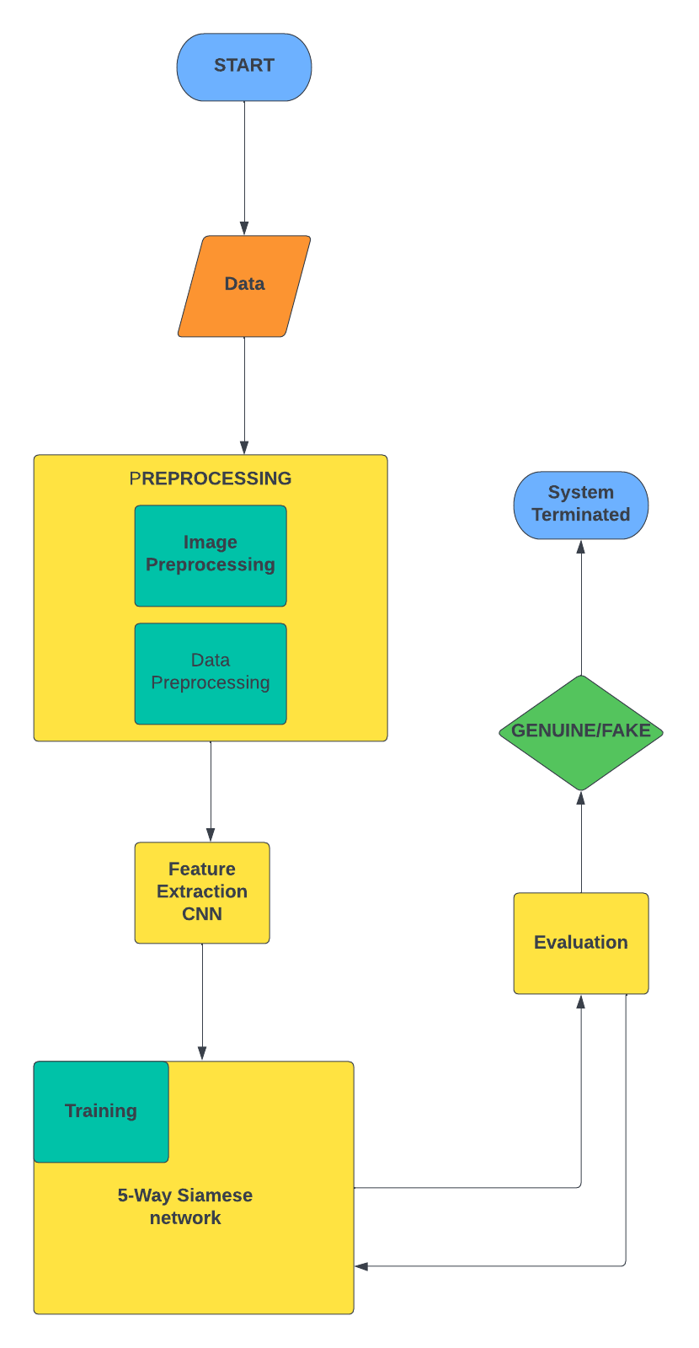

*Figure 2: Block Diagram*

## Problem Scope

This model will assist organizations in signature verification using deep learning and image processing techniques. App’s target audience will be banks but other organizations where signature verification is required can also use this app. Signatures can autonomously be identified by the app, this app will able to verify signatures more accurately than human eye because computer can see minute details which human can’t see. SVS will able to verify signatures of any size, color, pen type etc., there are also some limitations and hurdles like thickness of the nib, nib style, security (confidential information can be misused if signatures are wrongly identified), other possible hurdles are also listed below

## Challenges

Some of the main Challenges that can be faced while doing this project are

* **Algorithm chosen**
* As we are using 5 ways Siamese network**[1]** rather simple CNN or traditional 2way Siamese network so in depth understanding and implementation of the model will be the greatest challenge while doing this project
* **Dataset**
* Though we are using two standard benchmark datasets i.e., Sigcomp2011 and CEDAR**[2]** to train our model but our project requirement is to identify signature done by any nib type (Thick or Thin), any size, any orientation, angle and color which will also be a big challenge
* **Publishing Paper**
* Our project requires us to publish a Conference paper along with practical implementation of the project in short period of time where other people are doing only research based projects or developmental projects our project will base on both Research and Development, implementation
* **Less Related Work Available**
* As already stated, the algorithm we will be using in this project is completely a new and unique algorithm so no related work is available for implementing the model using 5 ways Siamese network**[1]**. So we will be doing most of the work ourselves which is also a major challenge.

## Knowledge Areas Required

Following are the knowledge areas required for this project, some of which we have learned during our degree and some, we will be learning during the course of our project:

* **Deep learning (Neural Networks)**

Deep learning is the most important knowledge area required to do this project Neural networks like CNN will be used to extract features from the signature image and predict similarity Siamese network is also a type of deep learning algorithm having multiple CNNs so in depth knowledge of deep learning and Neural Networks is required for this project.

* **Image Processing**

As Signatures will be provided in the form of scanned images to the model so Image Processing plays a vital role in this project for e.g. if there are images of signatures in different colors or resolution first all the signature images will be converted into same format and then further processing will take place. Algorithms like Gray scaling and Morphology will be used so extensive knowledge of Image Processing is also necessary for this project.

* **Development Knowledge**

Development knowledge is very crucial for this project. Development knowledge can further be divided into two parts i.e.:

* **Algorithm Development**

We will be using python to implement the logic and for developing the algorithm so a strong hold over python will be required to develop efficient algorithm

* **Desktop Application development**

The end product of our project will be a Desktop Application so knowledge about app development will also be required for developing the desktop application. We will use python to develop the app

* **Probability**

Knowledge about probability is important while doing a machine learning or AI based project because most of the algorithms work on the bases of probability

* **Linear Algebra**

As signatures will be in Image form and Image processing is also required in this project so knowledge about matrices and their operations will also be required

* **Software Engineering (Documentation)**
  + Knowledge about software engineering will also be required for this project for example which development model to follow, how to make software cost effective and scalable etc. also software engineering information will be required for Documentation

## Completeness Criteria

The completeness criteria of our project will be as follow:

* 10% weightage for Desktop Development
* 40% weightage for Algorithm which will further be divided into 3 subcategories
  + 13% weightage for python programming and implementing/understanding libraries
  + 12% weightage for Algorithm development
  + 15% of weightage for understanding the algorithm
* 10% weightage for implementing the whole project and making it a product
* 10% weightage for dataset processing
* 10% of weightage for publishing paper
* 10% of weightage for analyzing related work, research papers and books
* 10% of weightage for staying in contact with advisor and have scheduled meetings

## Research Outcomes/Nature of End Product

Following will be the research outcomes of our project:

* N- Way Siamese network implementation and architecture

By the end of this project we will have in depth knowledge of multi way Siamese network and its architecture, also we will get knowledge about the layers in Siamese architecture like distance calculation layer and averaging layer etc.

* Comparison of N- Way Siamese network**[9]** with tradition models which uses CNN or twin Siamese network

At the end of this project we will compare the results obtained by using 5- way Siamese **[9]**network and the traditional model which uses simple CNN. Based on the results comparison we will decide the superiority or inferiority of N- way Siamese network over simple CNN model

The end product will be a desktop app having our model implemented in backend which uses N-way Siamese network. For the registration process user will provide 4 genuine signature samples and these samples will be added to database against the user registration id. Now for the verification process user will provide 1 signature image which can either be fake or real and system will give decision based on extracted features

## Learning Outcomes

* **Familiarization with Python programming**

After doing this project we will become familiar to python programming and will have strong hold over python development

* **Understanding Deep learning and Machine learning**

As this is a deep learning project so after completing this project, we will be able to better understand Deep learning, Neural Networks, how they work and also some other machine learning algorithms and can continue making progress in this field

* **Image processing techniques**

Along with Deep Learning Image processing is also required to do this project so after doing this project we will have expertise in field of Image processing and its applications

* **Understanding N ways Siamese network**

We will be using 5 ways Siamese network in this project rather traditional 2-way Siamese network. Our algorithm is a new algorithm which we our self have to implement so after doing this project we will become familiar to this 5 ways network and also will able to develop new algorithms more easily

* **Analyzation of past results**

Good analytical skills will be developed after doing this project and analyzing related work i.e., work done by others via different techniques will allow us to analyze a paper comprehensively

* **Development**

Development is also an important aspect of this project as we will be making a user-friendly desktop app in python along with developing our model in python language. Hence after doing this project, we will gain proficiency in App development and Algorithm development

* **Rules for writing a research paper**
* **Familiarization with Python programming**

After doing this project we will become familiar to python programming and will have strong hold over python development

* **Understanding Deep learning and Machine learning**

As this is a deep learning project so after completing this project, we will be able to better understand Deep learning, Neural Networks, how they work and also some other machine learning algorithms and can continue making progress in this field

* **Image processing techniques**

Along with Deep Learning Image processing is also required to do this project so after doing this project we will have expertise in field of Image processing and its applications

* **Understanding 5 ways Siamese network**

We will be using 5 ways Siamese network in this project rather traditional 2-way Siamese network. Our algorithm is a new algorithm which we our self have to implement so after doing this project we will become familiar to this 5 ways network and also will able to develop new algorithms more easily

* **Analyzation of past results**

Good analytical skills will be developed after doing this project and analyzing related work i.e., work done by others via different techniques will allow us to analyze a paper comprehensively

* **Development**

Development is also an important aspect of this project as we will be making a user-friendly desktop app in python along with developing our model in python language. Hence after doing this project, we will gain proficiency in App development and Algorithm development

* **Rules for writing a research paper**

## Document Conventions

* Referencing style **IEEE**
* Font **Times New Roman**
* **SVS** :: SIGNATURE VERIFICATION SYSTEM
* Headings **BOLD**
* Size of headings 12
* Size of font 12
* Captions of Images and diagrams= Times new roman italic size 12
* Referencing style IEEE

## Miscellaneous

This application is designed for use by specific organizations and their registered employees. The administrator of the organization will be responsible for registering employees as users, who will then have access to the app and be able to perform designated tasks, such as verifying signatures of clients. This is distinct from a consumer-facing application that is open to registration by any individual.

# Background Study and Literature Survey

Six paper were reviewed results and findings are under

* **Signet Convolutional Siamese Network for Writer Independent Offline Signature [3]**

This Paper is about a writer independent signature verification task with convolutional Siamese network. Siamese network is a twin network with shared weights, training is done by exposing this network to similar and dissimilar observations, minimizing the Euclidian distance between similar pairs and maximizing the Euclidian distance between dissimilar pairs experiments are conducted on signatures in various languages and writing styles. While verifying signatures smallest and critical details need to be seen

Signatures are most commonly used and accepted biometric to identify people, signature verification is of two type online and offline in online SVS special equipment are required but in offline SVS signs are usually captured by scanners or any other imaging device like mobile camera which is a 2Dimensional signature image there can be two scenarios in offline SVS writer dependent and writer independent where writer independent scenario is preferred, for a particular signer signatures are coupled as similar (Genuine, Genuine) and dissimilar (Genuine, Forged) pairs, so signature verification can efficiently be modeled by Siamese network which consist of twin CNN accepting two distinct sign images coming from either similar or dissimilar tuples. Two CNNS are joined by cost function computing distance metric between highest level feature representation on each side of network

**Preprocessing**

Images of same size are needed for batch training a Neural Network but signature images could have different sizes ranging from **153 X 258** to **819 X 1137,** first all images need to be resized to a fixed size which is **155 X 220** in this case after resizing images are inverted using bilinear interpolation so background pixels have 0 values, further images were normalized by dividing the pixel value with standard deviation of the pixel value of image in dataset.

This paper also tells about CNN and its architecture. Deep CNN is a multilayer Neural Network consisting of several Convolutional layers having different kernel sizes interleaved by pooling layers which summarize and down sample the output of its convolutions before feeding to next layer kernel sizes ranging from 11 X 11 to 3 X 3 were used in this project, given a differentiable loss function, weight of different layers are updated using back propagation

**Working**

The twin CNN have the same configuration with the same parameter and shared weights, parameters updating is mirrored across both subnetworks, these subnetworks are joined by loss function at the top which computes a similarity metric involving Euclidian distance between, feature representation on each side of Siamese network.

**Loss**

Contrastive loss is a type of loss function used in Siamese network once a high level feature output from both of the constituting CNNs is obtained they are joined with a loss function which is

$$L\left(S1,S2,y\right)=α\left(1-y\right)D^{2} w+βymax{\left(0,m-Dw\right)}^{2}$$

In which L is a function of S1, S2 and y where s1 and s2 are the two samples (signature images) y is a binary indicator denoting whether two samples belong to same class or not α and β are constants and m=1 is margin

$$Dw={\left|\left|f\left(s1;w1\right)-f\left(s2;w2\right)\right|\right|}_{2}$$

**Dw = ||f(s1;w1)− f(s2;w2)||2** is Euclidian distance computed in the embedded feature space f is an embedding function that maps a signature image to real vector space through CNN and w1, w2 are learned weights for a particular layer, due to the loss function selected this space will have a property that images of same class will be closer to each other than the images of different classes i.e. forgeries or signature of different writers, both branches join together by a layer that computes Euclidian distance between the two points in embedded space in order to decide that two images belong to similar class or dissimilar class then threshold value on distance need to be determined. For convolutional and pooling layers CNN architecture is used the size of the filter is N X H X W where N is number of filter, H is height and W is width

**Dataset**

4 widely used benchmark datasets were considered including **CEDAR, GPDS300, GPDSsynthetic and BHSig290 signature corpus**. To evaluate signature verification algorithm. CEDAR contain signatures of 55 signers having 24 signature signed 20 minutes apart so total 1320 genuine signatures and equal number of forged signatures images are available in Gray scale mode in the dataset. Randomly M signatures were selected from K for testing and remaining K-M for testing purpose

**Result**

A threshold d is used on the distance measured D(Xi, Xj) to decide whether the signature (i, j) belongs to similar or dissimilar class sign pair (i,j) having same identity are denoted by Psimilar and having different identities are denoted by Pdissimilar then set of all the true positives $TP\left(d\right)=\{\left(i,j\right)єPsimilar,with D\left(xi,xj\right)≤d\}$ and true negatives

$$TN\left(d\right)=\{\left(i,j\right)єP_{dissimilar},with D\left(xi,xj\right)>d\}$$

True positive rate $TPR\left(d\right)=\left|TP\left(d\right)\right|/\left|P_{Similar}\right|$ and True negative rate $TNR\left(d\right)=\left|TN\left(d\right)\right|/|P_{disiimilar}|$

And final accuracy **Accuracy = max d∈D*1 /2(TPR(d) + TNR(d))**

$$Accuracy=max dєD*\frac{1}{2}(TPR\left(d\right)+TNR(d))$$

100 percent accuracy was achieved when CEDAR dataset was used ,77.76 percent accuracy when GPDS synthetic dataset was used and 63.36 percent accuracy was achieved when GPDS 300 was used

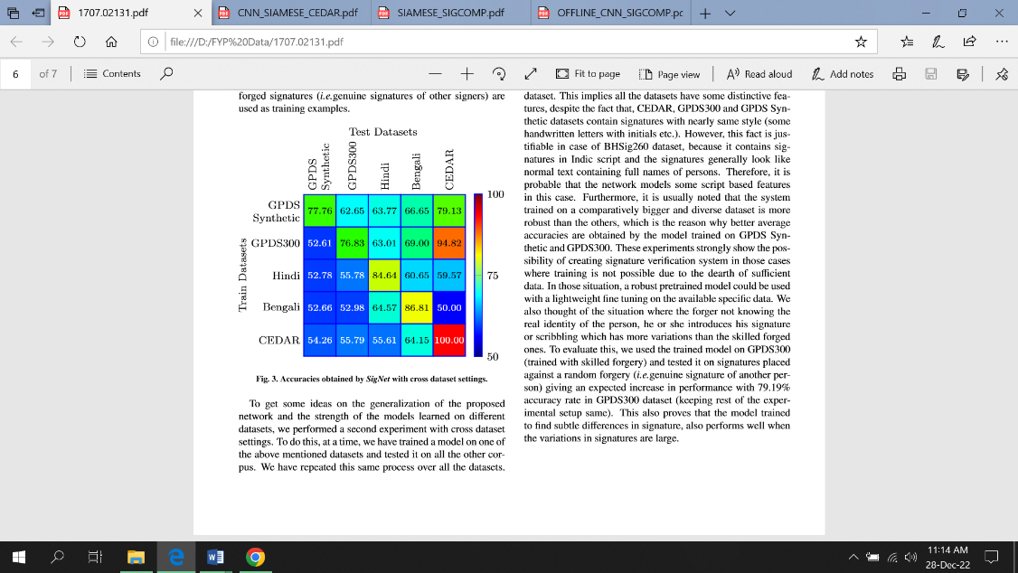

* **Offline Signature verification using Convolution Siamese network [4]**

This paper presents a method of signature verification using convolutional Siamese network, a deep learning base framework combining feature extraction and metric learning

**Introduction:**

This system verify person’s identity based on his chosen signature it classifies person’s signature sample genuine or forged. In offline signature verification signature is captured after the completeness of writing process, and represented as digital image, it is similar to other verification problem like face verification or person identification

**Working:**

Recent work explored different features like contours feature which encode directional property of signatures contours and length of regions enclosed inside letters and curvlet transformation which uses energy of curvlet coefficient computed from whole hand written signature.

In metric learning there are two approaches writer dependent and writer independent. A specialized metric model is learned for each individual, during training phase using person’s genuine or both fake and genuine signatures. Combining feature extraction and metric learning provide better performance. Siamese network is used in this problem, which assess similarity of *2 signature image in pair* for offline signature verification and combine the separate modules together i.e. feature extraction and metric learning

**System Design/System Working:**

In pattern recognition input of Neural Network is sample signature and the output is predicted label, but for signature verification, this style of Neural Network is not suitable so Siamese network is constructed including two sub CNNs which take a pair of sample as input and gives label as output, the input images in the pair are first preprocessed to same size and fed to CNN in Siamese network for feature extraction after that metric method is use to calculate distance of extracted feature.

**Dataset:**

Two publically available standard benchmark datasets are mentioned in this paper i.e., **CEDAR** and **GPDSsynthetic,** CEDAR contain signatures of 55 individual people signed **24** signatures each creating **1320 genuine** signatures having equal number of forged signatures. The images in CEDAR are available in grayscale mode, GPDSsynthetic is based on synthetic individual protocol dataset comprises of **4000** signers every individual having **24** genuine and **30** forged signatures making **96000** genuine and **120000** forged signs

**Preprocessing:**

There are differences between signature images from both datasets, the signature images in both datasets are more skewed so more steps are required to preprocess the signature images in CEDAR compared to GDPSsynthetic for CEDAR images **Otsu’s method** is used to binarize image which is a threshold selection method from gray level histogram, to clean grain noise **connected component analysis** is used, **Hough transform** is used to detect and remove lines which are not part of signature. After preprocessing CEDAR images signature region from images were extracted and it was found that signature images from both datasets have variable size but to train CNN all input needed to be of same size so images were normalized, for **CEDAR** signatures were centered in canvas of size **1060 X 450** pixels and for **GDPSsynthetic** signatures were centered in canvas of size **2800 X 1200** pixels then images were resized to fixed size of **224 X 512** pixels

**Feature extraction:**

Features are extracted by Siamese network containing two identical subnetworks with branches sharing same parameters features were extracted through CNN using automatic feature learning, the first layer in network is convolutional layer with **11 X 11** kernel then there are two parts one part comprises of **5** convolutional layer and **4** maxpooling layer second part make use of low level features, feature map size after first convolutional layer is **W X H** where **w** is width and **h** is height of feature map

**Metric learning:**

If features extracted from CNN are **f1** and **f2** now similarity need to be evaluated between these pairs f1 and f2 to measure similarity between feature pair **Euclidian** and **cosine** distances are used

$$d^{2}E\left(f1,f2\right)={\left(f1-f2\right)}^{t}(f1-f2)$$

$$dcos\left(f1,f2\right)=(f1*f2)/\left|\left|f1_{2}\right|\right|f2_{2}$$

a hybrid similarity layer combining both Euclidian and cosine distance is formulated

$$f_{hybrid}=[f_{abs},f_{multi}]$$

$$f_{abs}=|f1-f2|$$

$$f_{multi}=f1*f2$$

where abs mean absolute, multi means element wise multiplication a 2d vector **[p1, p2]** representing predicted probability that 2 signature images belong to same identity or not

Signature verification is considered a binary class classification and use cross entropy loss

$$loss\left(p,\hat{p}\right)=-\left(p\log\left(\hat{p1}\right)+\left(1-p\right)\log\left(\hat{p2}\right)\right)$$

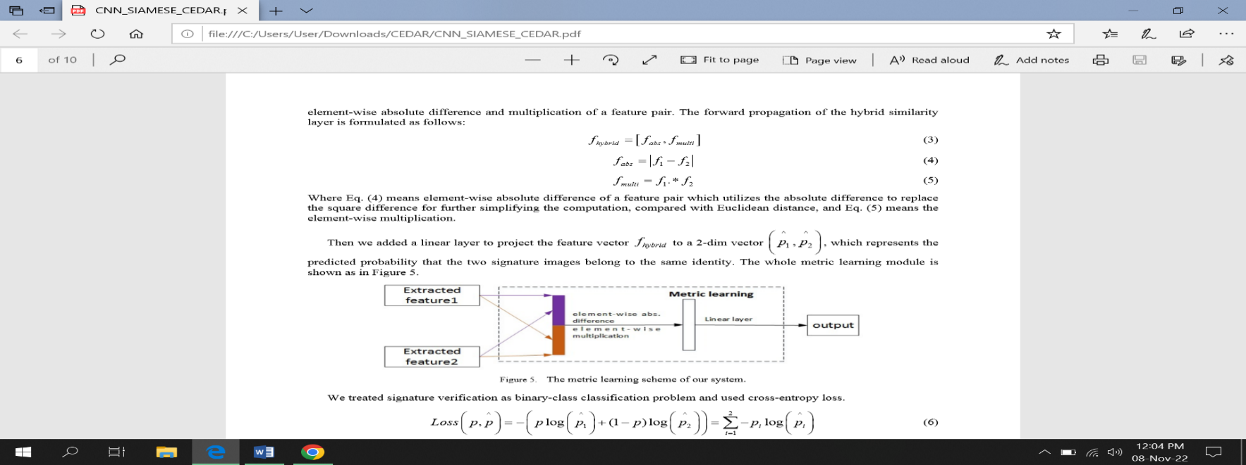*p is target class and p hat is predicted probability if image belong to* ***same signer p1=1, p2=0*** *else* ***p1=0, p2=1***

**Result:**

in GSDPsynthetic there are 24 genuine and 30 forged signers so **276** genuine genuine pairs and **720** genuine forged pairs and totally there are **2000 x 2 x 276 = 1104000** signature pairs for training and testing

in **CEDAR** there are 1320 genuine and 1320 forged signs of **55** signers **5** signers are randomly selected for testing purpose and rest 50 for training every individual have 24 genuine and 24 forged pairs so total **276** genuine genuine pair and **576** genuine forged pair compared to all algorithms trained on GSDPsynthetic this combined algorithm performed better

*EER USING DIFFERENT DISTANCE ALGO*

|  |  |
| --- | --- |
| ***METRIC METHOD*** | ***EER*** |
| *COSINE DISTANCE* | *20.46* |
| *EUCLIDEAN DISTANCE* | *12.30* |
| *HYBRID SIMILARITY LEARNING* | *10.37* |

*EER RESULT Of sampling GPDSsynthetic*

|  |  |  |  |
| --- | --- | --- | --- |
| ***SAMPLING ON TRAIN*** | ***SAMPLING ON TEST*** | ***EER*** |  |
| *NO* | *NO* | *10.65* |  |
| *YES* | *NO* | *10.87* |  |
| *YES* | *YES* | *10.37* |  |

* Signature Verification Using a Convolutional Neural Network [6]

1. **Abstract**

This paper discusses techniques for validating written signatures on bank cheque’s. CNN is used in the model for analysis of pixels from the signature image in order to detect abnormalities. CNN will better extract key features and optimize processing time. Multiple layers of receptive fields along with hidden layers will better analyze and extract vital features. The prime use case of this method is to detect and decrease fraud committed, especially in the banking industry. Future uses of signature verification could include legal documents and the justice system.

1. **How Data is Split & Dataset**

SIGCOMP_2011 Dataset is used . 20% Test dataset. 80% as Training dataset with validation of 25%. CNN was designed to split signatures into Dataset. Then Images were categorized into classes based on their origin . The two main categories in dataset are Real Signatures and Forged Signatures.

1. **Pre-Processing**

The check image will be adjusted according to a predefined image size and flattened into a feature vector before using as an input signature. Image Preprocessing is done firstly in order to remove varying backgrounds. Pixel intensity differences are minimized using a kernel. Dataset is labelled as per the signers. Image is preprocessed to fit according to the architecture. This architecture used in this paper accepts 150 x 230 input dimension. Open CV library used for reshaping Image. Image is converted to gray scale. Filter is applied to enhance pixel intensity differences, making edges clearer. Image Centering and Image Boxing are already catered by the dataset.

1. **Method & Details Regarding Architecture**

CNN architecture using the Keras library on Python with a Tensor Flow backend was used. Image comparison system was used based on an image classification system. Each Signature image will be assigned a label with its author name. After providing signature Image to the system, its features will be compared with the features of other signatures that will have similar labels. Computer vision systems will recognize a signature as single entity and then compare the features of the signature, for instance particular edges and spacing, with other signatures having the same label. Then, an image comparison system will provide probability of weather the input signature is valid or not. Multilayered CNN architecture detects precise features with minimal preprocessing. CNNs learn by generating their own filters, and gradually modify those filters to recognize features. This unique characteristic feature allows CNNs to be independent from prior knowledge, work without hand engineered filters. Time and effort for constructing the network is significantly reduced as compared to other neural networks.

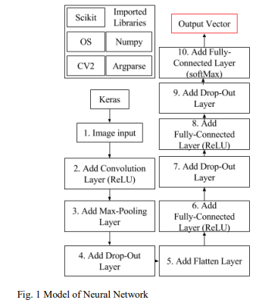

Relevant Libraries are Imported. Image is Input. Image is Flattened to enhance and emphasize prominent image features. Then those features are extracted from Image via multi Layered CNN Model.

***NETWORK ARCHITECTURE***

**Input Layer:**

Image will be Input to CNN in the form of Pixel matrix. Each image will have a specific Width and Height in the form of pixels. 3 color channels R (Red) .G (Green) .B(Blue) will be presented in the form of 3-D Python Array. Then the colored Image will be converted to GrayScale. After reading labels Input will be sent to next Layer for further processing.

**Convolutional Layer:**

CNN performs a convolution on the input image using several filters to get output images equal to the number of filters applied. Filters are used that are basically grayscale images represented in the form of matrices having pixel values. In this Layer filters / matrix of previous dimensions take each pixel along with surrounding pixel and perform element wise multiplication & sums up the results. The resulting sum is output onto the output image with similar pixel coordinates to the image where kernel was previously present. As surrounding pixels are taken into account the border size of image is decreased which is settled by padding i.e. filling empty border spaces by values that don’t alter the results.

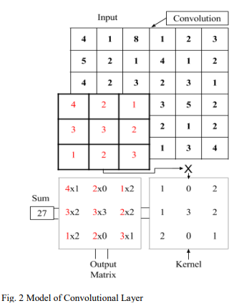

**Rectifier Layer:**

Rectifier Linear Unit (ReLU) layer performs activation function on the outputs of the CNN Layer.

F(x) = max(0,x) this function is used to convert all negative pixel values to 0 and rest +ve values remain same.

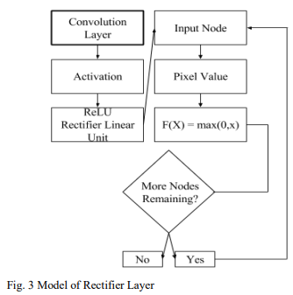

**Max pooling layer**

An Even Numbered input matrix is equally divided into several non-negative regions of pixels. For instance a 6 x 6 matrix is divided into 4 quadrants of 3 x 3. Now from each of these quadrants a maximum value will be taken and outputted as a smaller new matrix. Now this new matrix will be input of next Layer.

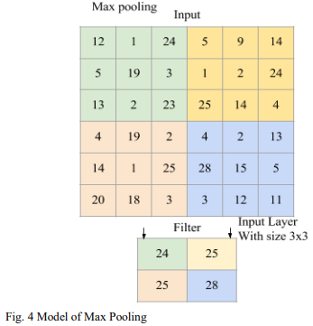

**Fully Connected Layer:**

The output Image received from Max Pooling Layer get connected to a Fully Connected Layer. Output Nodes are connected to Input layers. Each output Node has a matrix of weights. Node Matrix will be multiplied with weight matrix. Results will be added and placed in the specified output nodes.

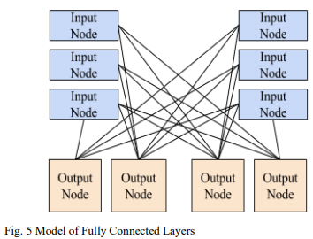

**Softmax Function:**

Softmax function is used to extract probabilities for each of the classes. Its equation is: $σ(z) j = e^{zj}/ (\sum_{k=1}^{k}{e^{zk}})$

Softmax Function turns a k-dimensional vector of z values to another k-dimensional vector of probability values. This function is used because a it can emphasize higher probabilities and de-emphasize lower probabilities

**Categorical Cross-entropy**:

Quantifies the quality of the neural network’s predictions, the cross-entropy of the probability distribution of the output vector is compared against the entropy.

$$H\left(p\right)=-\sum{p_{x}log⁡(p_{x})}$$

**Stochastic Gradient Descent:**

This is used to Optimize Neural Network between epochs. A learning rate is specified, and weights are optimized using the following equation

$$ω=ω_{i}-{μQ}_{i}(ω)$$

In this equation, 𝝎 is the value of the weight, 𝝁 is the learning rate as a decimal, and 𝑸(𝝎) is an approximation of the gradient.

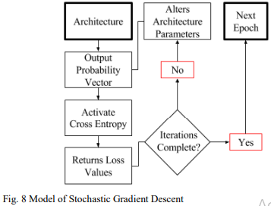

**Results**

83% Accuracy.

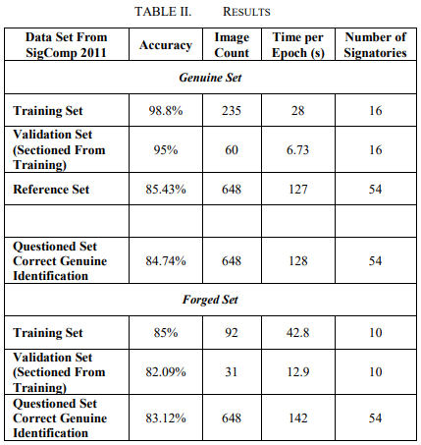

* SIGNATURE VERIFICATION USING SIAMESE NETWORK BASED ON ONE-SHOT LEARNING [5]

1. **Abstract**

Signature Verification is a biometric verification type & plays vital role in banking sector, judicial and administrative applications. Signature Verification is of two types, Online & Offline used for identifying signature forgery. Online signature verification is carried out during signing and temporal dynamic data are available regarding the person's signature. Offline verification is applied by scanning the image after signing, and this verification is limited to spatial data. Therefore, the offline signature verification process is considered a more challenging task. This study discusses offline signature verification, independent of the writer, based on One-Shot Learning using Siamese Neural Network. Successful classification by using less numbers of signature images has been achieved using this method. The proposed approach achieved percentage accuracy of 93.23, 90.11, 89.99, 92.35 verification in 4NSigComp2012, SigComp2011, 4NSigComp2010 and BHsig260 respectively

1. **How Data is Split**

4 different Datasets were used in the proposed study.

1. **Method & Details Regarding Architecture**

Signature verification is divided into online and offline signature verification. In offline signature verification, verification is performed by comparing an existing signature with reference signatures previously obtained from the relevant person. At this point, the document, on which the person has put the signature at that moment, is first scanned and converted into image format, then the signature is defined and verified from within this document. Two approaches are used for offline signing. These are writer-dependent and writer-independent approaches. In the writer-dependent approach, a separate model is created for each author, whereas in the writer-independent approach, it is used by creating a single model for all authors. In online signature verification, the signature is put on a tablet or monitor; therefore, features such as pen pressure and pen slope angle can also be analyzed. Therefore, in online signature verification, first of all, individuals' signatures are recorded in the system at the registration stage, with data preprocessing and feature extraction methods. Afterwards, when the user puts the signature again, the same attributes are extracted and compared with the reference signature features. If the difference is below a specified threshold value, it is accepted, otherwise it is rejected.

3 Layered CNN architecture was used. First Layer is convolutional layer, in which a kernel (or filter) of the weights is convoluted so as to extract the features. The second one is the nonlinear layer, which

$$L\left(S_{1},S_{2},y= α\left(1-y\right)D_{w}^{2}+ βy\max{{\left(0,m-D_{w}\right)}^{2}}\right)$$

applies an enable function to the feature maps, thereby enabling the network to model nonlinear functions. And the third one is the pooling layer, which reduces spatial resolution by replacing neighborhoods in a feature map with some statistical information about these neighborhoods (average, max, etc.). After this the input data is matched to a 1-dimensional feature vector.

Siamese Network having 2 identical subnets is also used. The twin CNN’s have equal configuration, they share same parameters & weights combined with a distance metric. Parameter updation is reflected in both subnets. In this architecture , one of the twin networks takes a real signature image as input and the other one takes a signature image that is requested to be verified by the model as input. Afterwards, each twin network does a feature extraction based on the given input. Finally, the difference (similarity-difference) of the features extracted by each of the twin networks is found by calculating the distance metric with the loss function applied in the last output layer. Equation for calculating similarity :

S1, S2 = Input Signature Images

y = binary indicator function that indicates whether two examples belong to the same class or not

α = constant

β = constant

m = numerator

$$D_{w}= {\left\|f\left(s_{1}; w_{1}\right)- f\left(s_{2}; w_{2}\right)\right\|}^{2}$$

f = embedding function that matches a signature image with a real vector space through CNN

w1 , w2 = learned weights for a particular CNN layer

In Siamese Network feature vectors belonging to same class are closer to each other while feature vectors of images belonging to different class are far. At last a threshold value is determined in the calculated distance metric and comparing to it , decision of image belonging to a class is made.

**One Shot Learning:**

This method is supported by Siamese Network. In One-Shot learning, learning is done from a single input image and a single target image. One Shot Learning obtains information about classes with one or more images from each object category.

**Model Creation:**

Firstly, a neural network that can distinguish the class identities of image pairs is trained. This step constitutes the ***image validation step***. The validation model ***learns the probability*** that the input pairs belong to the same class or to different classes. Afterwards, it is subjected to one-shot classification by using the network that is successful in the verification process. In the one-shot phase, an image pair is created with the test image and the image belonging to the new class and evaluated by the previously learned model, and it is decided whether the image is a real-fake signature

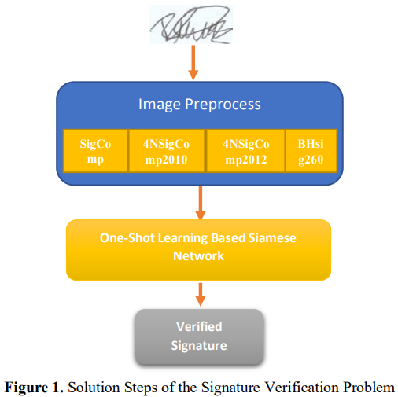

In this Network Architecture image vectors were learned with a supervised metric-based approach, and then the features of this network were re-used with on-shot learning without the need for retraining

**Pre-processing :**

**Bounding-Box** method to clip excess background image was applied. To standardize Image size sizing process was performed. **Binary thresholding** was applied to convert signature Image to binary. Then Images were inverted so that the pixel values of background become 0. **Normalization process** was performed to achieve standard deviation of pixel values. This pre-processing step was applied for both test and training images

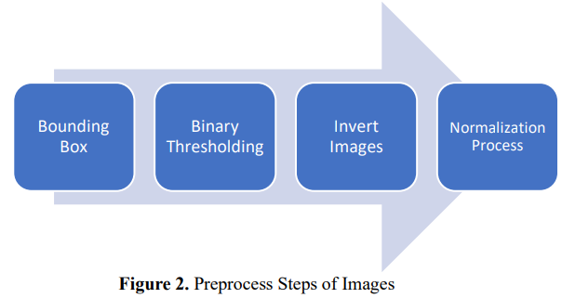

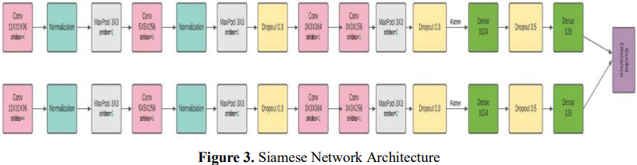

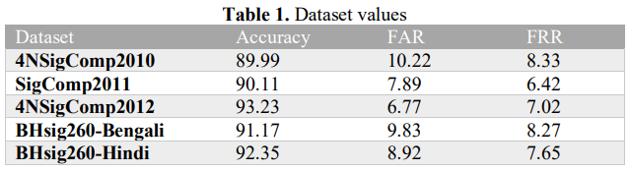

* **Machine Learning-based Offline Signature Verification Systems: A Systematic Review [8]**

**Abstract:**

The offline signatures are the most realistic authentication technique in banking systems. The machine learning based model OFSV systems using five aspects like database, preprocessing techniques, feature extraction methods, machine learning based verification model and performance evaluation metrics. These articles were published between January 2014 and October 2019. This review revelated that deep learning neural network achieved the most favorable results for the public datasets and OSFV performances in those selected datasets are (CEDAR, GPDS, MCYT-75,UTSig and BHSig260).

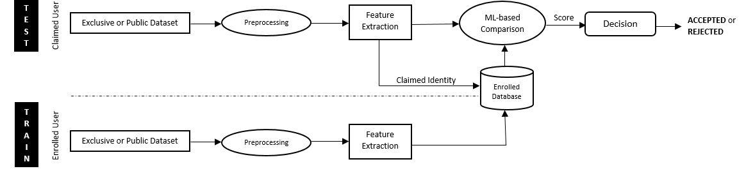

**Research Methodology:**

In this research methodology, the systematic review is two-phased; the review planning and the review conduction. The review planning phase describes the need for this evaluation, the specification of studies questions, and relevant journal identification and the review conduction phase includes research identification and primary study selection, and data synthesis and extraction.

**Phase 1: Review Planning:**

This phase covers the identification of the need to review and determine the research questions.

**Need for a Review Identification:**

To identify the ML-based OfSV systems using five aspects mentioned in Fig.1 to find the answers of the researched questions.

**Relevant Journal Databases Identification:**

In this research paper, the selected journal databases (ACM, Web of Science, IEEE, ScienceDirect, SpringerLink, and Scopus), which are covering the majority of journals and conference papers published in the world of computer science.

**Phase 2: Review Conduction:**

The current ML-based OfSV systems published in the English language. Therefore, summarizing the adopted offline datasets like current image preprocessing techniques, feature extraction methods.

**Identification and Selection of Primary Studies:**

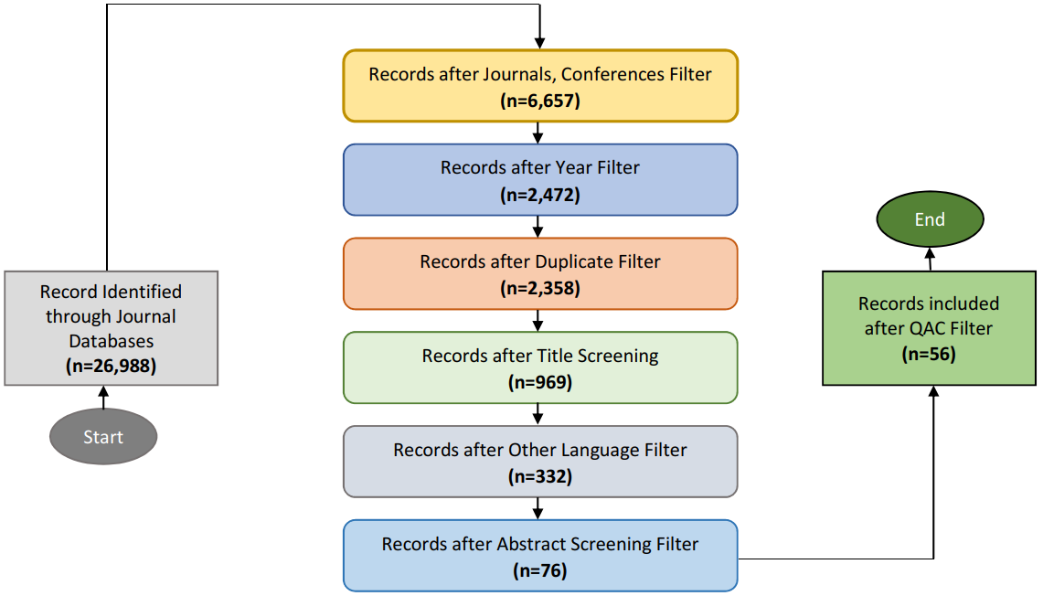

**RQ1 Which datasets are adopted for existing ML-based OfSV systems?**

Exclusive datasets and public datasets are adopted for existing ML-based OFSV systems. 6.98% of research favored generating the signature dataset themselves via adopting proper strategies. They requested unique signatories to place their signatures on the paper so they manually discarded those signatures, which were overlapping the distance available for any other signature. After that, the papers carrying the set of various genuine and forged signatures were scanned using different predefined dots per inch (dpi) resolution scanners. By scanning these papers, it would permit extracting greater figures and information from the offline signature, which became very beneficial for the photograph processing section of any ml-based totally OFSV machine.

**Exclusive datasets used in 56 selected studies.**

**Table 6:**

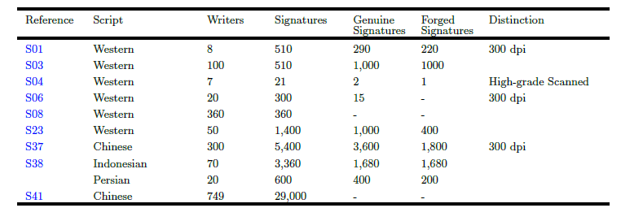

**Public datasets, used in 56 selected studies.**

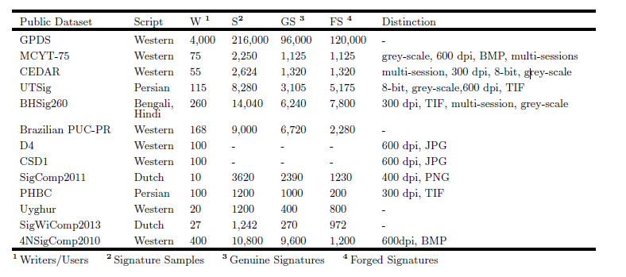

**RQ2 Which preprocessing techniques are applied to curtail inconsistencies in offline signature images?**

The preprocessing technique is to enhance the signature image quality and to cut out the inconsistencies in the signature image. The tasks involve in OFSV are binarization, thinning, noise removal, bounding box, segmentation, inversion and normalization activities.

Otsu was the most often used algorithm, which separates the offline signature image's pixels into foreground and background classes using a single intensity threshold (Otsu, 1979).



*Year-wise distribution of various preprocessing techniques*

**RQ3 What type of feature extraction methods are used in existing ML-based OfSV systems?**

While using the feature extraction method, it’s basically a procedure to convert the raw pixels of an offline signature image into a feature vector by creating new features from the existing ones. So, the feature extraction process can be performed manually or automatically. In manual feature extraction methods, appropriate domain knowledge is required to extract features from the signature image. Whereas, automatic feature extraction methods can extract features while training the model.



**Fig. 6:** Year-wise distribution of various feature extraction methods

In figure 6 it shows the distribution of various that 5 out of 56 studies adopted geometric methods for feature extraction.

**Advantages and limitations of various feature extraction methods used in selected 56 studies.**

These are types of feature extraction methods used in existing ML-based OFSV

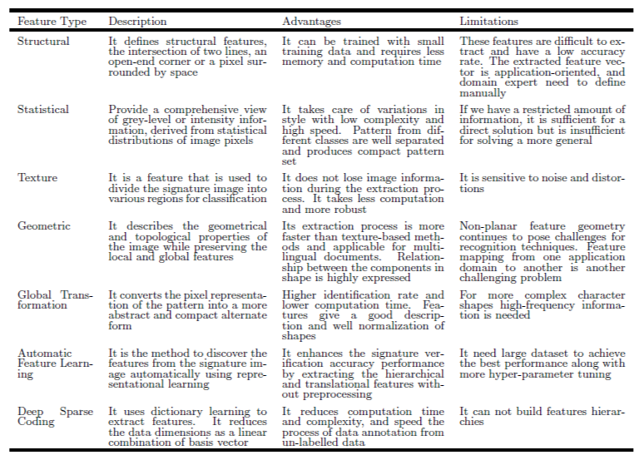

**RQ4 What type of ML-based verification models are developed for OfSV systems?**

**• Template Matching Model:**

Inthis process, it needs to find the signature object in the offline signature image by matching a pre-stored sub-image, containing the signature to be matched. This process works pixel by pixel to identify the matching of a template image with the main offline signature image then the template is placed at every possible pixel of the main image to those pixels, which are giving maximum match. To measure the similarity between the main image and the template image several techniques are being used that are given below:

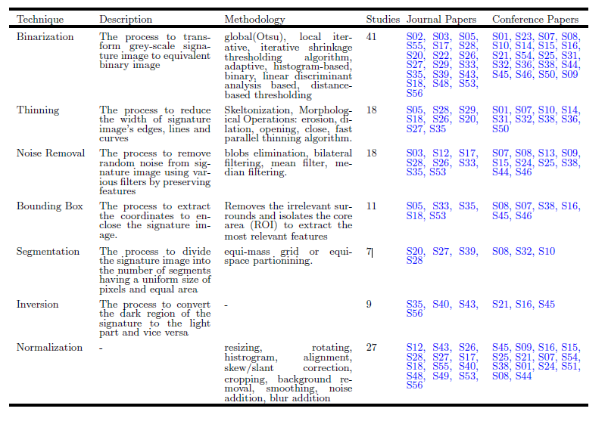



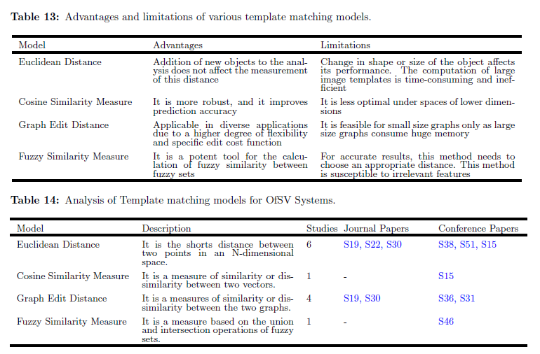

Here we discuss some models called Traditional Based models discussed given below.

**• Statistical Model:**

This model is being used to analyze and understand the data to make predictions. In OfSV systems, the average signature template is obtained by calculating the already collected template sub-images of the signature. Therefore, when, there is an addition of a new signature for verification purposes to the OfSV system, then these input signature images are compared with the average signature template to find out the minor or major difference using this concept.

**• Structural Model:**

This model is based on the related system of the low-level features into higher-level structures, and then these structures are compared with pre-stored images in the datasets to differentiate between the original and fake images. These models have shown excellent performance in verifying genuine offline signatures and forged offline signatures. Issues that are currently highlighted are that it uses a large dataset for better accuracy.

**• Neural Network-based Models:**

They are extensively adopted for their power, learning, ease of use and observing capabilities. The NNs models extract feature automatically and train their models in their own perspective.

**• Shallow Neural Networks:**

The single hidden layer in NN’s called shallow neural network (SNN). ANN is an advanced learning system that contains many simple components, called neurons or perceptron’s or hidden units or nodes. PNN is a four-layered, feedforward neural network consisting of input, hidden, pattern/summation, and output layers. It uses a kernel function to approximate the probability density function.

**• Deep Neural Networks:**

Deep neural networks (DNN) are multi-layer feedforward neural networks consisting of two or more hidden layers between the layers of input and output. This actually has to be appropriately configured and educate to get the desired performance and the performance of the DNN’s can be authentic due to the growing rate of the hidden layers.

**RQ5 Which performance evaluation metrics are employed for the appraisal of existing ML based OFSV systems?**

In the offline signature image, after implementing the process training, the test signatures are then fed to the trained ML-based model to evaluate its performance. This research paper, it will evaluate the process through standard performance evaluation metrics.

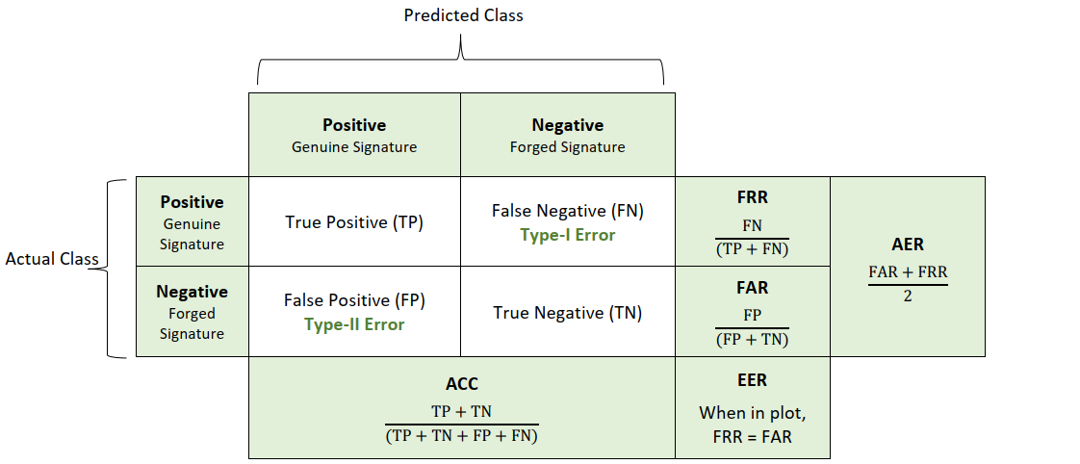

**Table 21:** Analysis of performance evaluation metrics

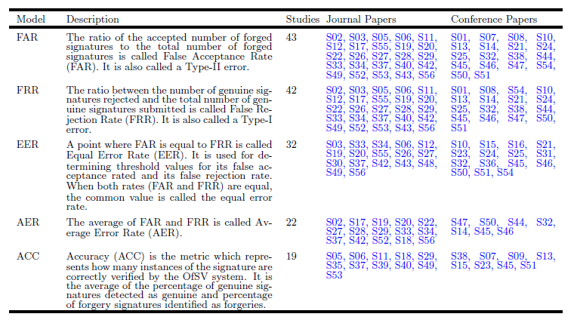

This research paper analyzed the major research in recent offline signature verification systems to help new researchers in this domain. The OFSV articles from 2014 – 2019 were reviewed. It indicates that a systemic approach has been adopted for 56 articles.

The first research question of this SLR is to identify datasets that are being adopted for existing ML-based OFSV system. It identified datasets with their scripts, number of writers, number of signatures, number of genuine signatures, number of forged signatures, image scanning resolution

In 2nd research question, multiple algorithms can be used in binarization preprocessing, but more than half of the researchers have used the Otsu algorithm because of its fast working and enlightening the images with bi-modal histograms, then OFSV systems have achieved better performances by adopting binarization along with other preprocessing techniques

In 3rd research question, DL-based automatic feature extraction methods, take less human efforts. Moreover, these strategies can study the characteristics of raw image with little preprocessing. This shows the great results of DL-based automatic feature learning methods over the manual features for OFSV.

In 4th research question, it was revealed that researchers had shown full-size range in the choice in their ml-primarily based models (template matching models, traditional machine learning-based models, deep learning-based models and structural models) for classification task in their OfSV systems.

In 5th research question, according to the observations of the researchers, the future of ML-based OfSV systems is promising, and the use of DNN may be the key to overcome many of the issues mentioned in this SLR. Between these issues, we highlight motivation in getting researchers to interest in this field.

* **Offline Signature Verification with Convolutional Neural Networks [7]**

**Abstract:**

Signature verification is an important technique to find whether the signature is fake or genuine. The project aims to mechanize signature verification using CNN. The version is based on the VGG16 architecture, and it uses the ICDAR 2011 SIGComp dataset to instruct the version. When classifying a given signature is forgery or not, it gains accuracies of 97% for Dutch signatures.

**Related Work:**

**Task within the signature verification system:**

The University of Hongkong hosted the first international signature verification competition but it was for online signatures. But this event paved the way for both online and offline SVFS. The forgery exposure of the task is determined by what kinds of signatures the model is trained on. Some authors train on forgeries and genuine signatures, but test on different forgeries and genuine signatures during testing; some authors do not use forgeries at all during training. Then, how the training test should be used to accomplish each task? Well, it will develop both writer-dependent and writer-independent models in the report. The writer-dependence distinction is that the model has a different classifier for each identity or a single classifier for all identities. Writer-dependent models use a different classifier for each user.

• **Competing Models:**

In 2012, Khalajzadeh used CNNs for Persian signature verification, which is the only report of CNNs being used in the offline signature verification literature. Unfortunately, the paper includes truly little information about their methodology. So, they assume that their model is trained on forgeries and genuine signatures for all IDs.

**Methods:**

**• Convolutional Neural Networks(CNN):**

CNN have confirmed a success in latest years at a huge variety of picture processing-based machine learning tasks. A cnn consists of a number of layers, starting at the raw image pixels, which each carry out an easy computation and feed the end result to the subsequent layer.

• **VGG Architecture:**

In this research paper, it used the VGG-16 CNN architecture. This network contains a total of 16 layers with learnable parameters. These layers are of the following types: Fully Connected layers every output depends on every input according to the weight matrixW, a learnable parameter. Outputs also depend on a bias term b which is learnable but doesn’t depend on the inputs.

f(X) = WX + b

W 2 Rnxh; b 2 Rh

ReLU Nonlinearity: ReLU layers do not have any learnable parameters. Their computation is very simple, saving time during training. ReLU neurons also do not become saturated at high input values, meaning their gradient does not vanish to zero when receiving such values.

Softmax Nonlinearity: It appears in the final layer of the neural network and computes final class scores that will be fed into the loss function or outputted during testing. It has no learnable parameters.

Convolutional Layers: Convolutional layers lend themselves naturally to understanding of images, in which the program often wants to extract features by looking at small areas of an image, where it doesn’t care exactly where in the image the feature is.

Max Pooling Layers: Max pooling layers reduce the size of an image by combining 2x2 regions of the input into a single output value. For each 2x2 region of input, the output value is simply the max value of those 4 input pixels.

Dropout layers: A dropout layer takes in a number of inputs and for each input, sets it to 0 with probability p and leaves it unchanged with (1-p) . It behaves deterministically and multiplies all input values by (1-p).

• **Transfer learning:**

VGG-16 is a large neural network with a huge number of learning parameters. Thus, it requires a large dataset to train a network. Though, it can leverage the similarities between diff image datasets. The low-level features learned by the first few layers of a network will be same. This means that it can initialize the neural network with parameter values learned from a different dataset and expect that the values for the first layers of the network will work well without having to be trained.

• **Comparing Networks:**

For image patch comparison the model will be used of the siamese and 2-channel network. In the 2-channel network, two images are stacked each image serves as a channel as an input to a convolutional network. The CNN then leads to a fully connected linear decision layer with 1 output that indicates the similarity of the two patches.

**Datasets and Features:**

**• Dataset:**

(ICDAR) 2011 Sig-Comp international signature verification competition. The dataset includes both online and offline signatures for both Chinese and Dutch signers. It splits into training sets or testing sets. The Dutch training set includes a total of 366 images for 10 IDS, with about 25 genuine signatures and 11 forged signatures for each ID.

**Results:**

**• Evaluation Metrics:**

By evaluating the research dataset, whether a given signature is fake or real. It will evaluate the performance using three metrics: classification accuracy, False Acceptance Rate, and False Rejection Rate.

• **Main Task:**

In this research paper, the first task was to train a CNN to recognize whether individual signatures are forged or genuine then it will label all data points in SIGCOMP 2011 Dataset as either genuine or forged, then it will train one network on signatures from all identities together. For each language, all the data for that language is split into training, validation, and test data consisting of new copies of signatures of the same people whose signatures are in the training set.

**• Parameter Updates:**

In this research paper, the most trouble finding the parameters that got Adams. Adam is often recommended as an update rule instead of simpler methods, but it was unable to get Adam to achieve the same accuracies as RMSprop or Nesterovrov. Then the final choice of update algorithm was Nesterov Momentum, which performed similarly to the other best algorithms in terms of accuracy and it was attractive because of its simplicity.

**• Hyperparameter choice for Main Task:**

This research-based paper uses hyperparameter, a coarse-to-best search technique and selecting values that produced quality accuracy. It used a learning rate of 1e-4 to conduct a few pieces of training but did not see any accomplishments. The value that was coded into VGG-16 architecture of dropout value is 0.5. So finally, it decided to let only the fully connected layers at the end of the network training.

• **Unseen Identities Experiment:**

In this research paper, the data is split into training test and validation sets containing 80% and 10% of the data. The validation and test data consists of signatures and forgeries by new people. Because of the class skew of the Dutch dataset, a genuine signature would achieve an accuracy of 67% (with an FAR of 100% and FRR of 0%). The actual performance is somewhat better than this, and the mistakes are more evenly spread out between both types of misclassifications.

• **Writer-Dependent Comparison Task:**

In this research methodology, they adapted the 2- channel network and train network on (genuine, genuine) pairs and (genuine, forged) pairs for all ID’S in the training set. The network should learn to tell when two signatures are diff or the same. There are 10 genuine signatures and 25 genuine and forged signatures. When testing, it sends every questioned signature into the network paired with each genuine signature. Well, this experiment contains some errors but it gives room for hope in future experiments.

**Conclusion:**

In this research paper, experiment with several variations on signature verification tasks. CNN did an excellent job of verifying the signatures of the same people that are either forged or genuine. A novel architecture model is used. The Writer Dependent Comparison Task also appears to be a promising direction for the future. This task is attractive because it mirrors the situation of a real-world application of signature verification. Although that was unable to achieve high results on this task, the literature on signature verification indicates that this method is promising. Having access to more datasets would likely achieve stronger results. In the end, it will allow training of the model on larger datasets and more layers of training.

# Methodology/Proposed Solution

First **Data** will be acquired and preprocessed, We will be using 2 standard benchmark datasets namely **ICDAR SIGCOMP 2011** and **CEDAR,** our primary focus will be on sigcomp 2011 dataset as it is a large dataset so training our model on this dataset will provide better results, whereas data in CEDAR dataset is more neatly organized and also images are available in grayscale mode which will make the process easy so cedar can also be used if accuracy of model is to be tested, SIGCOMP dataset contains original signatures of several people and for every original signature of a person there is a forged signature available in dataset some signature images are attached for reference. The preprocessing phase will comprise of two phases namely **Image Preprocessing** and **Data Preprocessing** in image preprocessing images will be converted to grayscale mode and will scaled to a fixed size using image processing techniques so that if there is any variation like color and size in test and train signature image can be eliminated using gray scaling and resizing, whereas in data preprocessing our data (Images in this case) will be split into testing and training parts also forged images and real images will be separated and finally data will be arranged according to our requirement i.e 4 genuine signature images against each test image, also we will arrange data in the form where 1 genuine signature will be compared with 1 test signatures, because results will be compared by the end of this project**.** After preprocessing data will be sent to CNN (Convolutional Neural Network) model for feature extraction and after that, model will get trained on the dataset using 5-way Siamese network.4 genuine and 1 test signature image will be provided to the model. Once the training phase is over, then comes the evaluation phase. Based on feature comparison between 4 real and 1 test signature image. Consequently, an output resulting in either the signature being real or fake will be provided

A user friendly Desktop app will provide interface to the model where people or the organization using the software will able to register people along with their 4 genuine scanned signatures and will be able to upload a test image to app which will tell either this image is original or fake.

Once the model is completed using 5 way Siamese network results will be compared to traditional model which compare 1 test image with 1 train image based on the extracted features

**Genuine Signatures**

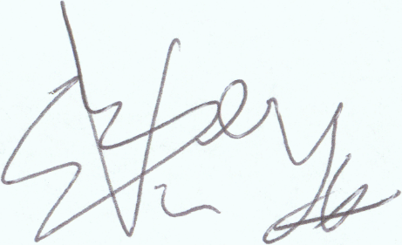 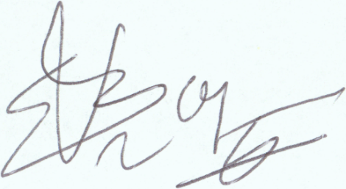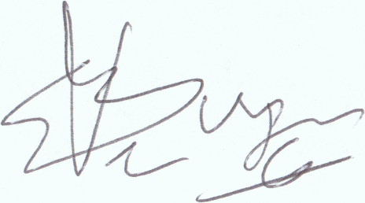

**Forged signatures**

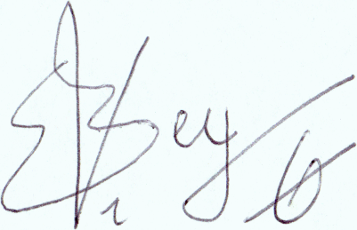 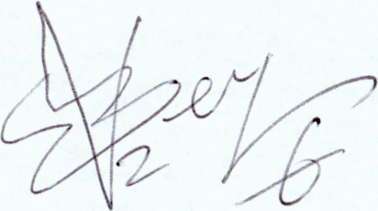 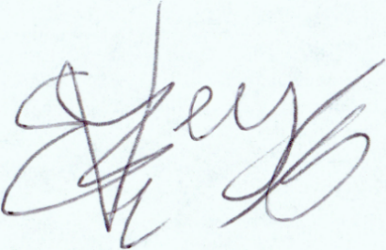

*Signature images from SIGCOMP 2011 dataset*

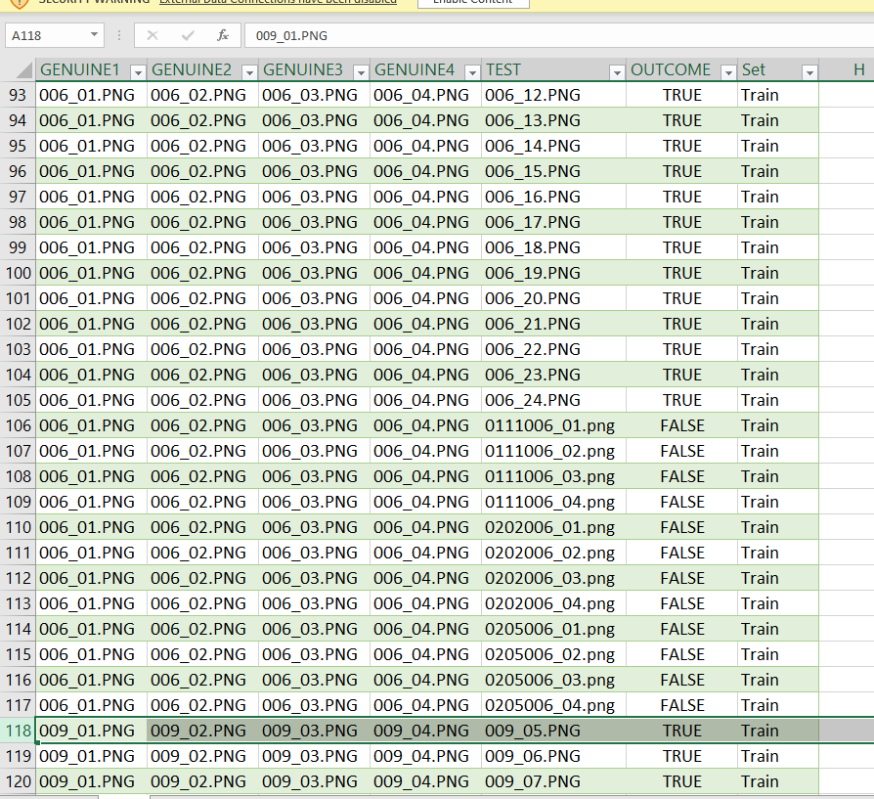

*Fig 1. Arrangement of data present in Sigcomp 2011*

In this arrangement of dataset we have total **1382** records/rows where in each row there is 4 genuine signature images and 1 test image which can either be original or fake then there is outcome column entry for every row also an entry is present for train and test label of dataset this makes total of **1382** rows and **7** columns of data arranged in excel. There are total **965** train and **415** test records available **631** true and **749** false labeled entries **463** entries are train and true **502** train false entries **168** test true and **147** test false entries available

# System Requirements

## Functional Requirements

Following are the Use Case diagrams

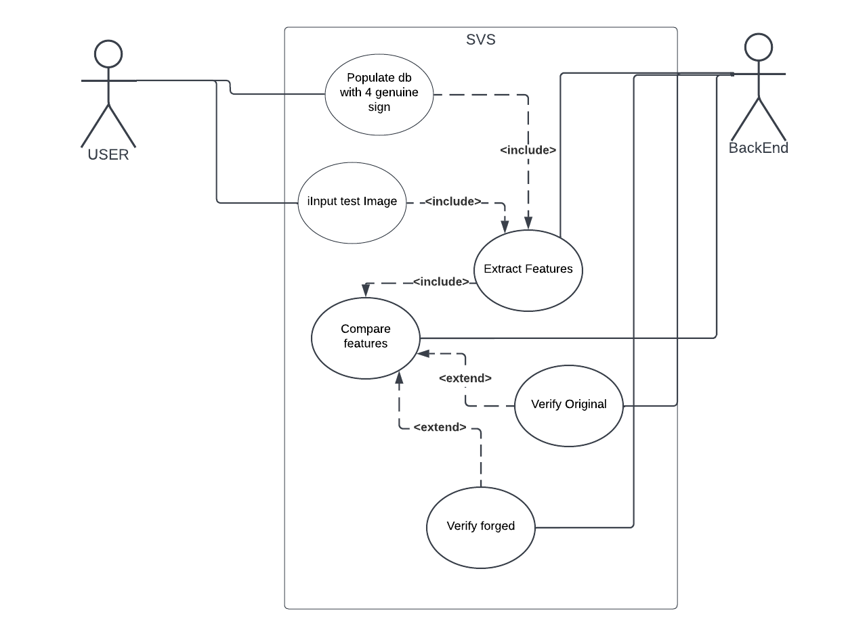

*Fig3. Use case diagram for back end and user*

### Use-Case 1: Signature Verification

|  |  |  |  |
| --- | --- | --- | --- |
| **Identifier** | | SVS | |
| **Purpose** | | Signature Verification | |
| **Priority** | | High | |
| **Pre-conditions** | | Database should have signatures of people | |
| **Post-conditions** | | Signatures will be authenticated based on extracted features | |
| **Typical Course of Action** | | | |
| **S#** | **Actor Action** | | **System Response** |
| **1** | User upload 4 sign Images | | Extract feature and do training |
| **2** | User upload 1 test image | | Extract feature |
| **3** | Backend compare feature | | Signatures verified person is real |
| **…** |  | |  |
| **Alternate Course of Action** | | | |
| **S#** | **Actor Action** | | **System Response** |
| **1** | User upload 4 sign Images | | Extract features and do training |
| **2** | User upload 1 test image | | Extract features |
| **3** | Backend Compare features | | Signatures are fake person is not real |
| **…** |  | |  |

Table : SVS Model

### Use-Case 2: SVS Desktop APP

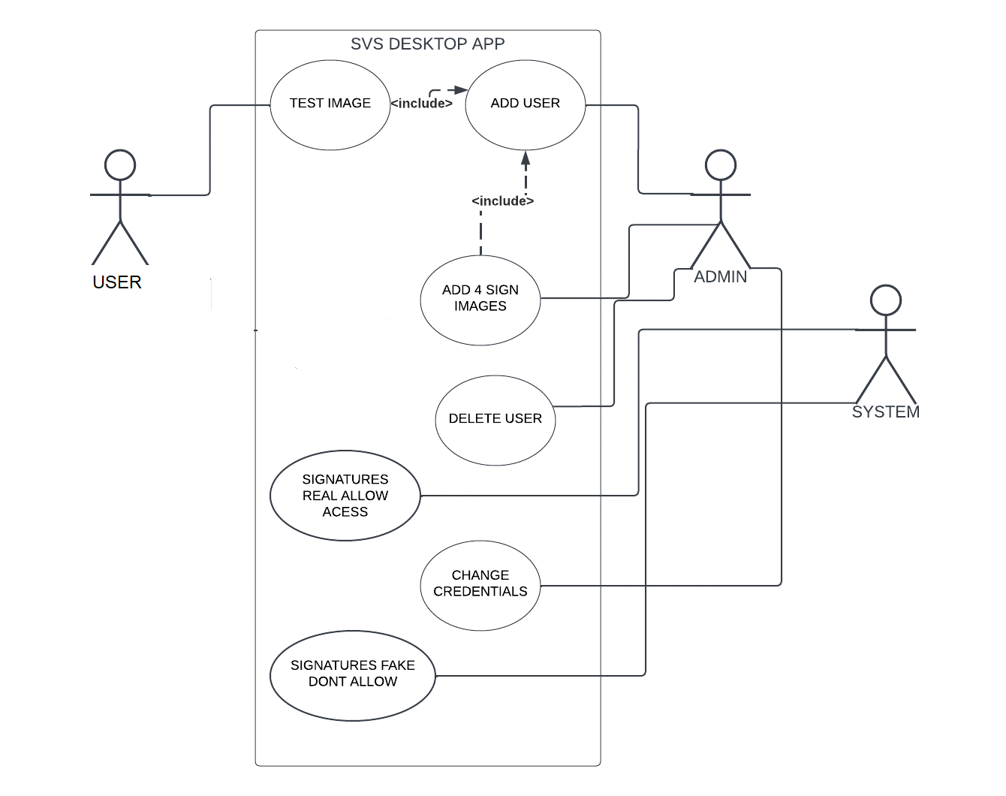

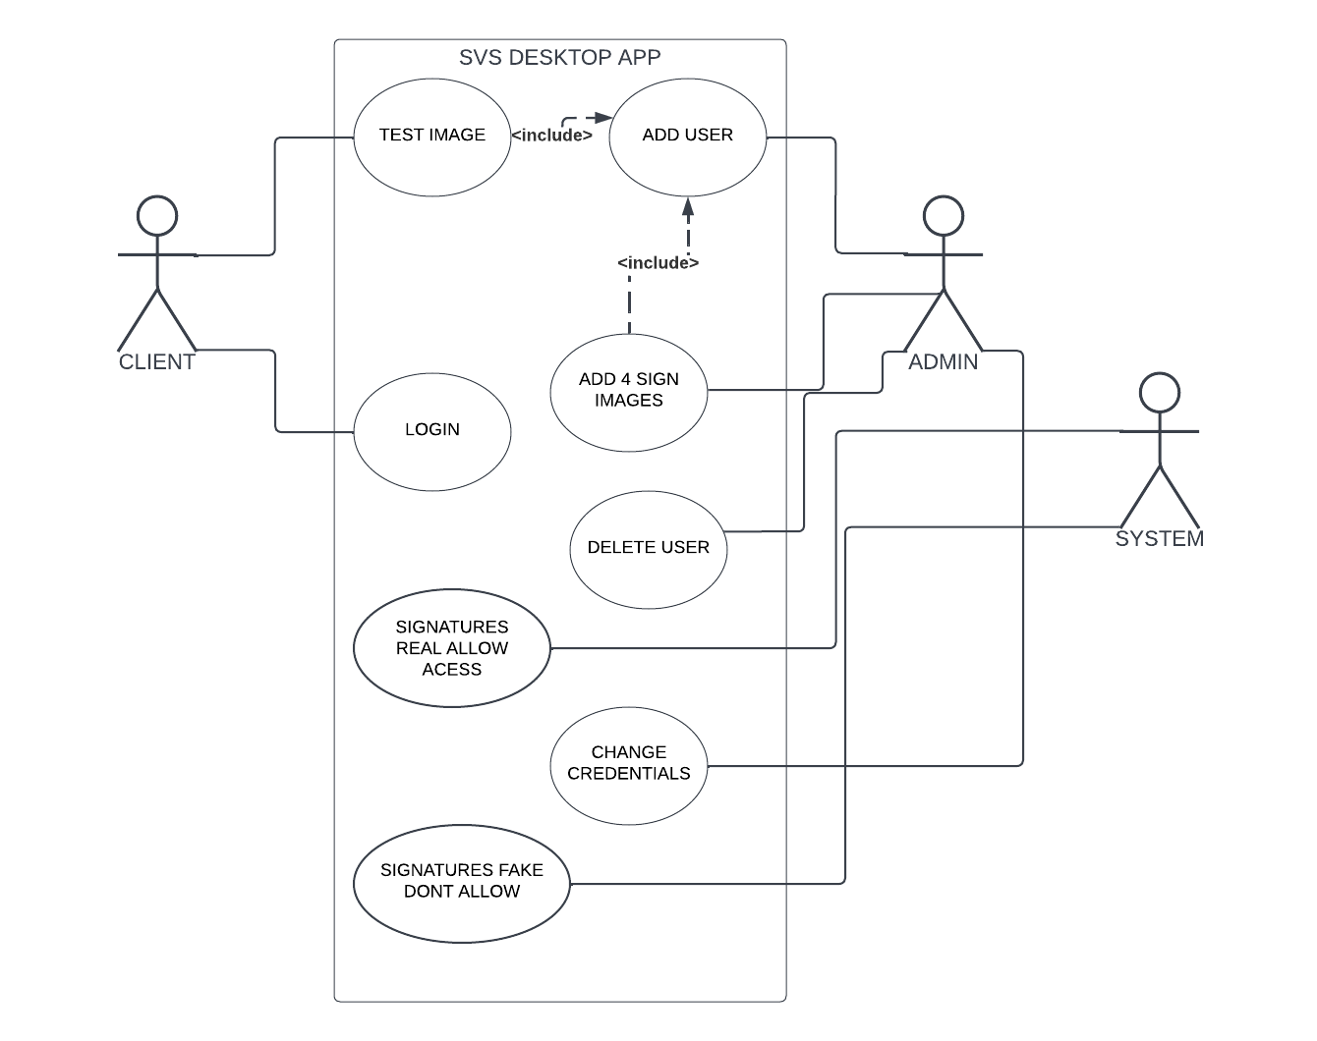

*Fig4. Use case diagram for App*

|  |  |  |  |
| --- | --- | --- | --- |
| **Identifier** | | Desktop App | |
| **Purpose** | | User Authentication sign verification | |
| **Priority** | | medium | |
| **Pre-conditions** | | Model must be implemented in backend | |
| **Post-conditions** | | Access to user bank account will be granted based on verified signatures | |
| **Typical Course of Action** | | | |
| **S#** | **Actor Action** | | **System Response** |
| **1** | Admin add user with 4 sign images | | Populate database with signature against person |
| **2** | User upload test sign image | | Verify test image accurately |
| **3** | Image matched | | Grant access to account |
| **Alternate Course of Action** | | | |
| **S#** | **Actor Action** | | **System Response** |
| **1** | Admin add user with 4 sign images | | Populate database with signature against person |
| **2** | User upload test sign image | | Verify test image accurately |
| **3** | Image not matched | | Deny access to account |

**SVS DESKTOP APP**

### Proposed Workflow

The workflow of project is as under,

In first phase of our project we reviewed related work, related papers after that we analyzed dataset and have done dataset preprocessing, arranged data according to requirement, then we understand existing algorithms, in 2nd phase of project we will implement and test existing algorithms and will understand 5 way Siamese network in 3rd phase we will implement algorithm and will train and test the model finally in 4th phase of the project we will make a desktop app and our model will be compared with traditional models at last research paper will be published

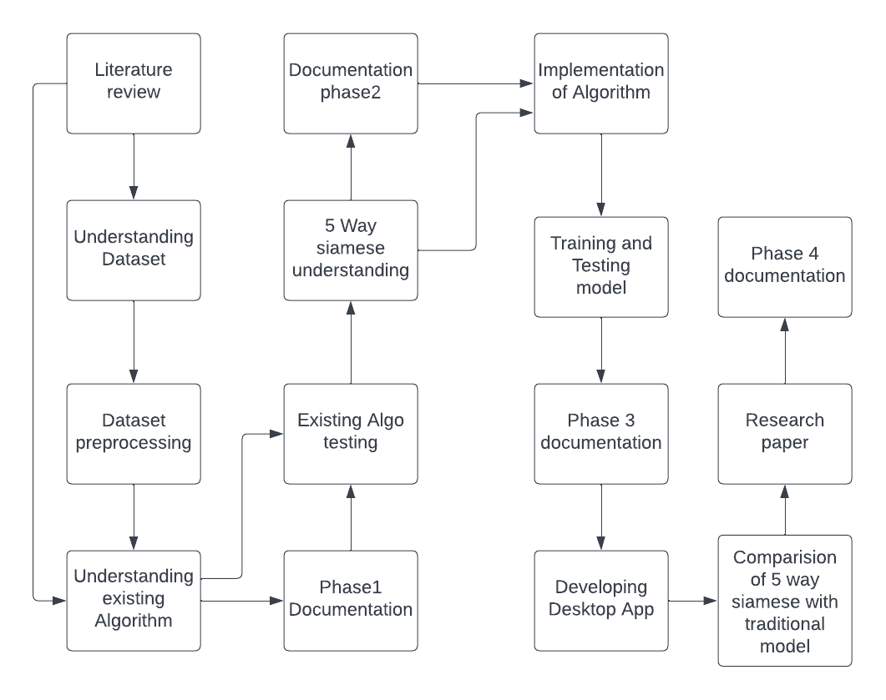

*Fig 5. Block diagram of Workflow*

### Analysis and Modeling of Requirements

All relevant diagrams are:

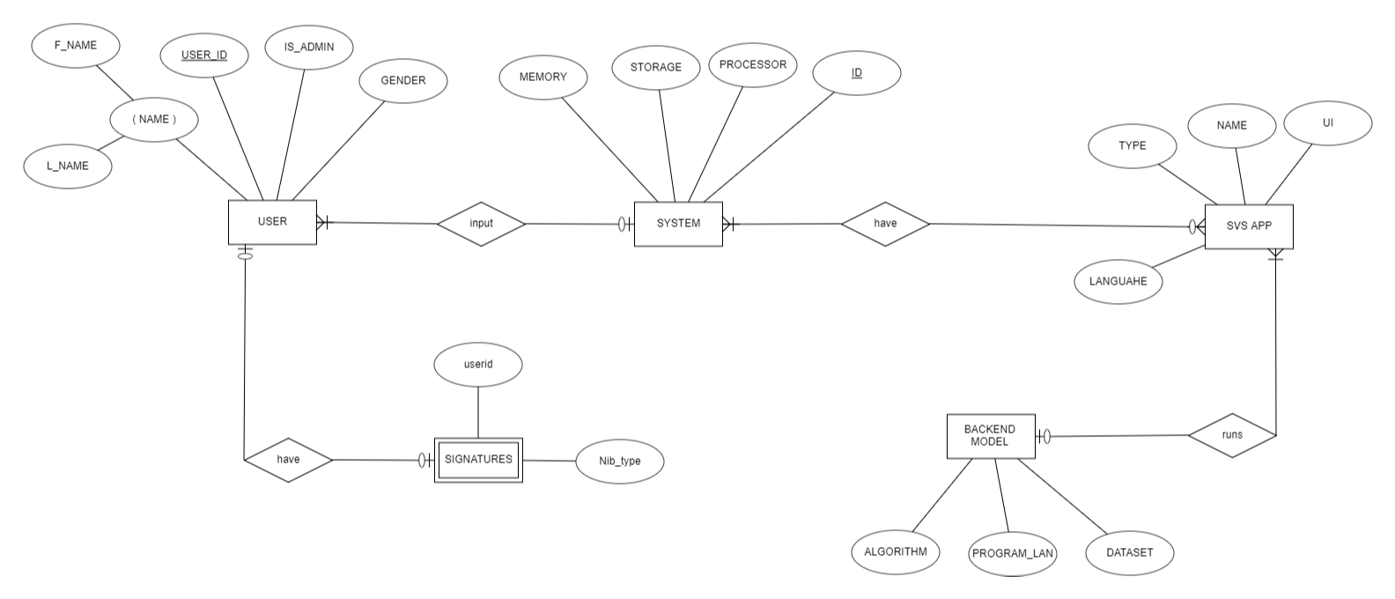

*Fig6. ER Diagram of the system*

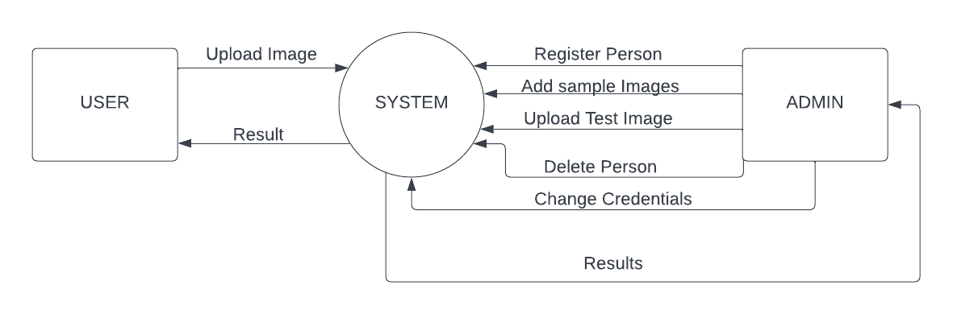

*Fig 7. Context/Level0 DFD of the System*

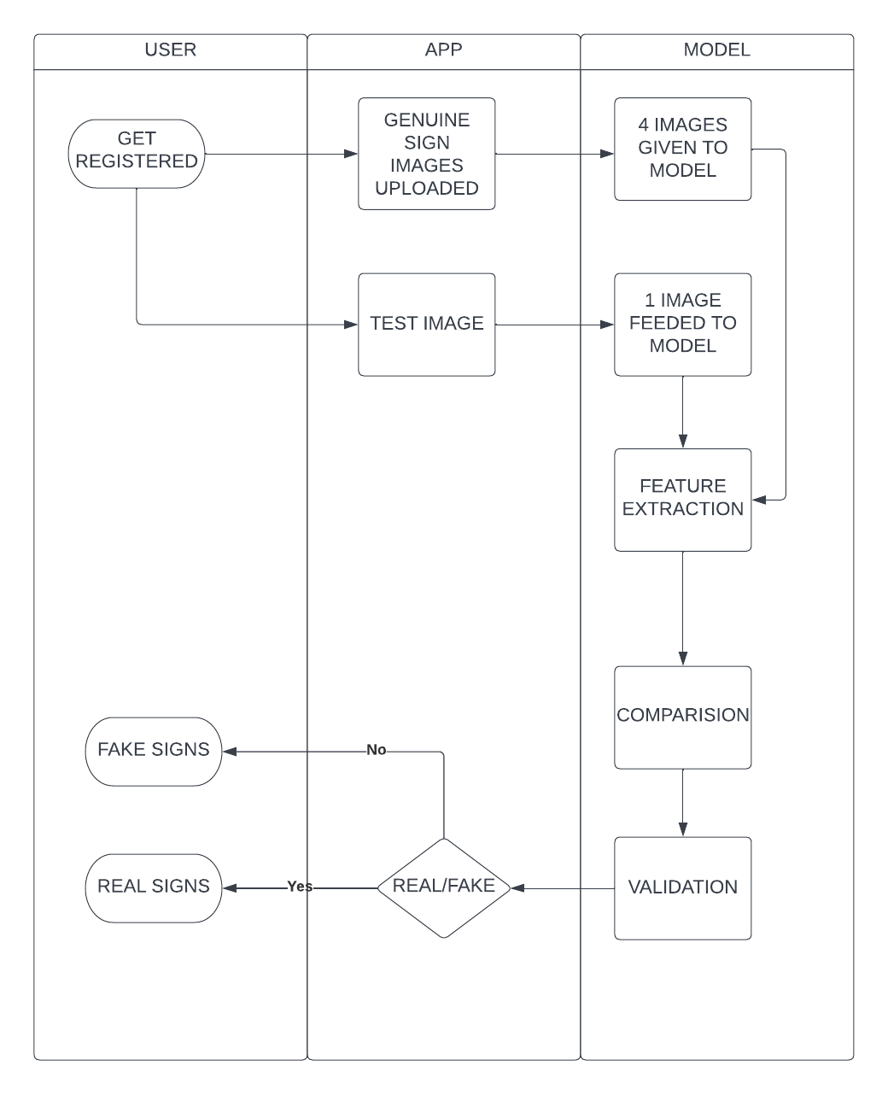

*Fig 8. SWIMLANE DIAGRAM OF PROJECT*

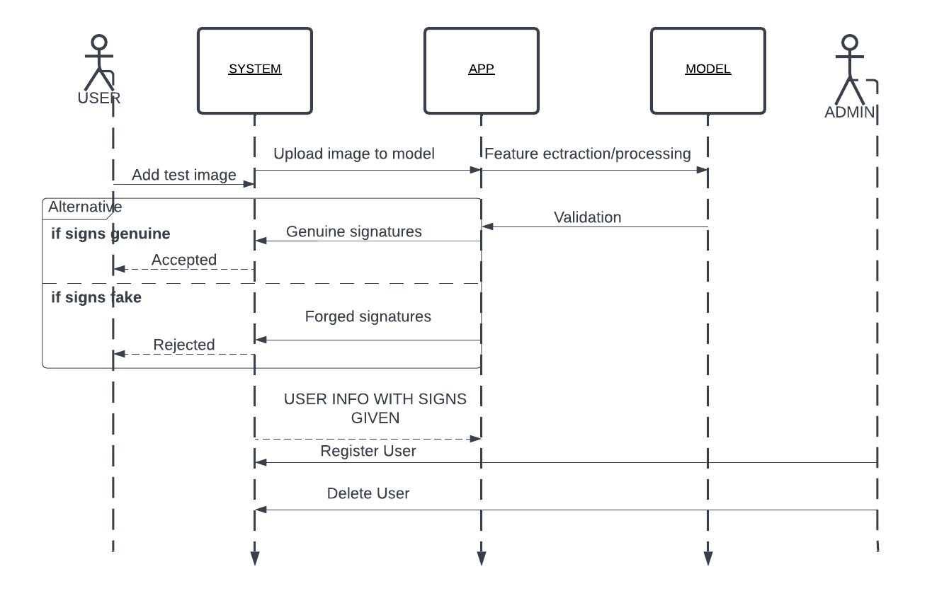 *Fig 9. Sequence diagram of the project*

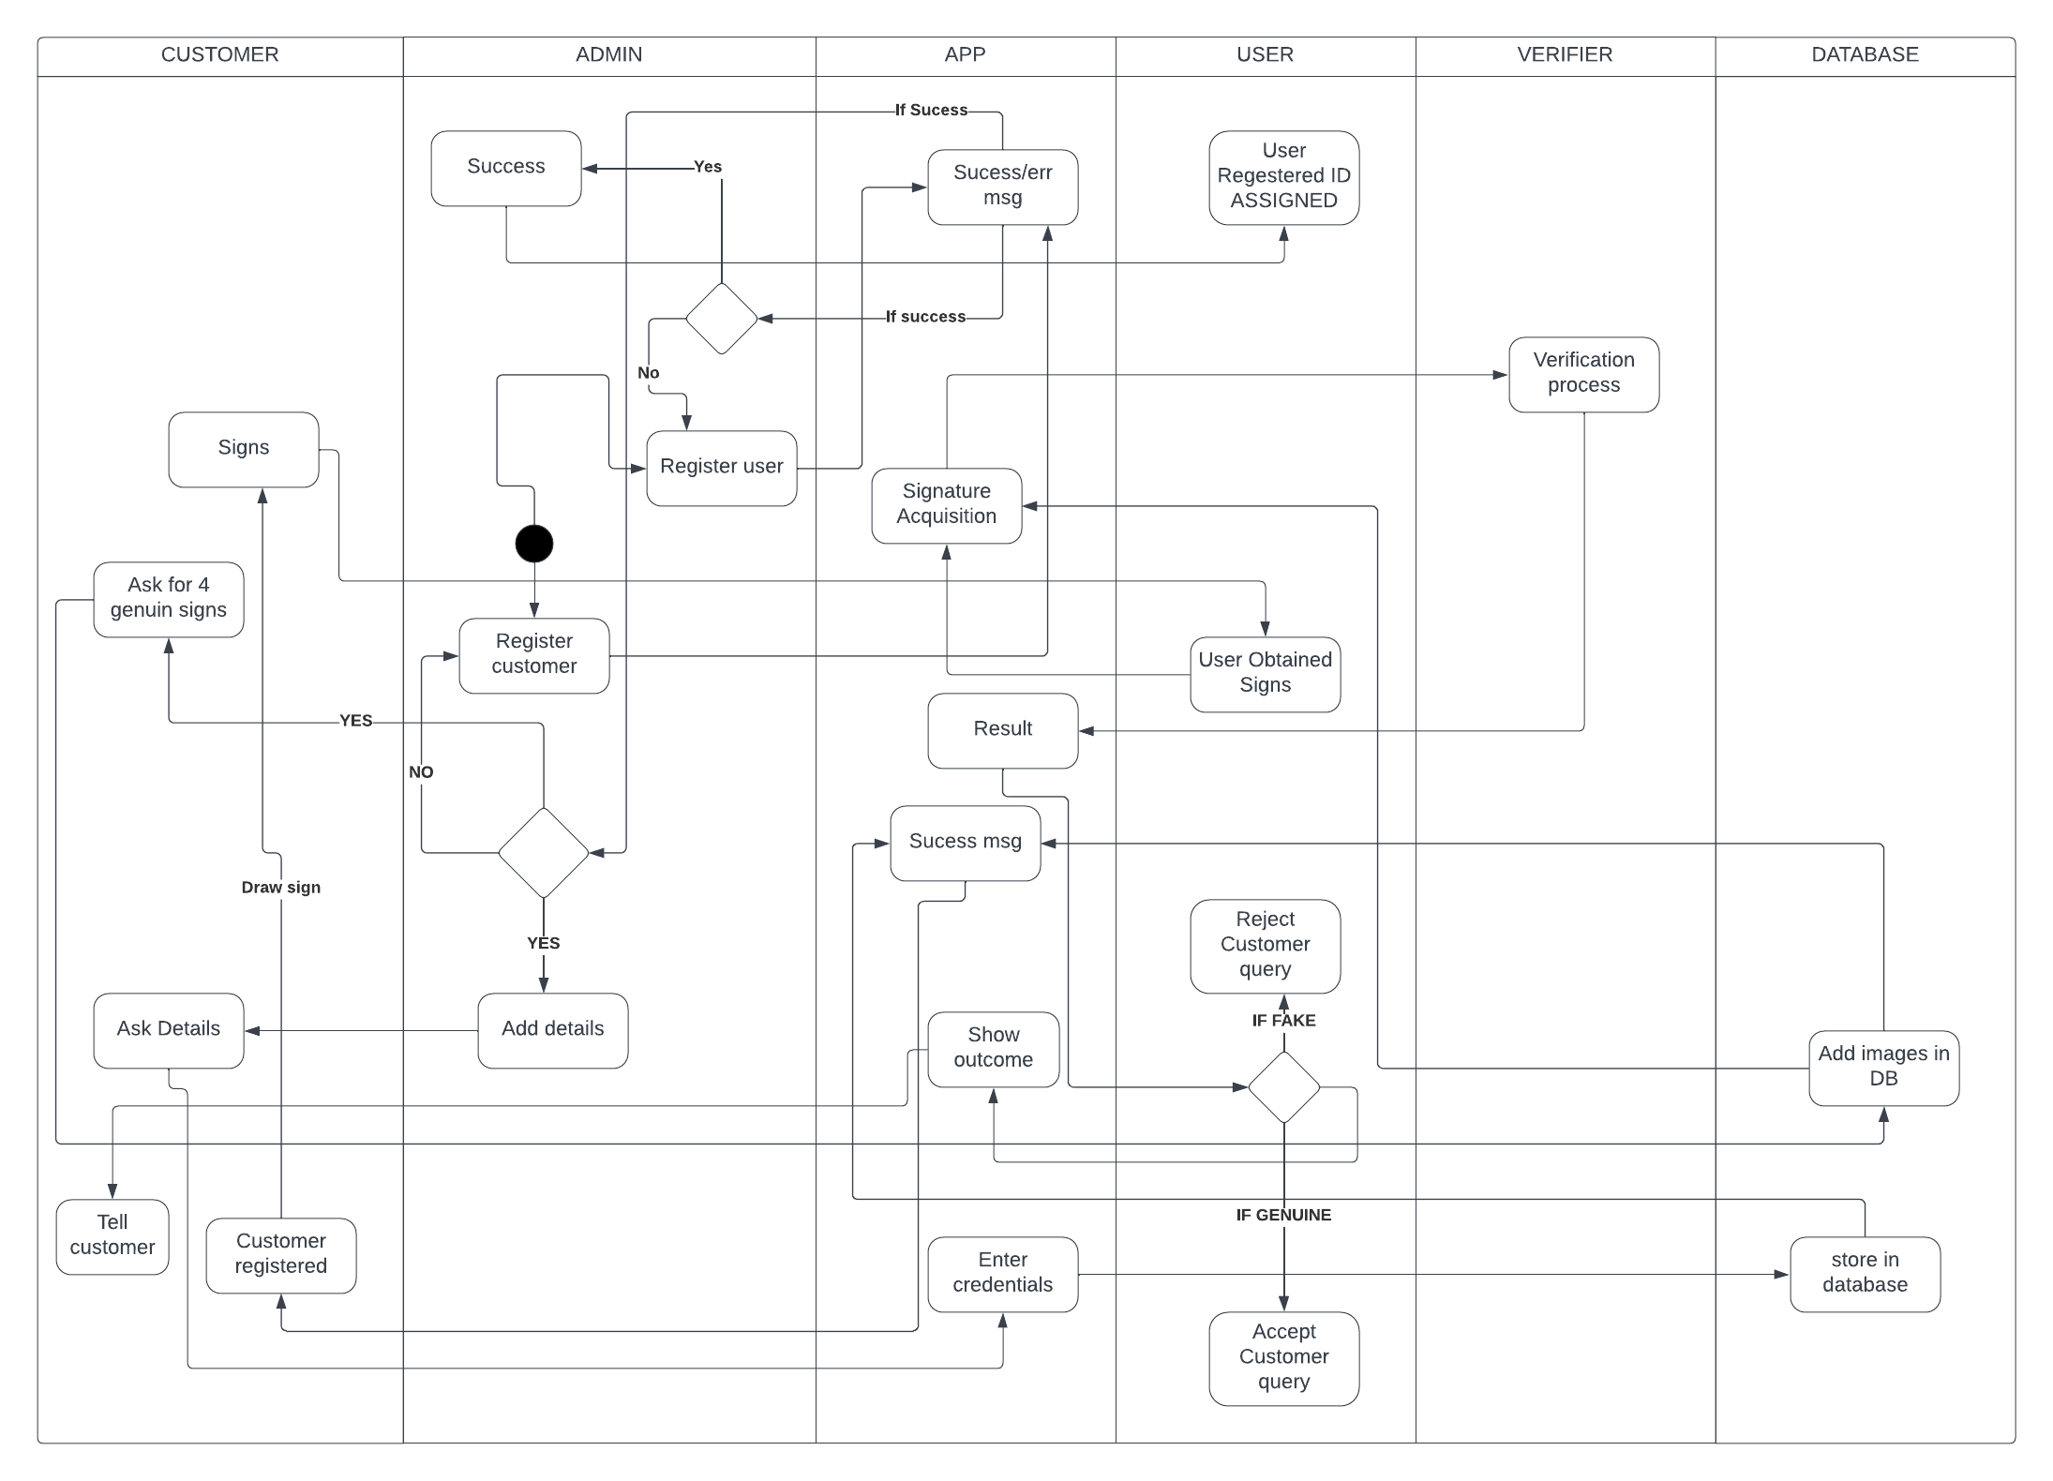

Fig 10:  *Design level activity diagram of system*

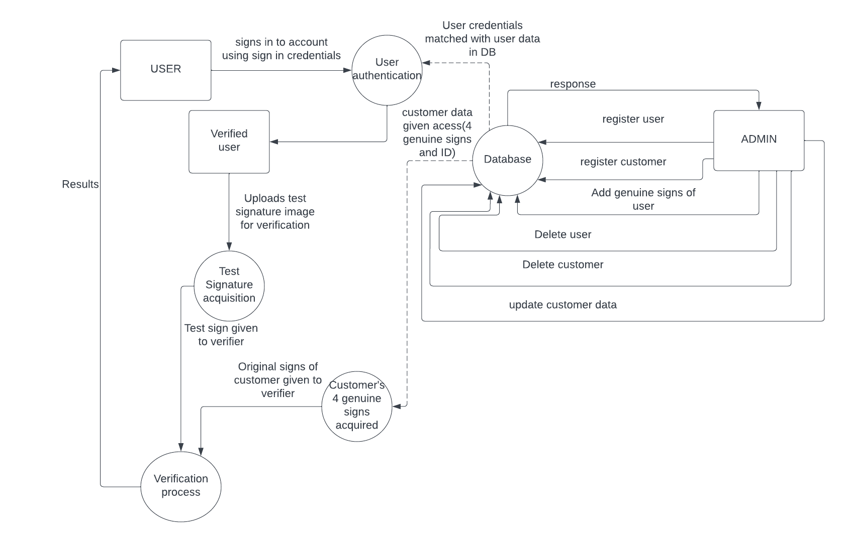

Fig 11: *Level 1 DFD of the system*

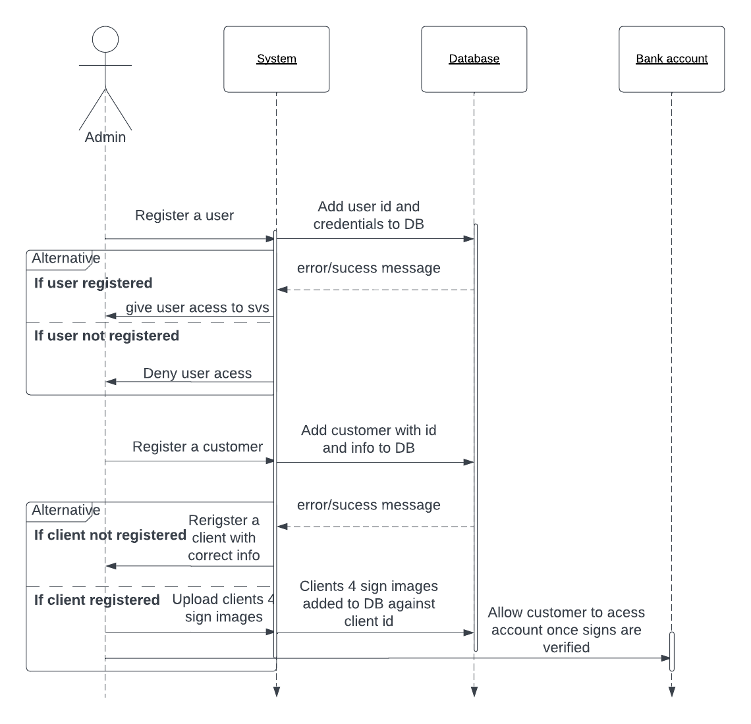

Fig 12: *Sequence diagram showing admin’s interaction*

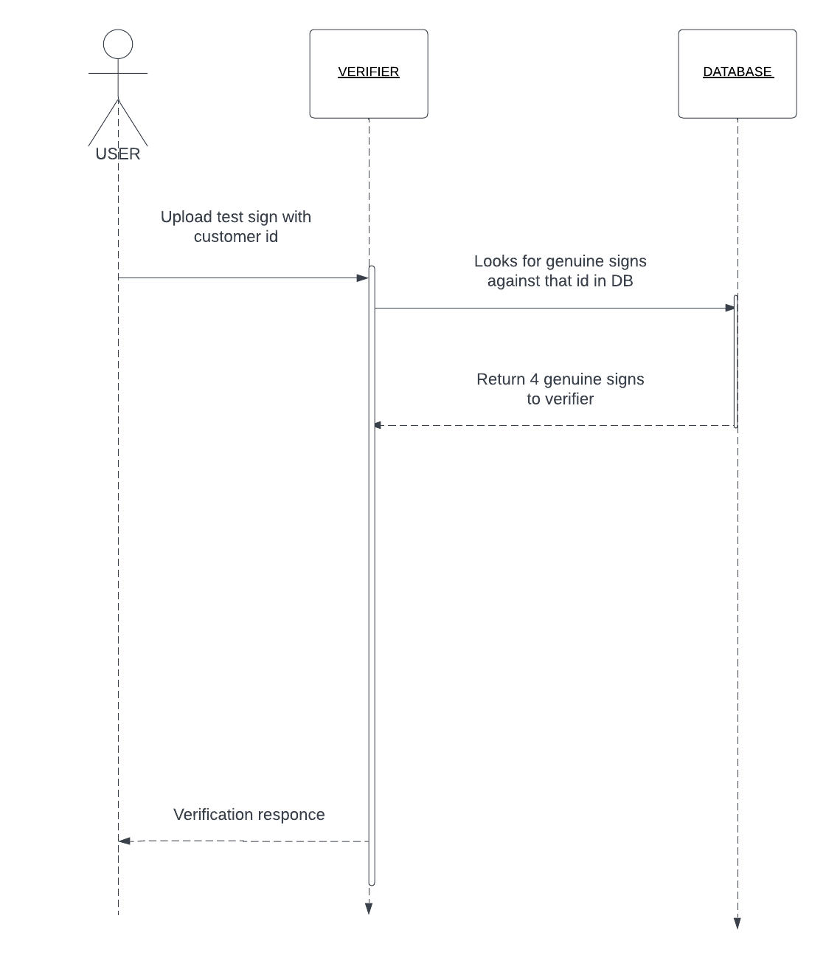

Fig 13:  *Sequence diagram of user’s interaction with system*

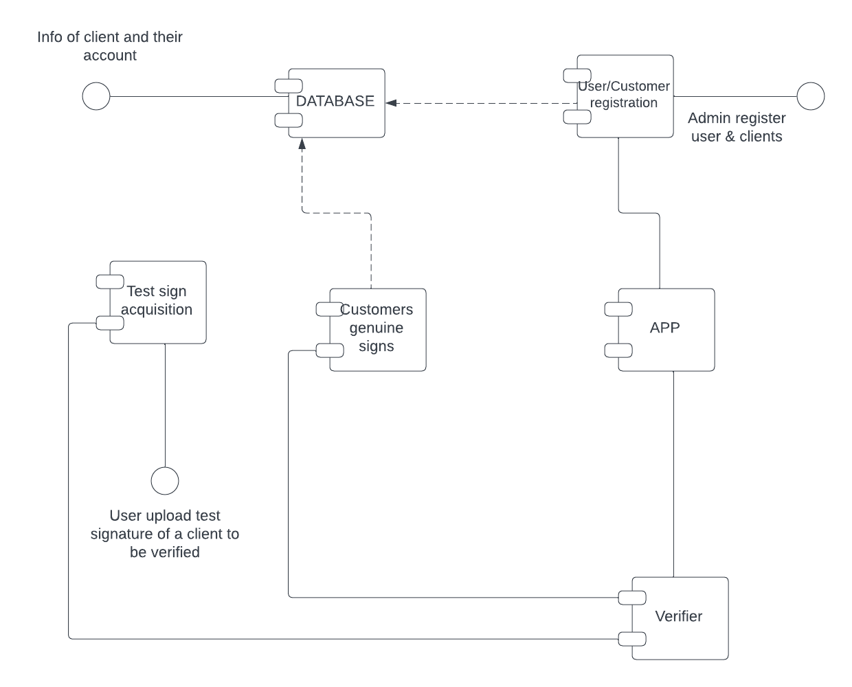

Fig 14: *Component diagram of the system*

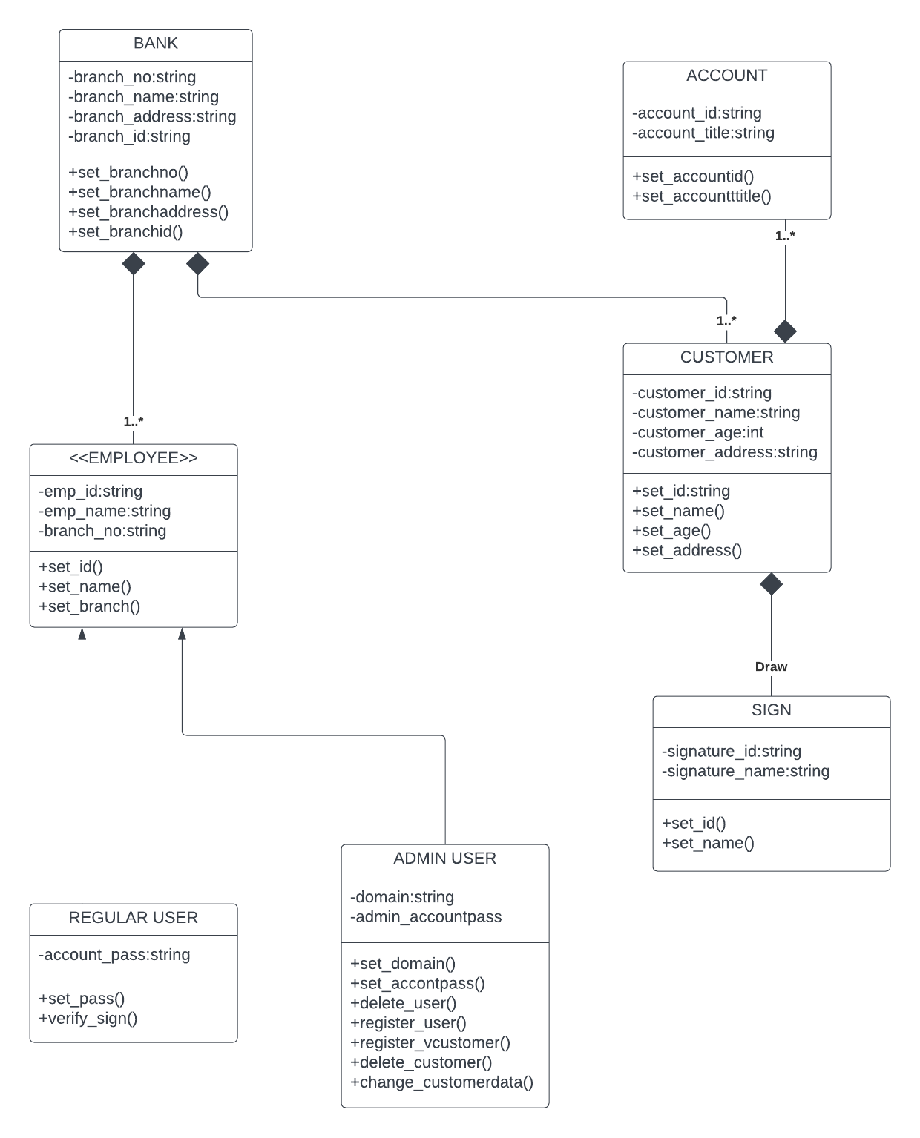

Fig 15: *Class diagram of the system*

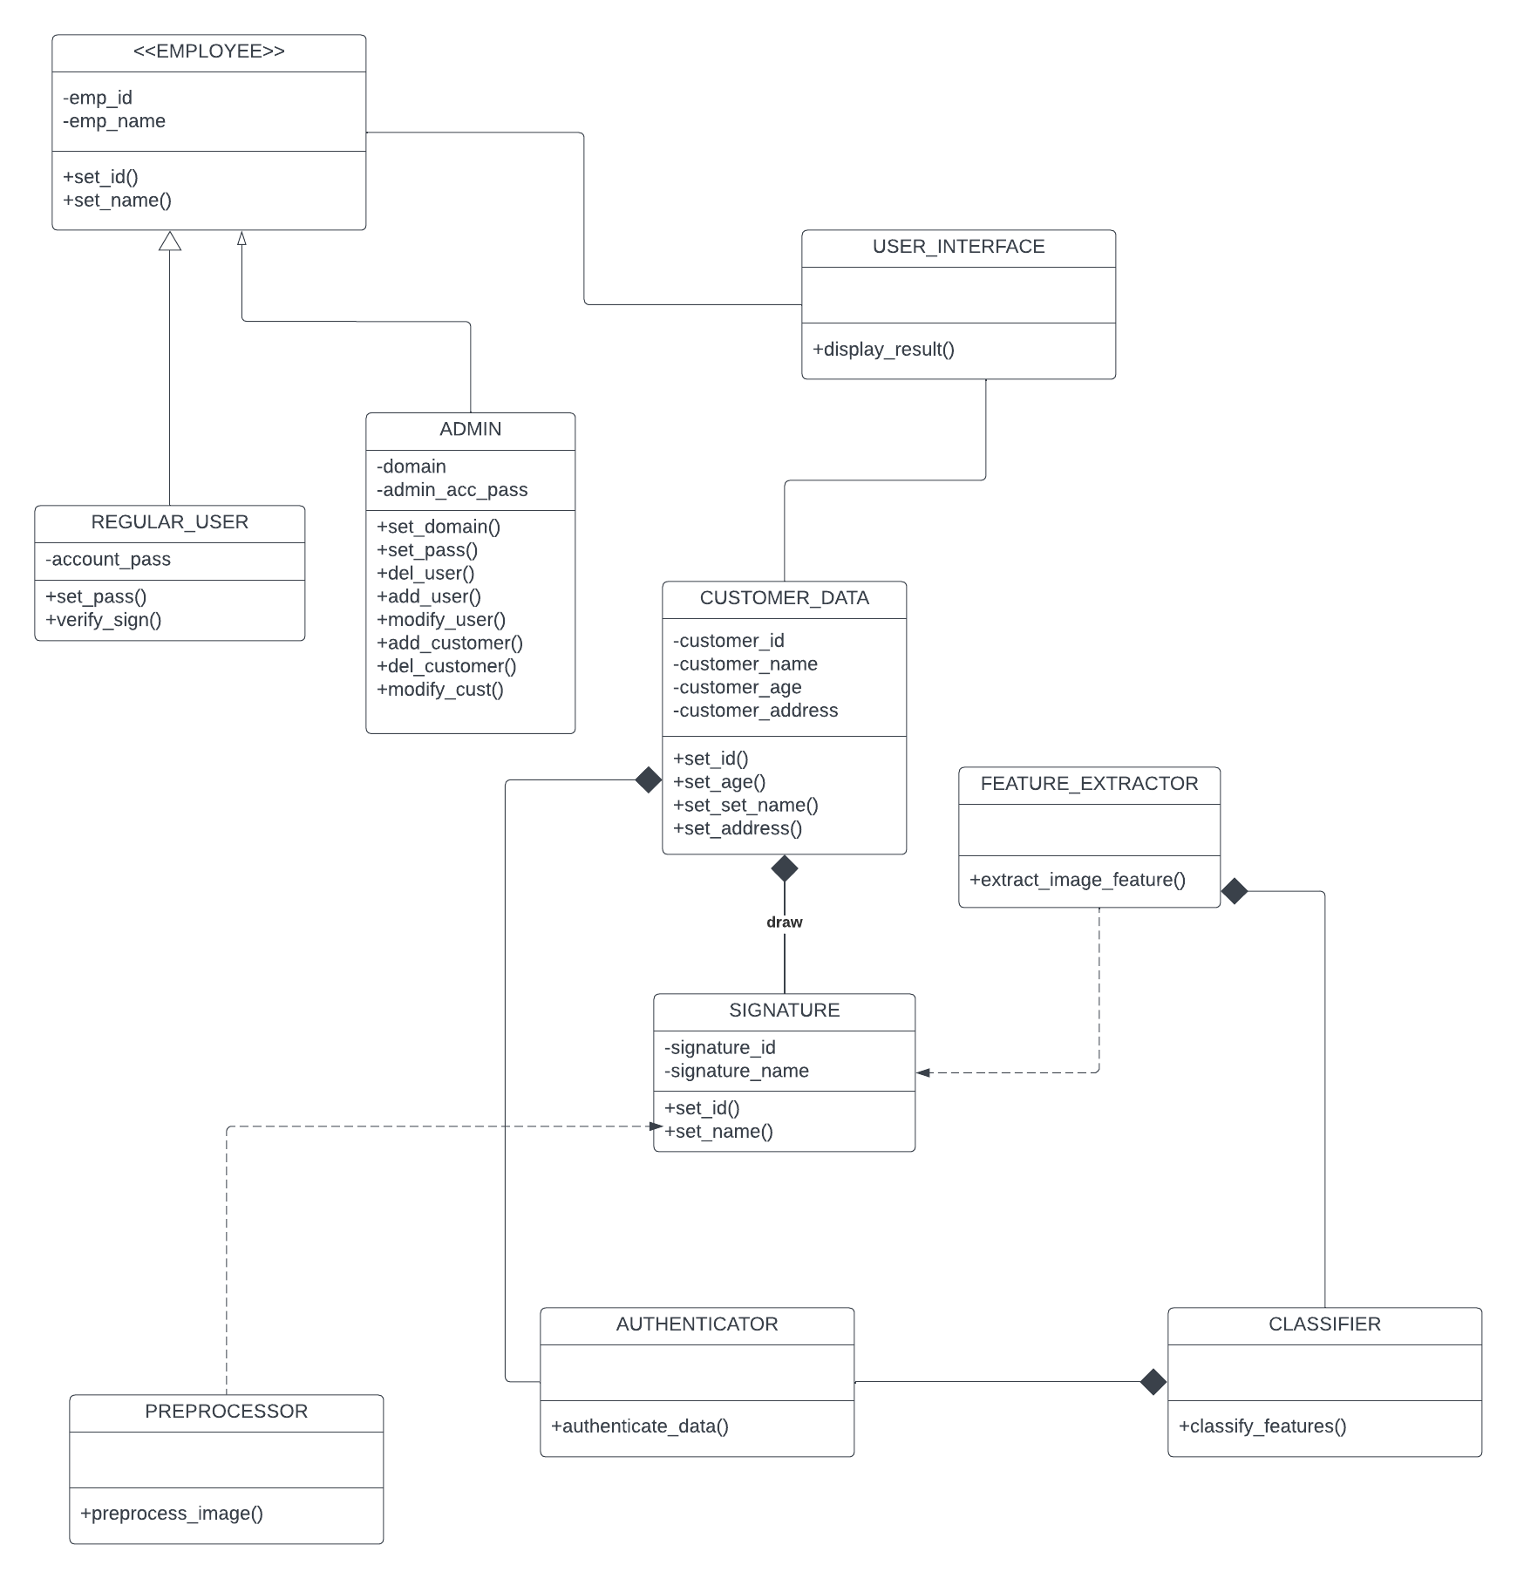

**:**

Fig 16:  *Design level class diagram of system*

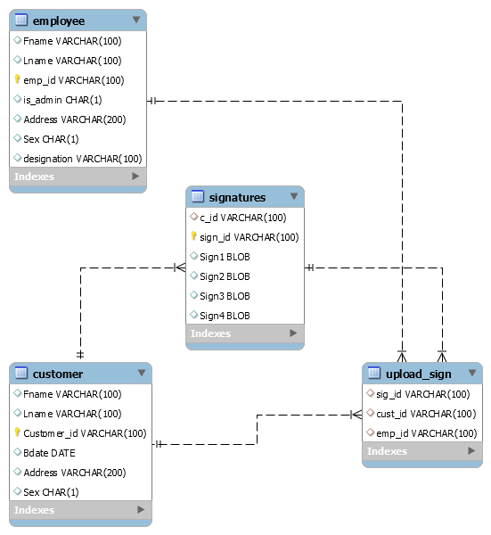

Fig 17:  *Database schema of system*

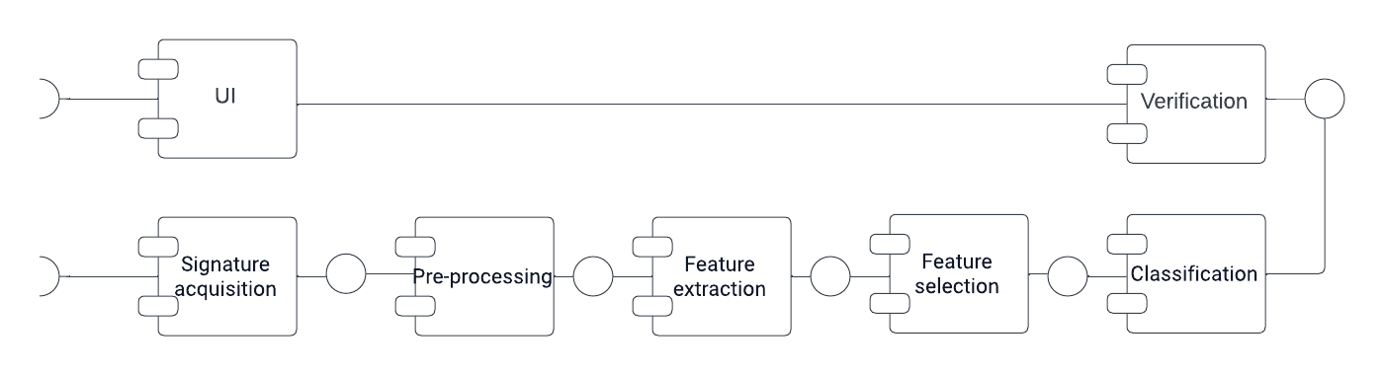  
  
Fig 18:  *component-component diagram*

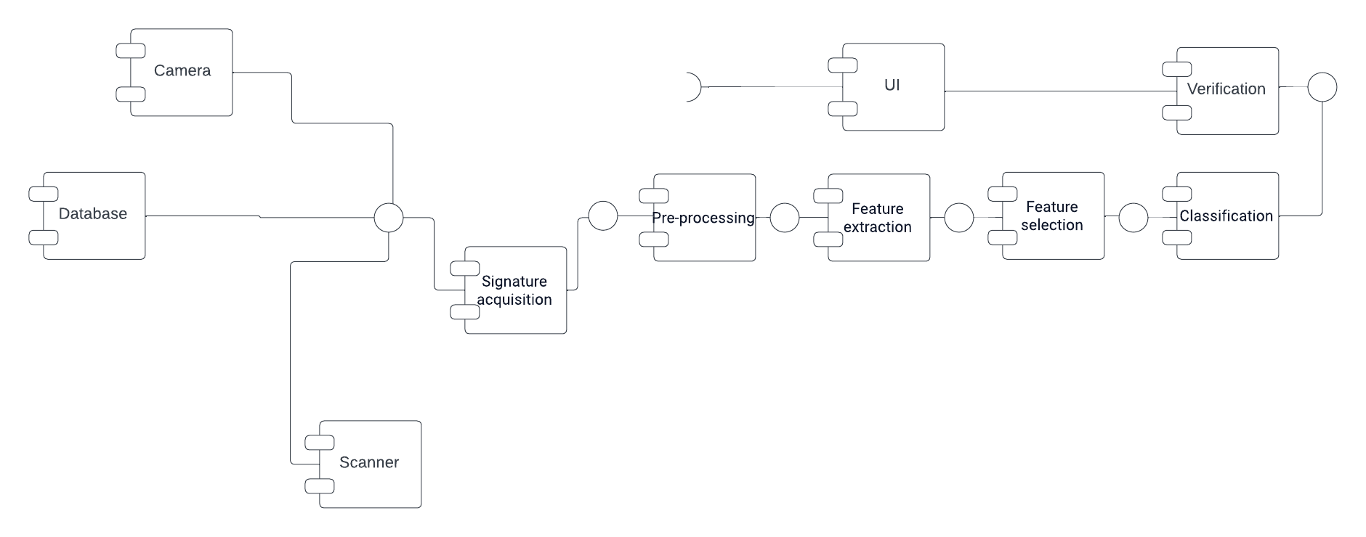

Fig 19:  *Component external entity interaction*

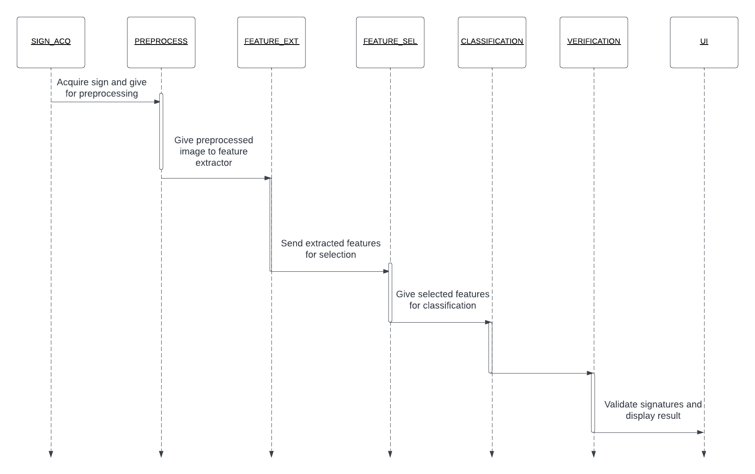 Fig 20:  *Sequence diagram of system*

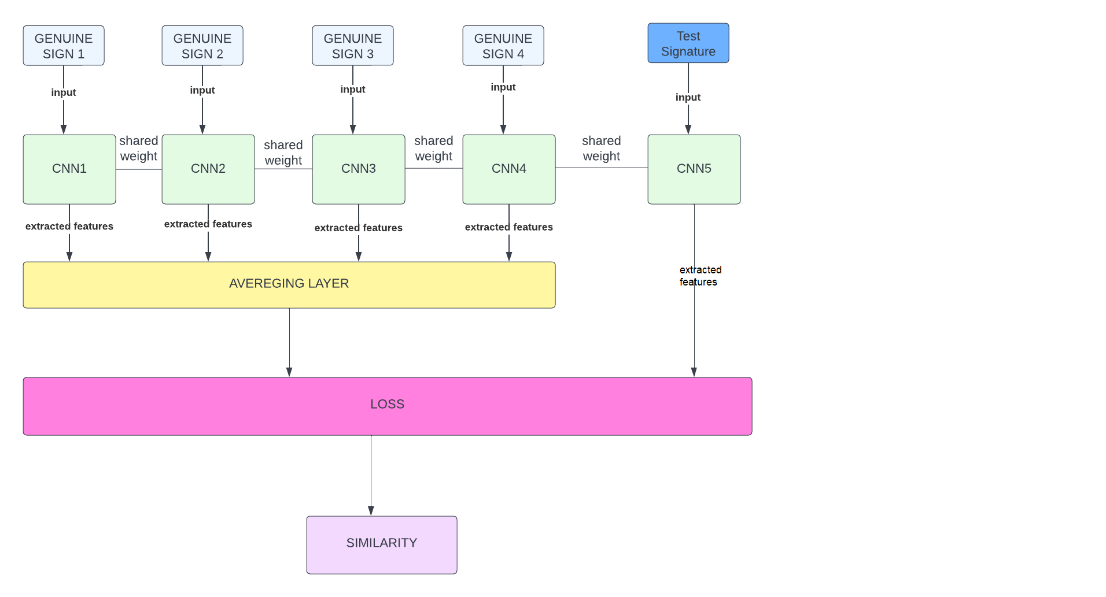

*Fig 21:* architecture of 5 way Siamese network

## Nonfunctional Requirements

## Target Performance

In banks, signature verification is being manually done by the relevant officer. As per human tendency, it takes considerable amount of time to verify a signature as real or forged, along with that precision is also compromised. Our model will also take almost the same time to identify the signatures; however, with better accuracy and precision. Because the computer can see and analyze the minutest details which human cannot identify, as we are using 5 ways Siamese network so performance of our system will surely be better as compared to other available systems

## Safety Requirements (if applicable)

Banks are meant to have highly secure and protective environment, in order to ascertain customers financial security. A minute level security breach may procure devastating outcomes, like misuse of someone’s signature to access its bank account etc., safety measures to avoid this scenario should be taken

## Security Requirements (if applicable)

Every user should have its account protected which no one can change or modify except Admin

## Additional Software Quality Attributes

Our app will be user friendly and simple to use for layman so our app will have high adaptability also our app will be scale able in which more information of clients could be added in future, our app will work on common desktop operating systems used by banks or organizations like windows

## Other Requirements

N/A

# Results

**Accuracy:**

We tried total 5 models having different architecture and layers first we used Traditional twin Siamese architecture which uses BH-SIG dataset it gave an accuracy of 78% after that we moved toward 5- way Siamese architecture and made 5 way architecture using 3 conv blocks having 64,128 and 265 number of filters respectively which gave us an accuracy of 61% after that, to increase accuracy we also tried a model with six CONV blocks but no improvement was seen then we moved towards transfer learning and used pre trained models.

**Transfer Learning:**

Transfer learning is reuse of a pre trained model for a new problem. In our case we used 2 pre trained models VGG16 and RESNET VGG16 gave us an accuracy of 70 percent and RESNET gave an accuracy of 72 percent on specific thresholds found using ROC

**ROC:**

ROC shows performance of a classification model at all classification thresholds in our case ROC told us the overall accuracy of model based on decisions made while predicting and gave an estimated threshold which will then be compared with distance and if distance is greater than threshold signature is fake if distance is smaller than that threshold signature is considered to be fake. In custom model using ROC we obtained an accuracy of 57 percent on threshold 47 then we manually try to find accuracy we passed array having certain thresholds to a function which shows accuracy on that specific threshold and then plotted it

**Custom Accuracy Calculation:**

We created our own accuracy calculation function once a good threshold is found we pass array of prediction to the function which compares threshold with actual labels and then find TRUE POSITIVE, FALSE POSITIVE, TRUE NEGATIVE and FALSE NEGATIVE Rates and then find accuracy using the formula:

$$\frac{TP+TN}{TP+TN+FP+FN}$$

For prediction array 0 is appended in array if distance found is smaller than threshold and 1 is appended to array if distance between signature samples is smaller than threshold. Meaning it’s a true case

**Similarity Estimation:**

We used and understood technique known as Similarity

**Robustness and Generalization:**

Testing the model's ability to handle variations in signature styles, sizes, and quality.

Generalization to new, unseen signatures beyond the training dataset.

**Effectiveness of N-Way Siamese Network:**

Validation of the N-Way Siamese network's ability to handle multiple genuine signature samples for a single user.

Investigation of improvements in accuracy compared to 2-way Siamese networks.

**User Interface and Usability:**

Assessment of the user interface's intuitiveness and ease of use.

Feedback from users on the application's usability and functionality.

**Impact on Signature Verification Process:**

Analysis of the impact of the developed application on manual signature verification processes in organizations.

Potential reduction in verification time and human error.

# Analysis and Discussion

## Result Comparison (General Discussion)

First we implemented and analyzed previously made models using Twin Siamese network which uses BH sig dataset also we used our own dataset i.e., Sigcomp ICDAR 2011. It gave us an accuracy of 78 percent having TP,FP,TN,FN Rates equal 204,71,437,116 after that we made our own architecture i.e., N-way Siamese Network N=5 in our case first we built a custom model having 3 CONV blocks first one having 64 filters, second one with 128 filters and third one having 256 filters which gave us an accuracy of 62.5 % at threshold 50 having TP,FP,TN,FN Rates equal 129,118,129,39 respectively then for increasing accuracy we tried custom model with 6 CONV blocks initially having 16 filters which becomes double at every successive CONV block but no significant improvement in result was seen so we moved towards Transfer learning first we tried VGG16 model which gave an accuracy of 70% on threshold 60 and TP,FP,TN,FN Rates equal 101,58,189,67 respectively then we tried another pre trained model RESNET which gave us an accuracy of 72 on threshold 48 and TP,FP,TN,FN Rates equal 94,45,202,74 respectively. Previous work which was done on BHSIG Dataset using Twin Siamese gave an accuracy of 78% but when we used our own dataset along with same number of layers used in 5 way Siamese it gave an accuracy of 51% which shows the superiority of our model N-Way Siamese over traditional twin Siamese

## Screenshots/Prototype

## workflow

First Screen will pop up when person opens the Desktop App. The person will then have to choose whether he/she is a user of the Desktop App or an Admin. Respectively, he/she will choose the desired mode for login. Now, If the person is Admin, He will Sign In as Admin. Enter his credentials, i.e. Username and Password. Next the Admin panel will open once credentials are verified from the database. This panel will allow the Administrator to Update record of a certain customer, Delete his/her record and also allow adding of new customers. When the Admin will add a user, he will be asked to provide details of the customer. The details will include information such as Name, CNIC, Contact No. CNIC along with uploading his 4 Sample Signatures. Now, If the person using the Desktop app is customer and wants to validate his signatures. He will Sign in as User and Enter his credentials, i.e.Username & password. After user logs in, His unique Id will be displayed in front of him/her and will be asked to upload his test signature in the Space provided. The user will then test the Signature by tapping the Test Button. Next, the customer will be shown his 4 Sample Signatures along with his uploaded signature. And will be shown a message of whether His Signature is Matched or Not.

## SCREENS

**SCREEN 1**

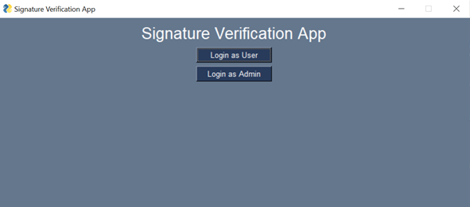

**SCREEN2:**

**IF EMPLOYEE IS ADMIN:**

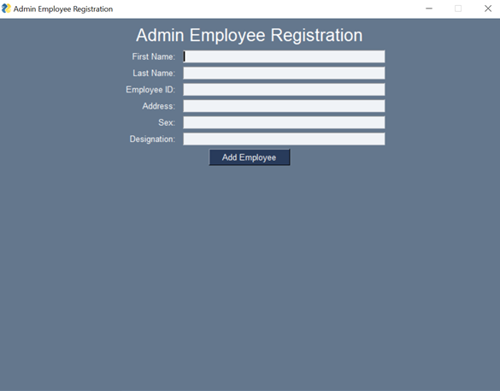

**SCREEN3:**

**ADMIN PANEL:**

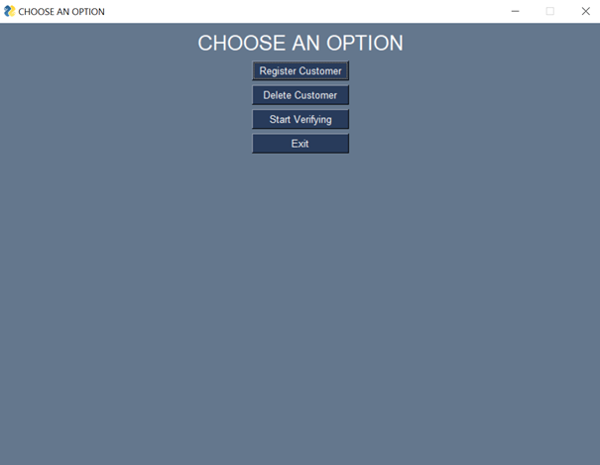

**SCREEN 4:**

**REGISTERING CUSTOMER:**

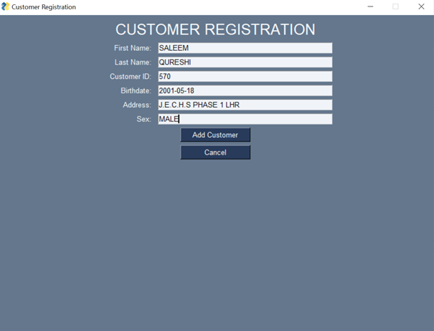

**SCREEN 5:**

**CUSTOMER DELETION:**

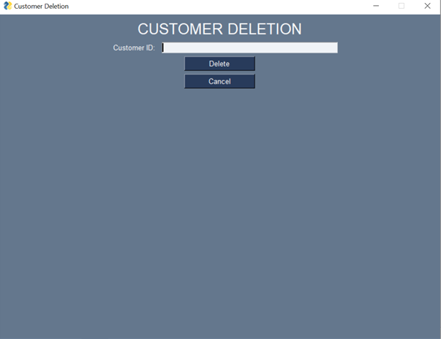

**SCREEN 6:**

**SAVING CUSTOMER SIGNATURE AGAINST ID IN DB:**

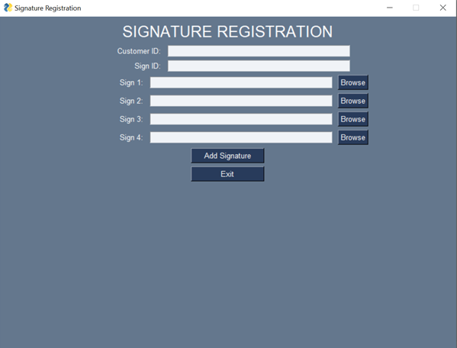

**SCREEN 7 VERIFICATION:**

**FIRST SCREEN:**

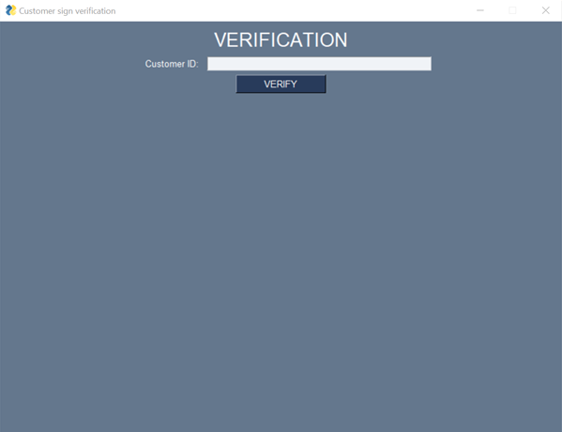

**SCREEN 8:**

**VERIFICATION SCREEN AFTER ADDING CID UPLOAD TEST SIGNATURE AND GENUINE SIGNATURES:**

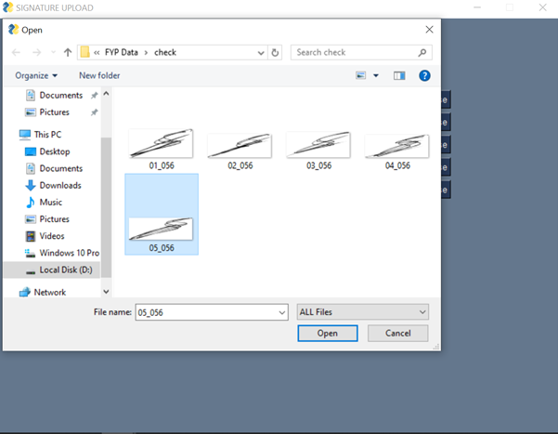

**SCREEN 9:**

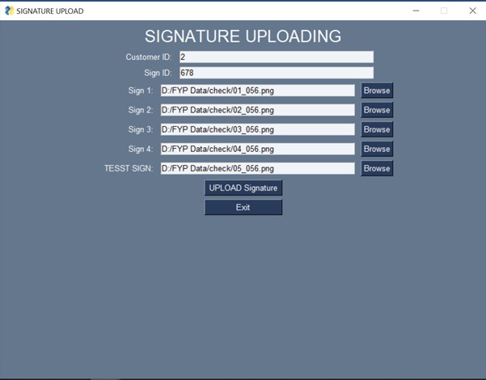

**SCREEN 10:**

**FINAL SCREEN SHOWING RESULTS:**

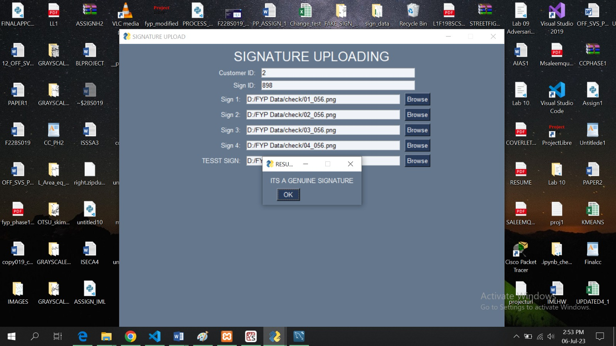

**SCREEN 11:**

**PANEL IF EMPLOYEE IS USER:**

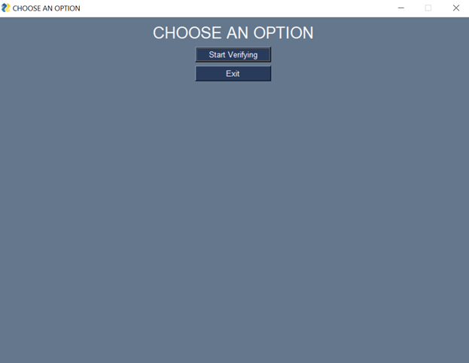

## Additional Information

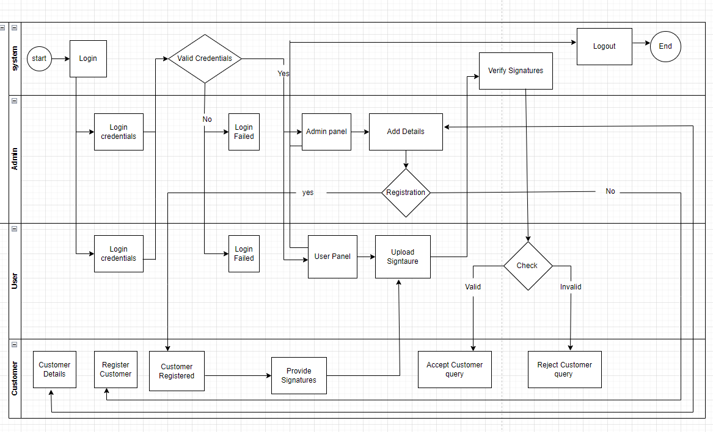

*Fig 22*:Activity diagrams for screen

## Other Design Details

Total six research papers were reviewed 2 papers by each group member which include

* Signet convolutional Siamese network for writer independent offline signature verification **[7]**
* Proceeding of SPIE offline SVS using Convolutional Siamese network
* Signature verification using Siamese network based on one shot learning **[6]**
* signature verification using a convolutional neural network **[4]**
* Offline signature verification with CNN [**5]**
* Machine learning based offline signature verification system A systematic review **[8]**

4 papers Focus on **CEDAR [2]** dataset and two papers focus on **SIGCOMP 2011 [1]** dataset by studying these papers we got knowledge about the architecture, the model and algorithms we are going to use in this project 3 papers focus on convolutional Siamese network 1 paper talked about machine learning techniques for signature verification and 2 papers were on signature verification using CNN, we understood algorithm and architecture of the model we are going to implement to a great extent by studying these papers, we got knowledge about Siamese networks the layers in Siamese network like the layer which calculate distance or also there can be averaging layer, we got knowledge about the CNN architecture and how it extracts features, Loss functions how to calculate loss how to calculate accuracy of a system how to verify error rate true positives true negatives and overall accuracy of the system along with specificity and sensitivity, papers also talked about the results and performance of algorithm on different datasets. Our primary focus was on CEDAR and SIGCOMP datasets, by reading papers we came to know that algorithm achieve maximum efficiency 100% in some cases where CEDAR dataset is used and a less accuracy when SIGCOMP dataset is used, we came to know that images in CEDAR are available in grayscale mode so preprocessing will be easy in cedar dataset on the contrary data in SIGCOMP is not well structured and images are also not available in grayscale mode so preprocessing will be difficult but SIGCOMP being a large dataset is good for training the algorithm as compared to CEDAR as cedar has less images available than SIGCOMP, we came to know that CEDAR give accurate results when the algorithm is being tested whereas SIGCOMP provide better results when better training of the model is required, we also got knowledge about preprocessing techniques especially image preprocessing techniques superiority of Siamese network was proved over simple CNN architecture by reading these research papers, we got information about neural networks and there layers also we came to know about the effective data split ratio into training and testing parts, we gained knowledge about the implementation of algorithm, we also came to know about APIS and backend like KERAS and TENSORFLOW for model implementation and efficient pairing of data for model training. Multiple image processing techniques were written I paper like Hough transformation and Otsu’s method also different distance calculating algorithms were understood by us like Euclidian distance cosine distance or any combination of two distance calculating algorithms i.e., hybrid distance also there comparison was made in paper, also the reviewed papers talked about what kind of databases, preprocessing techniques and feature extraction methods are required, comparisons between preprocessing techniques and datasets were made some research questions were raised and answered to give a clear understanding about the concepts, paper also talked about deep neural network and shallow neural network, usage of performance evaluation metrics etc., after studying these research papers we have clear understanding of the problem and model we are going to implement.

**Preprocessing done on dataset and images:**

Also we have worked on dataset preprocessing and image preprocessing we arranged data in the format where there are 4 genuine signature images which are matched by test signature image, the test signature image can either be fake or real so for every test signature there will be 4 genuine images to compare and obtain results complete details about this are given in phase 1 document also we have done image preprocessing first we targeted ICDAR SIGCOMP 2011 **[1]** dataset in this dataset there are black signatures on blue background, also in real world the signatures can be of any color or the background on which signatures are done can be of multiple colors which will make it very tough for model to get trained on this type of data so in this case we will do gray scalingof the images to eliminate this problem some of the images of signatures from dataset are below:

**ORIGINAL IMAGES IN DATASET:**

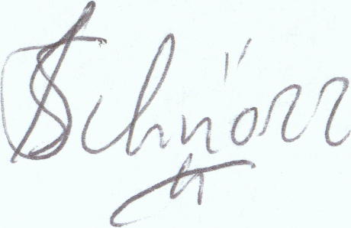 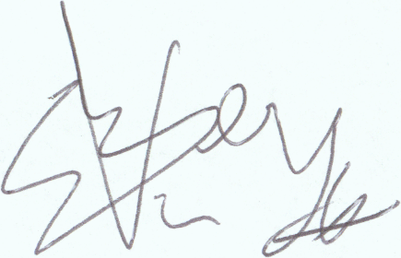

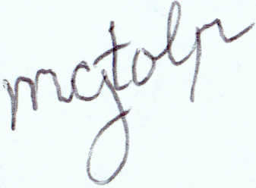 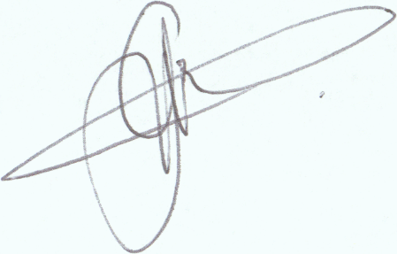

Fig 23: Sample signature images from dataset

**GRAY SCALED IMAGES USING OPENCV:**

Firstly, we tried to convert these images to grayscale mode using OPENCV library images were converted to grayscale but the problem with opencv was that it reads image in BGR mode which can sometime cause problem in image color or processing. The images after gray scaling using opencv are:

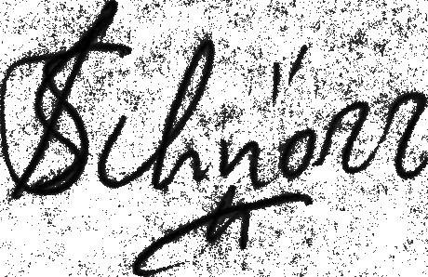 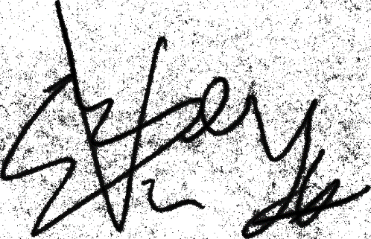

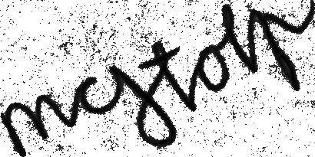 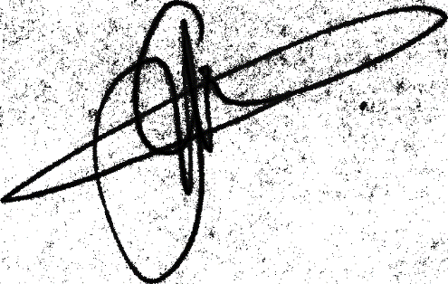

Fig 24: Gray scaled images using Opencv library

**GRAY SCALED IMAGES USING SKIMAGE LIBRARY:**

We also tried SKIMAGE library to convert colored signature image to grayscale and it gave better results compared to opencv library as it reads image in RGB format. The sample of grayscaled sign images using skimage library are:

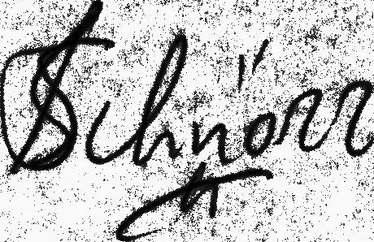 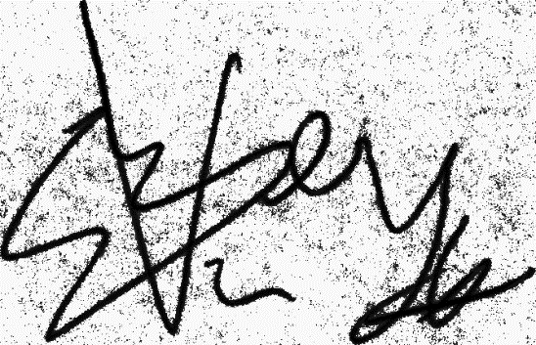

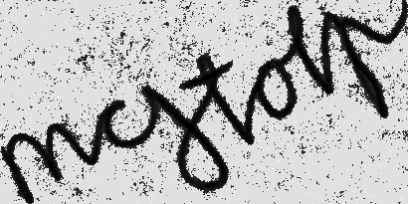 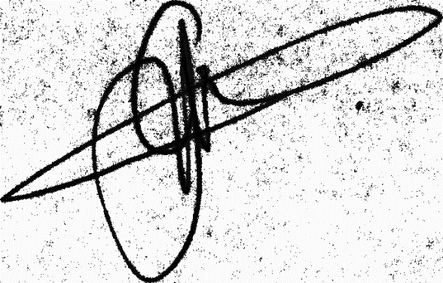

Fig 25: Gray scaled signature images using SKIMAGE library

**GRAYSCALE IMAGES WITH GLOBAL HISTOGRAM EQUALIZATION:**

After comparison of these results, we decided to continue with skimage library to further preprocess the images. After converting the images to grayscale mode, we decided to do histogram equalization to enhance the contrast so our model can get better training. We tried two equalization techniques i.e., global histogram equalization and local area histogram equalization the result of global histogram equalization on grayscaled images are:

 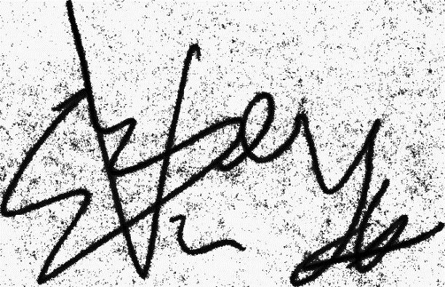

 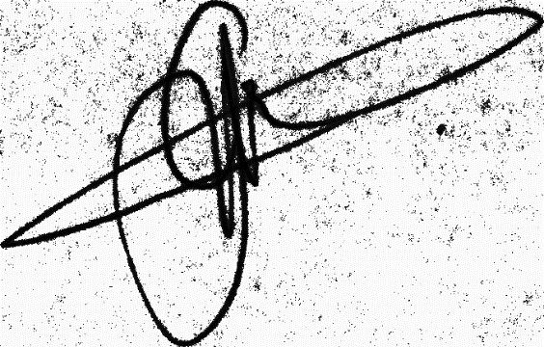

Fig 26: gray scaled images after global histogram equalization

**IMAGES AFTER GRAYSCALING AND GLOBAL HIST EQUALIZATION HAVING OTSU METHOD IMPLEMENTED:**

Now after converting images to grayscale mode and doing histogram equalization noise can be seen clearly in the background to eliminate this noise we will use a method called OTSU’s method or OTSU thresholding result of images after applying OTSU thresholding are:

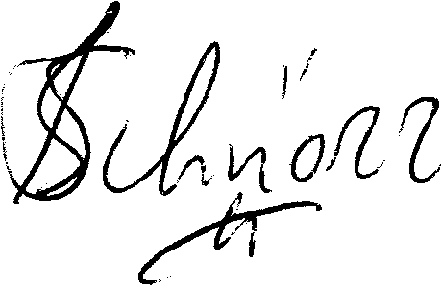 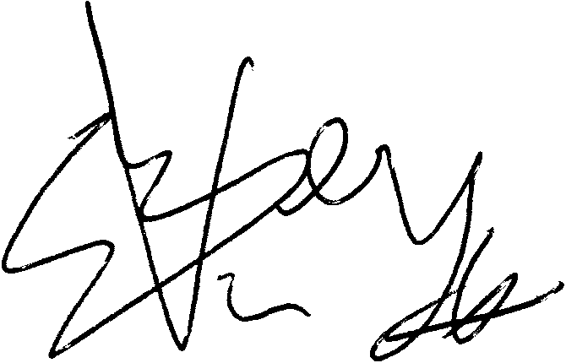

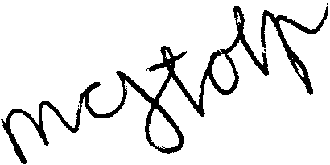 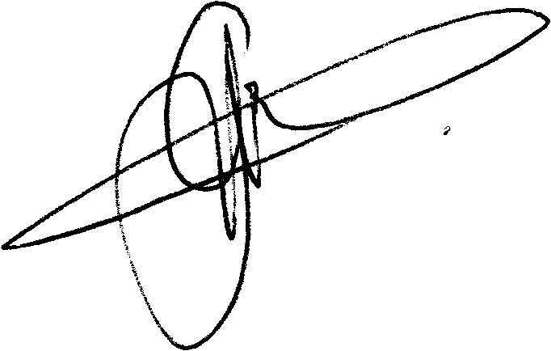

Fig 27: Signature images after applying Otsu thresholding, histogram equalization and gray scaling

**GRAY SCALED IMAGES HAVING CONTRAST LIMITED ADAPTIVE HISTOGRAM EQUALIZATION (CLAHE) IMPLEMENTED INSTEAD OF GLOBAL HIST EQ:**

There is a type of histogram equalization known as local area histogram equalization (CLAHE) which enhance contrast of the image locally unlike global histogram equalization the result of CLAHE on grayscale images are as under:

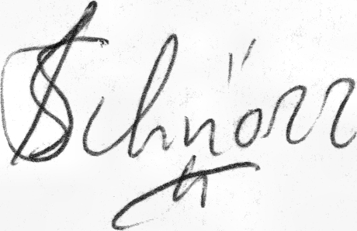 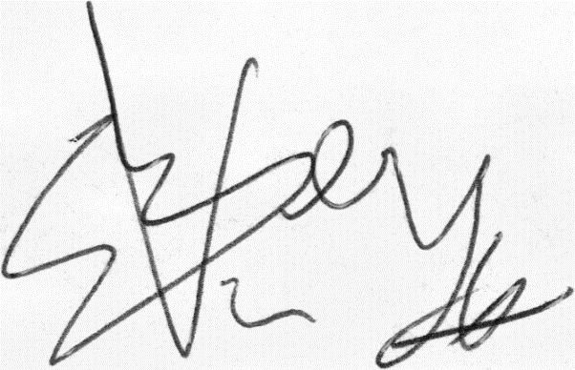

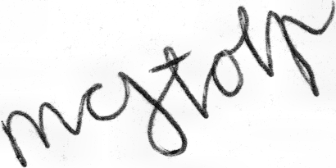 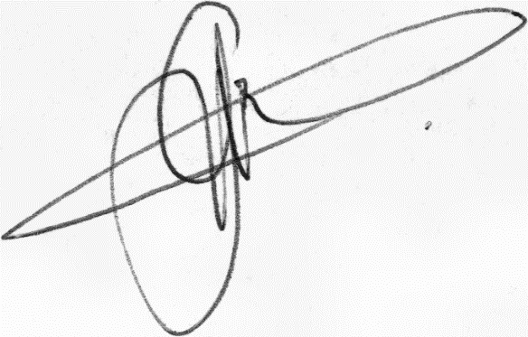

Fig 28: Images after applying CLAHE on grayscale images

**OTSU AND CLAHE IMPLEMENTED ON GRAYSCALED IMAGES**

Finally, we applied Otsus thresholding after local area histogram equalization and the results are:

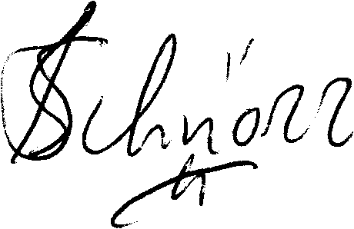 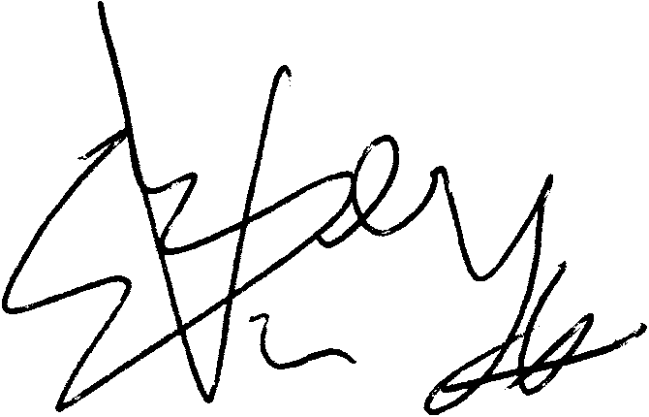

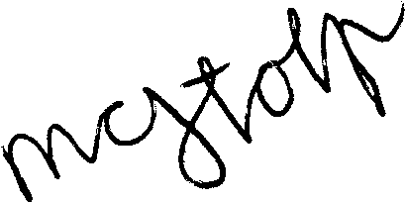 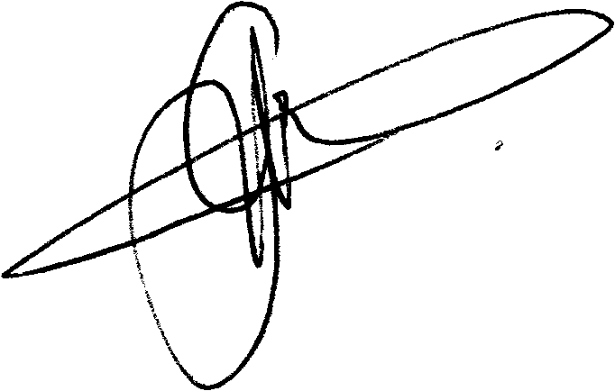

Fig 29: Final Images

**Choosing Model for SVS:**

Initially, we developed a custom model consisting of three convolutional (CONV) blocks using a sequential model. The depth or number of kernels/filters began at 64 and progressively increased in each CONV block. In the first CONV block, there was a Conv2D layer with 64 filters of size 11x11, utilizing ReLU activation and a stride of 1. For each Conv2D layer, we employed the "Glorot uniform" kernel initializer, L2 regularization of 0.0005, and applied padding to maintain the same output size. Following the Conv2D layer, a batch normalization layer was applied, with epsilon set to 1e-6, axis set to 1, and a momentum value of 0.9. Subsequently, a max pooling layer with a pool size of 3x3, stride of 2x2, and padding set to maintain the same output size was utilized.

Moving on to the second CONV block, a Conv2D layer was employed with 128 kernels of size 5x5, while maintaining the same configuration as the first Conv2D layer. Similarly, batch normalization layers with the same parameters as the first CONV block were utilized. This was followed by a max pooling layer with a pool size of 3x3, a stride of 2x2, and padding set to maintain the same output size. A dropout layer with a value of 0.3 was then added.

In the third CONV block, a Conv2D layer was used with 256 filters of size 3x3, employing ReLU activation, a stride of 1, the "Glorot uniform" kernel initializer, L2 regularization of 0.005, and padding to maintain the same output size. Next, a max pooling layer with a stride of 2x2, a pool size of 2x2, and padding set to maintain the same output size was employed. A dropout layer with a value of 0.3 was added once again. Following this, the output was flattened using the **flatten()** function.

A dense layer with a size of 1024, ReLU activation, the "Glorot uniform" kernel initializer, and L2 regularization of 0.0005 was then applied. Subsequently, a dropout layer with a value of 0.5 was placed, followed by another dense layer of size 128, maintaining the same parameters as the previous dense layer.

Using this model, we achieved an accuracy of **62.5 percent**. Additionally, we attempted to improve the results by increasing the number of CONV blocks to six. In this configuration, the first CONV block had 16 filters, the second had 32 filters, the third had 64 filters, the fourth had 128 filters, the fifth had 256 filters, and the sixth CONV block had 512 filters. In each CONV layer, we maintained the filter size at 3x3, similar to AlexNet. However, we did not observe any significant improvement in the results.

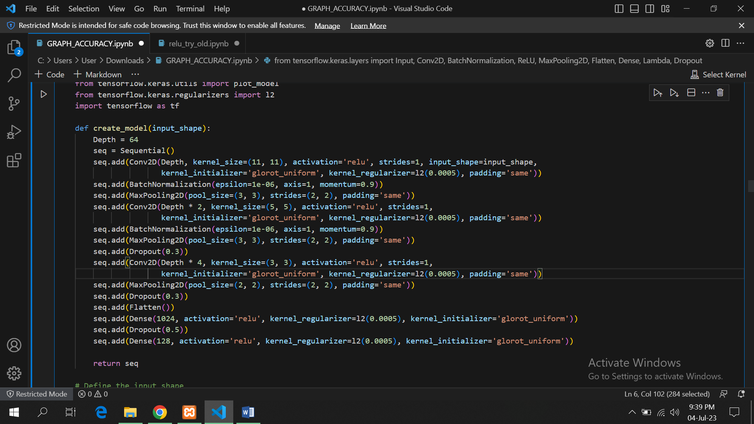

Fig 30: Layers arrangement in custom model

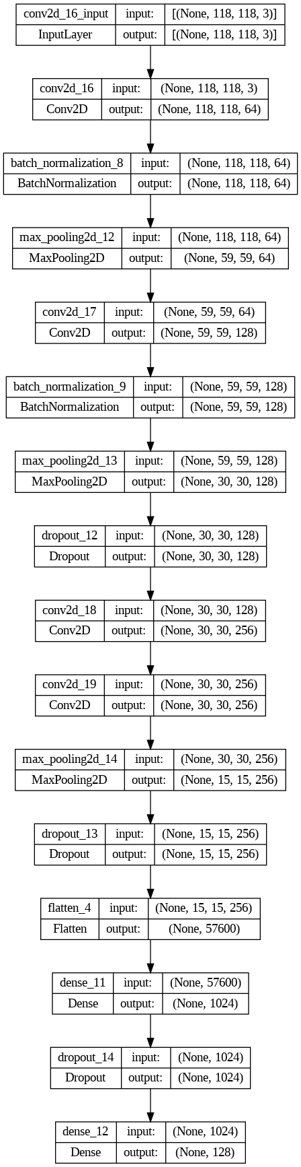

Fig 31: Internal Sequential Structure for above given layers

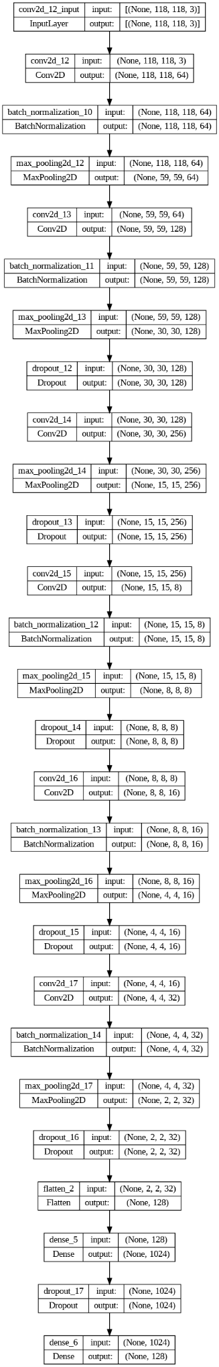

Fig 32: Internal Sequential structure for 6 conv block arrangement

**How we Calculated Accuracy?**

We used ROC function to determine the accuracy of system which takes predictions for every set of training data and labels against it as input and then calculates True positives, False Positives, True Negatives and False negatives and then calculates accuracy and sensitivity based on calculated values for our model the values returned for accuracy and threshold were 58.7 and 42 respectively but accuracy of 58.7 was not satisfactory so we made our custom function to calculate accuracy which takes predictions for every set of data in train split and there labels and compare the prediction or distance in this case with the threshold if distance is greater than threshold then its considered a false case and if distance is less than equal to threshold its considered as a true case and then the result is compared with label for that set if distance is greater than threshold and label is 0 so it’s a correct prediction and accuracy is incremented by 1 and if distance is greater than or equal to value of threshold and label is 1 its also a correct prediction and 1 is added to prediction then we divide accuracy by total number of sets in train split and get an accuracy probability and percentage can be obtained by multiplying it with 100 then for increasing accuracy we passed different values of threshold to function and see values of accuracy on that threshold by doing this we achieved maximum accuracy of 62.5 at threshold 50 and then we plotted graph for accuracy on certain thresholds for custom model the **True positive rate** was **129 , TRUE NEGATIVE = 129 , FALSE POSITIVE= 118 , FALSE NEGATIVE = 39**

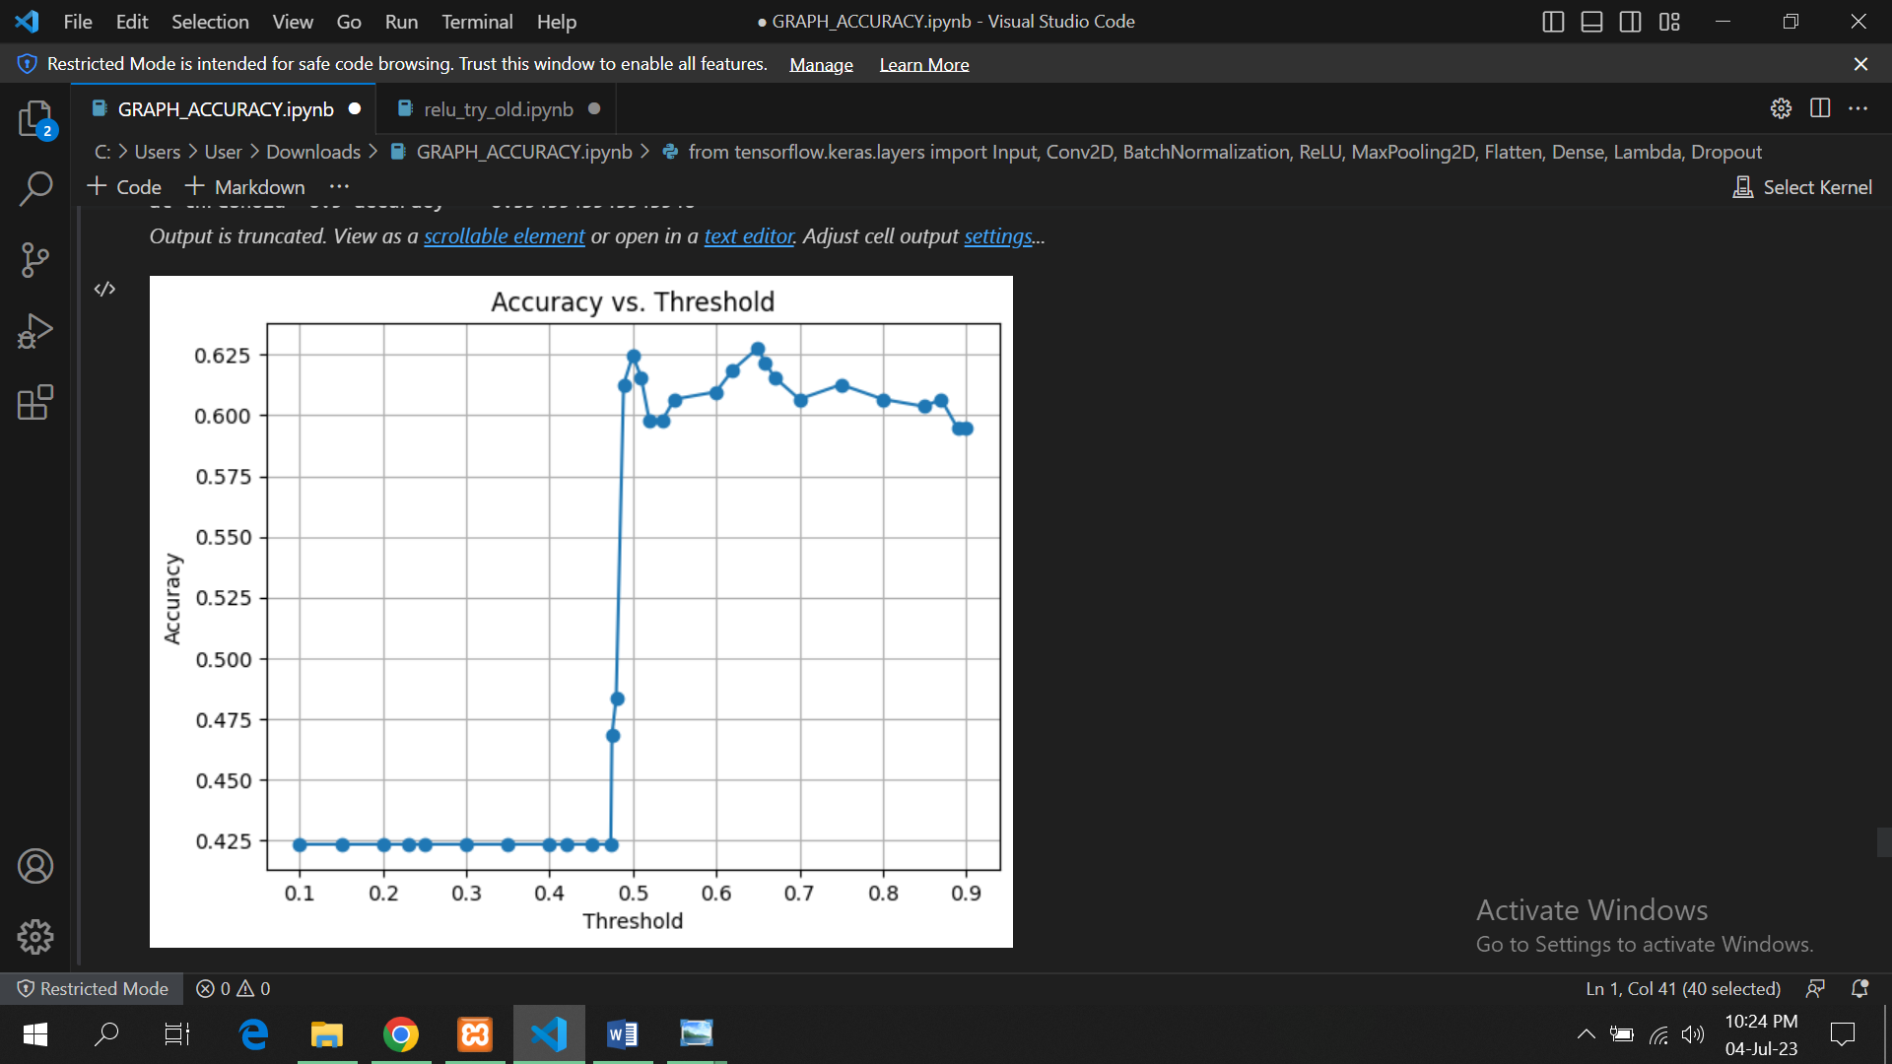

Fig 33: Graph showing accuracy on different levels of threshold

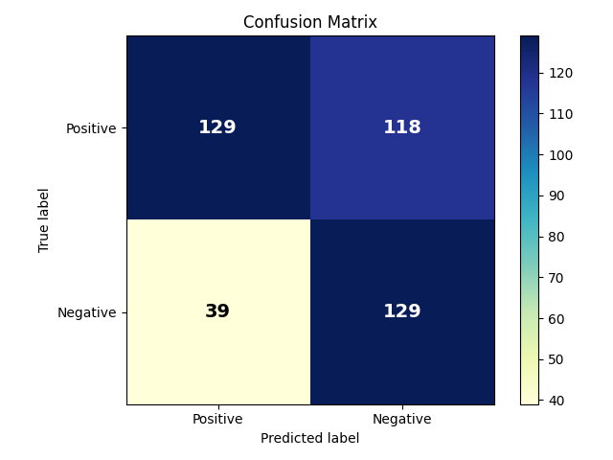

*Fig 34* : Confusion matrix for custom model

**VGG 16:**

As dataset was small so 63 percent accuracy obtained by using our model was good but not satisfactory so we decided to use any pre trained model for feature extraction first we used VGG16 for feature extraction rest of the architecture was same we just used it in place of sequential and then we checked values of accuracy at different threshold maximum accuracy obtained in this case was **70 percent** at threshold 60 the **True positive rate** was **101 , TRUE NEGATIVE = 189 , FALSE POSITIVE= 58 , FALSE NEGATIVE = 67**

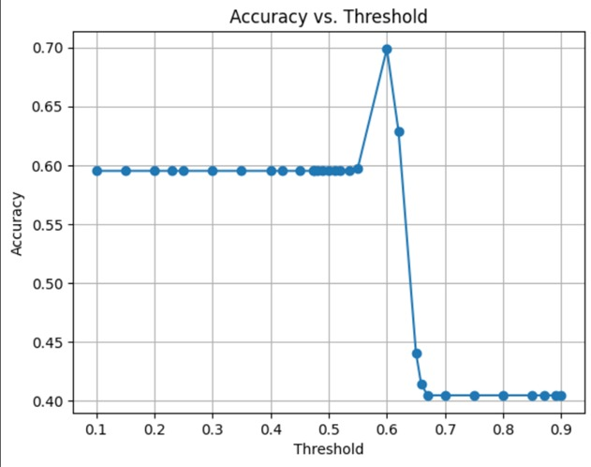

Figure 35: Graph showing accuracy on different levels of threshold using VGG16

Fig 35: Graph showing accuracy on different levels of threshold using VGG16

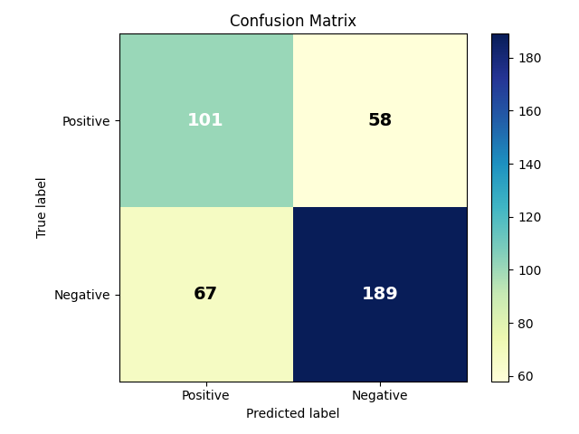\

Fig 36: Confusion matrix for VGG16

**RESNET:**

We also tried RESNET for feature extraction which gave us maximum accuracy compared to other models we use it for feature extraction and placed it in our architecture in place of sequential the accuracy obtained was **72 percent** at threshold 48 the **True positive rate** was **94 , TRUE NEGATIVE = 202 , FALSE POSITIVE= 45 , FALSE NEGATIVE = 74**

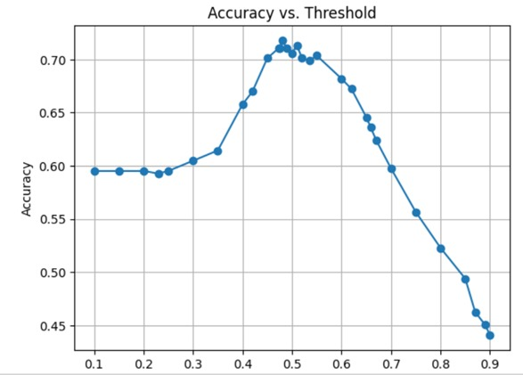

Fig 37: Graph showing accuracy on different levels of threshold using RESNET

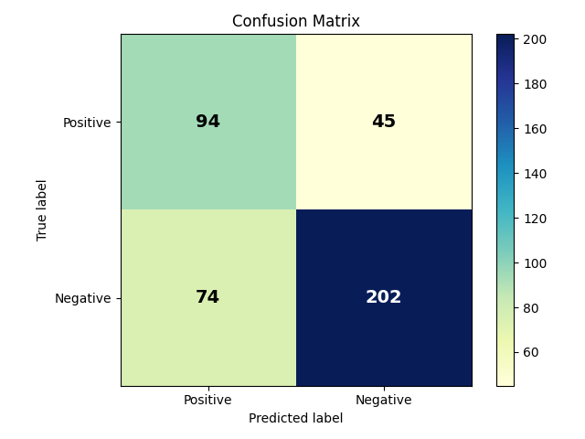

Fig 38: Confusion matrix for RESNET

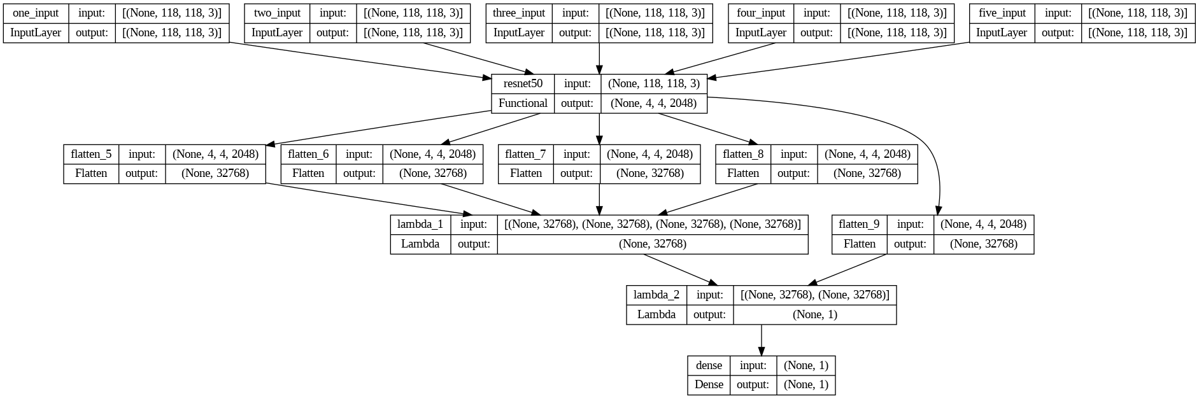

Fig 39: model architecture using RESNET for feature extraction

**Twin Siamese:**

We also used our custom model for traditional twin Siamese network in that case we layers in model was same the only changing was that we used 2 CNNS instead of 5 one was for genuine image and one for train the accuracy obtained was **78** percent and the **True positive rate** was **204, TRUE NEGATIVE = 437, FALSE POSITIVE= 71 , FALSE NEGATIVE = 116**

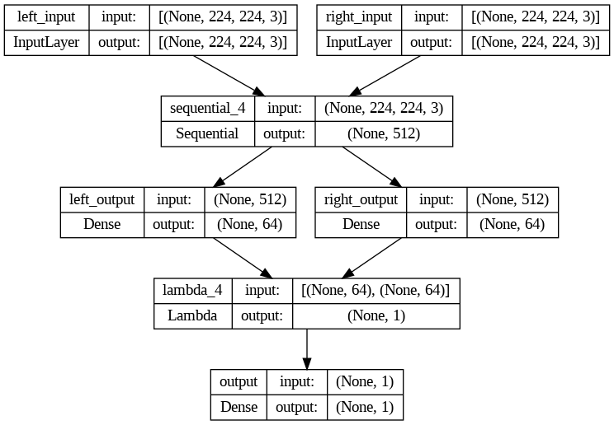

Fig 40*: model architecture 2 way Siamese*

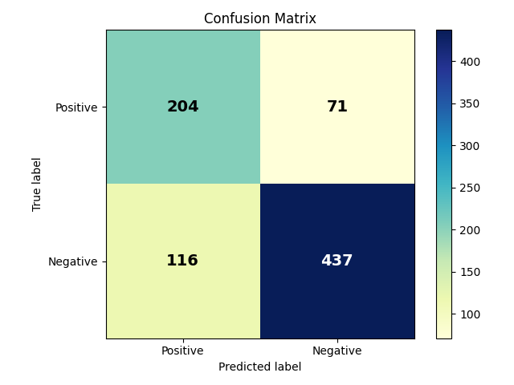

*Fig41: Confusion matrix for twin Siamese*

# Test Specification and Results

## Test Case Specification

Table 7.1.1: TC-1 (Sign Image Acquisition)

|  |  |
| --- | --- |
| **Identifier** | TC-1 |
| **Related requirements(s)** | Functional Requirement #1: The system shall be able to acquire the signature image from an input device. |
| **Short description** | This test case verifies if the system can acquire a signature image from the input device. |
| **Pre-condition(s)** | The system is powered on and ready for use |
| **Input data** | Signature image. |
| **Detailed steps** | 1. Provide the system with a signature image.   1. System processes the input. |
| **Expected result(s)** | The system should be able to acquire the signature image from the input device. |
| **Post-condition(s)** | The signature image is available for further processing. |
| **Actual result(s)** | System should take signature image as input successfully |
| **Test Case Result** | System takes signature image as input successfully |

**Table 7.1.2: TC-2 (Preprocessing of input)**

|  |  |
| --- | --- |
| **Identifier** | TC-2 |
| **Related requirements(s)** | The system shall be able to preprocess the acquired signature image. |
| **Short description** | This test case verifies if the system can preprocess the acquired signature image. |
| **Pre-condition(s)** | A signature image is available for processing. |
| **Input data** | Signature image. |
| **Detailed steps** | 1. Provide the system with a signature image.   1. System preprocesses the Image. |
| **Expected result(s)** | The system should be able to preprocess the signature image. |
| **Post-condition(s)** | The preprocessed signature image is available for further processing. |
| **Actual result(s)** | Signature gives acquired image to backend for preprocessing |
| **Test Case Result** | System preprocess image correctly |

Table 7.1.3: TC-3 (Feature extraction from images)

|  |  |
| --- | --- |
| **Identifier** | TC-3 |
| **Related requirements(s)** | Functional Requirement #3: The system shall be able to extract features from the preprocessed signature image. |
| **Short description** | This test case verifies if the system can extract features from the preprocessed signature image. |
| **Pre-condition(s)** | A preprocessed signature image is available for processing. |
| **Input data** | Preprocessed signature image. |
| **Detailed steps** | Provide the system with a preprocessed signature image. |
| **Expected result(s)** | The system should be able to extract features from the preprocessed signature image. |
| **Post-condition(s)** | The extracted features are available for further processing. |
| **Actual result(s)** | Preprocessed image shall be given to model for feature extraction |
| **Test Case Result** | Backend successfully extracted image features |

Table 7.1.4: TC-4 (Training on extracted features)

|  |  |
| --- | --- |
| **Identifier** | TC-4 |
| **Related requirements(s)** | The system shall be able to train a model using the extracted features. |
| **Short description** | This test case verifies if the system can train a model using the extracted features. |
| **Pre-condition(s)** | Extracted features are available for training. |
| **Input data** | Extracted features. |
| **Detailed steps** | Provide the system with the extracted features. |
| **Expected result(s)** | The system should be able to train a model using the extracted features. |
| **Post-condition(s)** | A trained model is available for further processing. |
| **Actual result(s)** | Model should be trainable |
| **Test Case Result** | Model is trainable |

Table 7.1.5: TC-5 (Testing of model)

|  |  |
| --- | --- |
| **Identifier** | TC-5 |
| **Related requirements(s)** | The system shall be able to test the trained model with a signature image. |
| **Short description** | This test case verifies if the system can test the trained model with a signature image. |
| **Pre-condition(s)** | A trained model is available for testing. |
| **Input data** | Signature image. |
| **Detailed steps** | 1. Provide the system with a signature image.   1. System tests the trained model with the signature image. |
| **Expected result(s)** | The system should be able to test the trained model with the signature image and provide a verification result. |
| **Post-condition(s)** | The verification result is available for further processing. |
| **Actual result(s)** | Extracted features of a preprocessed image will be given to model and prediction will be made |
| **Test Case Result** | Model do predictions accurately |

Table 7.1.6: TC-6 (Result Verification)

|  |  |
| --- | --- |
| **Identifier** | TC-6 |
| **Related requirements(s)** | The system shall be able to provide a verification result for the tested signature image. |
| **Short description** | This test case verifies if the system can provide a verification result for the tested signature image. |
| **Pre-condition(s)** | The trained model has been tested with a signature image. |
| **Input data** | Tested signature image. |
| **Detailed steps** | 1. Provide the system with a signature image. |
| **Expected result(s)** | The system should be able to provide a verification result for the tested signature image. |
| **Post-condition(s)** | The verification result is available for further processing. |
| **Actual result(s)** | System should give results |
| **Test Case Result** | System outputs results either signatures are genuine or fake |

Table 7.2: Summary of Test Results

|  |  |  |  |  |
| --- | --- | --- | --- | --- |
| **Module Name** | Test cases run | Number of defects found | Number of defects corrected so far | Number of defects still need to be corrected |
| **Module 1 Sign image acquisition** | completed | 1 | 1 | 1 |
| **Module 2 processing of acquired image** | completed | Null | Null | Null |
| **Module 3 feature extraction from processed image** | completed | Null | Null | Null |
| **Module 4 Model training on extracted feature** | completed | Null | Null | Null |
| **Module 5 Testing of signature images** | completed | Null | Null | Null |
| **Module 6 model predict results** | completed | Null | Null | Null |
| **Complete System** | completed | 1 | 1 | 1 |

# Chapter 8. Project Completion Status

Table 8.1: Project Completion Status

|  |  |
| --- | --- |
| **Module Name** | **Status**  (Complete, Partially Implemented, Not Implemented) |
| **Module 1** | Complete |
| **Module 2** | Complete |
| **Module 3** | Complete |
| **Complete System** | Complete |

Table 8.2: Objective(s)/Target(s) Status

|  |  |  |
| --- | --- | --- |
| **Target/Objective** | **Status**  (Completed,  Partially Completed,  Not Completed) | **Reason(s)** |
| **Creation and Updating of Datasets** | Complete | All necessary requirements are completed. |
| **Preprocessing of Dataset Images** | Complete | All necessary requirements are completed. |
| **5 ways Siamese Network Model** | Complete | All necessary requirements are completed. |
| **SVS Desktop Application** | Complete | All necessary requirements are completed. |
| **Number of Targets Completed** | 4 |  |
| **Number of Targets Partially Completed** | 0 |  |
| **Number of Targets Not Completed** | 0 |  |

# References

**[1]** Wikipedia. <https://en.wikipedia.org/wiki/Siamese_neural_network>

**[2]** Kaggle [cedar_dataset_university_of_buffalo](https://www.kaggle.com/datasets/shreelakshmigp/cedardataset)

**[3]** Dey, S., Dutta, A., Toledo, J. I., Ghosh, S. K., Lladós, J., & Pal, U. (2017). Signet: Convolutional siamese network for writer independent offline signature verification. *arXiv preprint arXiv:1707.02131*.

**[4]** Navid, S. M. A., Priya, S. H., Khandakar, N. H., Ferdous, Z., & Haque, A. B. (2019). Signature verification using convolutional neural network. In *2019 IEEE International Conference on Robotics, Automation, Artificial-intelligence and Internet-of-Things (RAAICON)* (pp. 35-39). IEEE.

**[5]** ARISOY, M. V. SIGNATURE VERIFICATION USING SIAMESE NEURAL NETWORK ONE-SHOT LEARNING. *International Journal of Engineering and Innovative Research*, *3*(3), 248-260.

**[6]** Navid, S. M. A., Priya, S. H., Khandakar, N. H., Ferdous, Z., & Haque, A. B. (2019). Signature verification using convolutional neural network. In *2019 IEEE International Conference on Robotics, Automation, Artificial-intelligence and Internet-of-Things (RAAICON)* (pp. 35-39). IEEE.

**[7]** Alvarez, G., Sheffer, B., & Bryant, M. (2016). Offline signature verification with convolutional neural networks. *Tech. Report*.

**[8]** Hameed, M. M., Ahmad, R., Kiah, M. L. M., & Murtaza, G. (2021). Machine learning-based offline signature verification systems: a systematic review. *Signal Processing: Image Communication*, *93*, 116139.

Appendix A Glossary

**SVS:** SVS means Signature Verification System it’s a process in which signatures are verified using computer aided technology instead of human

**CNN:** convolutional Neural network, a type of artificial neural network, which is widely used for image/object recognition and classification.

**Siamese network:** A neural network architecture containing two or more identical subnetworks

**Dataset:** A structured collection of data

**Preprocessing:** preliminary processing of data to prepare it for the primary processing or for further analysis

**Grayscale:** in digital images, grayscale means that the value of each pixel represents only the intensity information of the light

**Histogram Equalization:** A technique for adjusting image intensities to enhance contrast

**CLAHE:** CLAHE means Contrast Limited Adaptive Histogram Equalization. It is a technique used to improve the visibility level of foggy images.

**N-WAY Siamese network:** A modified version of conventional Siamese architecture where there can be N number of subnetworks.

Appendix B IV & V Report

(Independent verification & validation)

**IV & V Resource**

Name Signature

|  |  |  |  |  |  |
| --- | --- | --- | --- | --- | --- |
| **S#** | **Defect Description** | **Origin Stage** | **Status** | **Fix Time** | |
| **Hours** | **Minutes** |
| 1 |  |  |  |  |  |
| 2 |  |  |  |  |  |
| 3 |  |  |  |  |  |
| … |  |  |  |  |  |

**Table B.3: List of non-trivial defects**

# Deployment/Installation Guide

This guide will walk you through the deployment and installation process for the Signature Verification System application. Please follow the steps below:

**Step 1: Install XAMPP**

1. Download XAMPP from the official website (<https://www.apachefriends.org/index.html>).



2. Run the downloaded installer and follow the on-screen instructions to begin the installation process.

3. Choose the installation directory where you want to install XAMPP. The default directory is usually "C:\xampp" (for Windows) or "/Applications/XAMPP" (for macOS).

4. Select the components to install. Make sure that both Apache and MySQL servers are selected. You can also include other components like PHP and phpMyAdmin if needed.

5. Click the "Next" or "Continue" button to proceed.

6. Review the installation settings and click the "Next" or "Continue" button to start the installation process.

7. Wait for the installation to complete. This may take a few minutes.

8. Once the installation is finished, click the "Finish" button.

**Step 2: Install MySQL Workbench**

1. Download MySQL Workbench from the official website (<https://www.mysql.com/products/workbench/>).

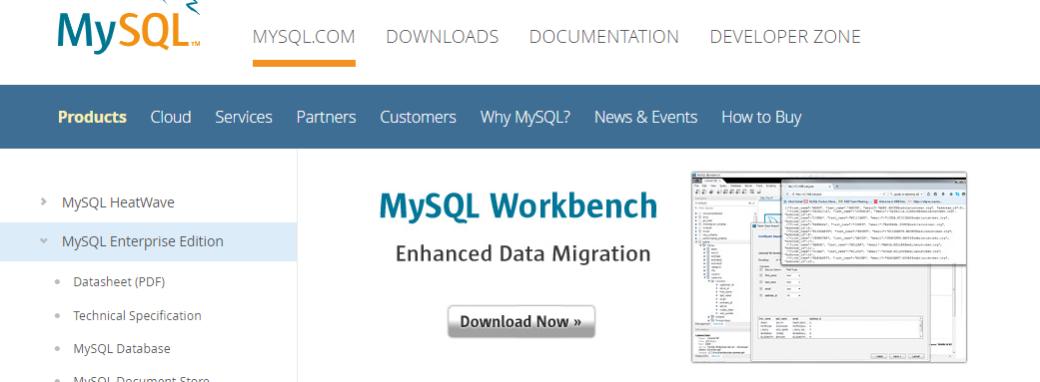

2. Run the downloaded installer and follow the on-screen instructions to begin the installation process.

3. Choose the installation directory where you want to install MySQL Workbench.

4. Select the desired options and features to install. The default options are typically sufficient for most users.

5. Click the "Next" or "Continue" button to proceed.

6. Review the installation settings and click the "Install" button to start the installation process.

7. Wait for the installation to complete. This may take a few minutes.

8. Once the installation is finished, click the "Finish" button.

**Step 3: Set up the Signature Verification System**

1. Launch XAMPP by double-clicking the XAMPP Control Panel icon on your desktop or by navigating to the XAMPP installation directory and running the "xampp-control" application.

2. Start both the Apache and MySQL servers by clicking the "Start" button next to each of them in the XAMPP Control Panel. The server status should change from "Stopped" to "Running."

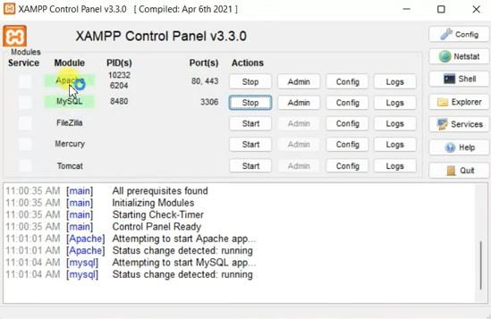

3.Open your web browser and type "http://localhost/phpmyadmin" in the address bar to access the phpMyAdmin interface.

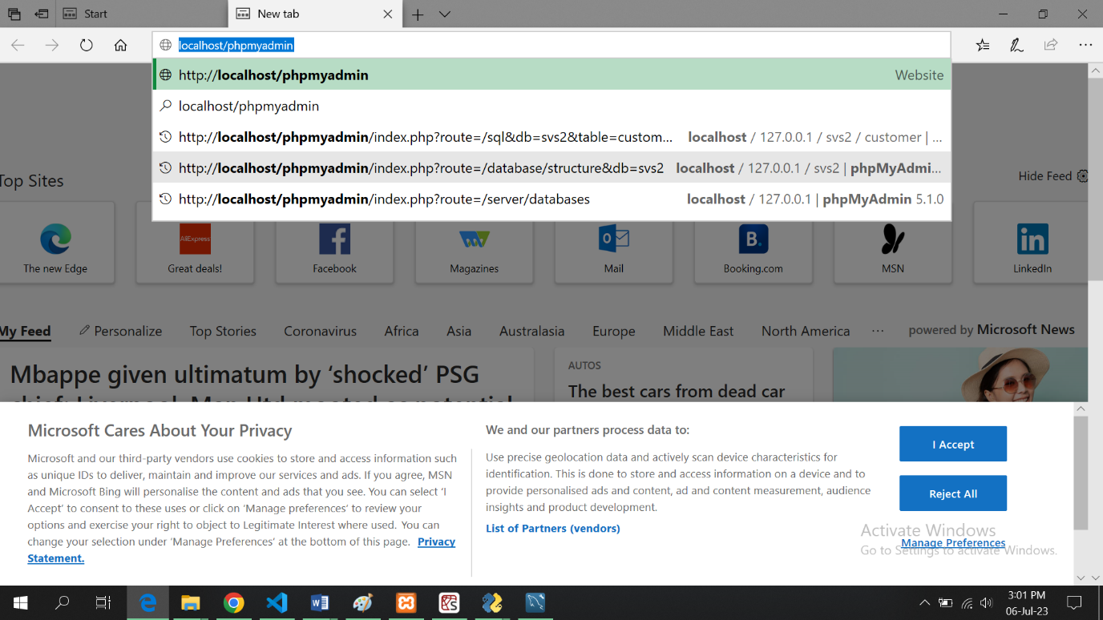

4. If prompted, enter your MySQL username and password to log in to phpMyAdmin.

5. Once logged in, you will see the phpMyAdmin interface with a list of databases on the left-hand side.

6. Click on the "New" button on the left-hand side to create a new database for the Signature

Verification System. Enter a name for the database (e.g., "signature_verification_system") and click the "Create" button.

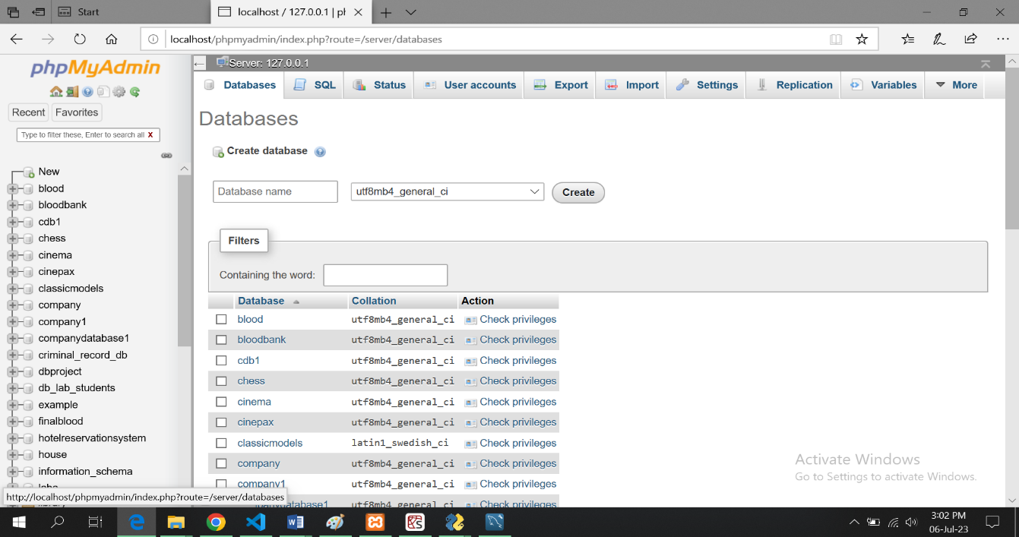

1. After creating the database, click on its name in the left-hand side panel to open it.

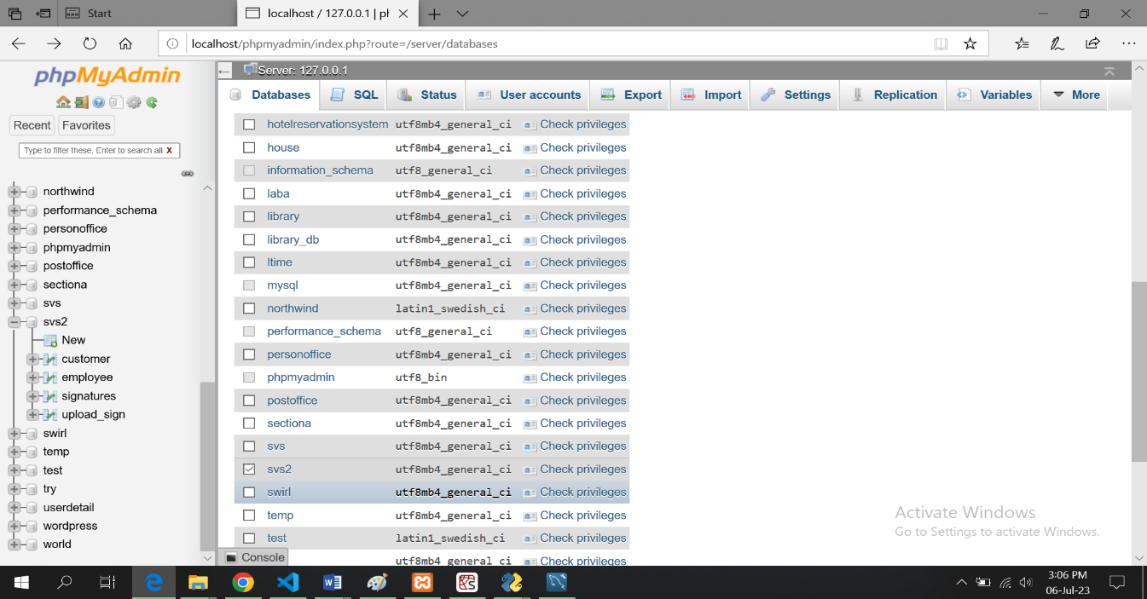

8. Look for the "Import" tab within the phpMyAdmin interface and click on it.

9. Click the "Choose File" button and select the provided database file (usually in .sql format) to import.

10. Click the "Go" button to start importing the database file into your local MySQL server. Wait for the import process to complete. This may take some time, depending on the size of the database.

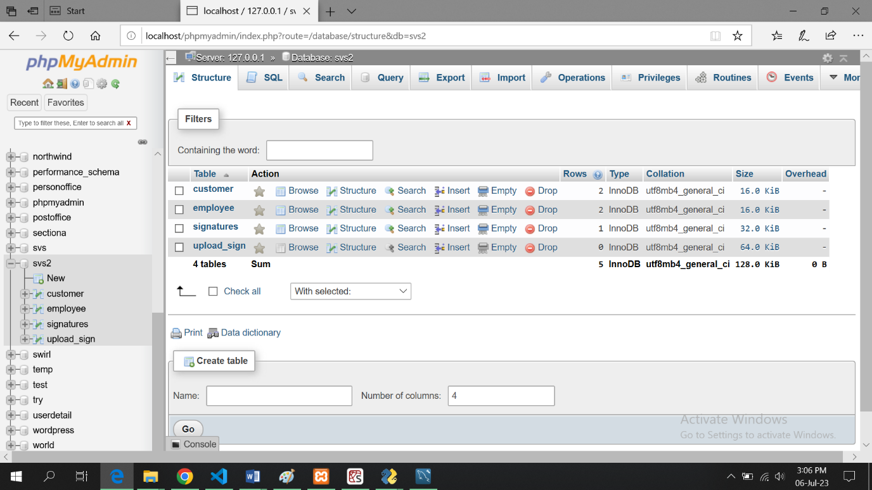

**Choose the table in which you want to add data let us choose customer:**

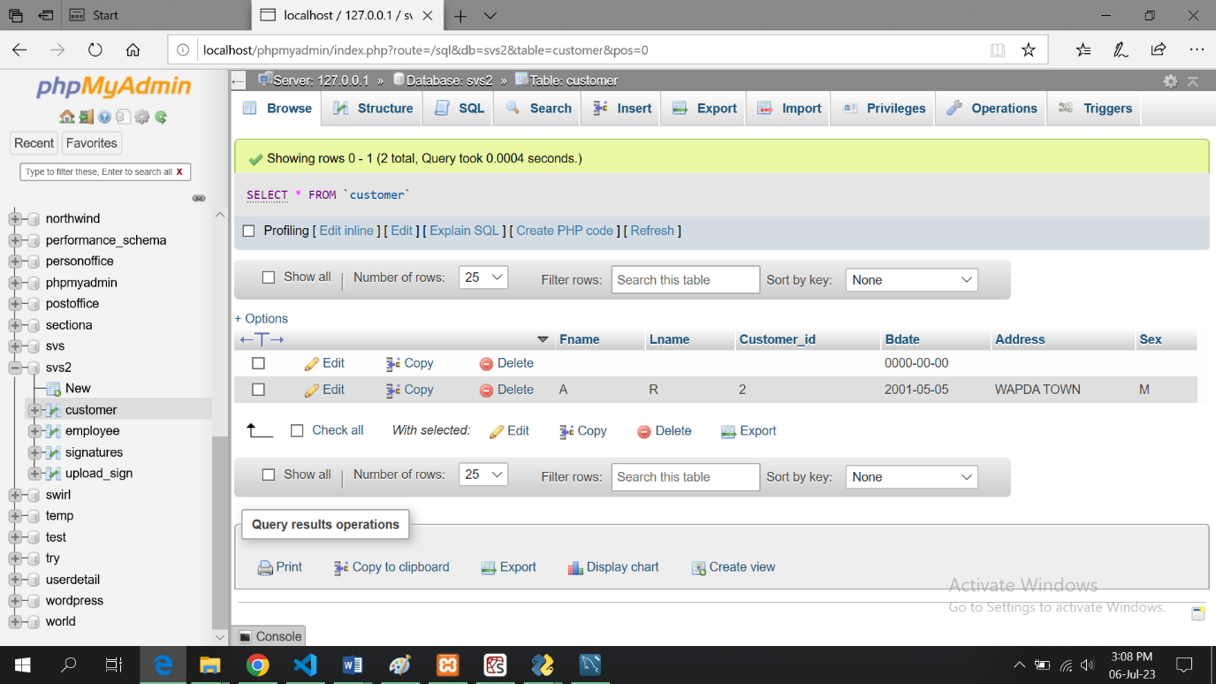

**Click on insert tab to insert data:**

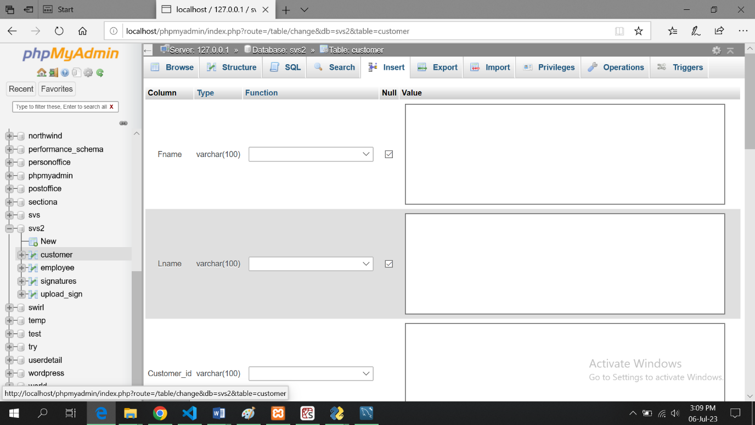

11. Once the import is finished, you should see a message indicating that the import was successful.

**Step 4: Run the Signature Verification System Application**

1. Locate the provided .exe file for the Signature Verification System application.

2. Double-click on

the .exe file to run the application. You may see a security warning or a User Account Control (UAC) prompt. Click "Allow" or "Yes" to proceed with the installation.

3. The installation process will begin, and the necessary files will be extracted and copied to the appropriate location on your system.

4. Follow the on-screen instructions provided by the installer. This may involve selecting an installation directory or accepting the default settings.

5. Once the installation is complete, you can choose to create a desktop shortcut or launch the application directly.

6. Double-click on the .exe file or the desktop shortcut to launch the Signature Verification System application.

7. The application should open and be ready to use.

Note: If you encounter any issues or errors during the installation or setup process, refer to the application's documentation or contact the support team for further assistance.

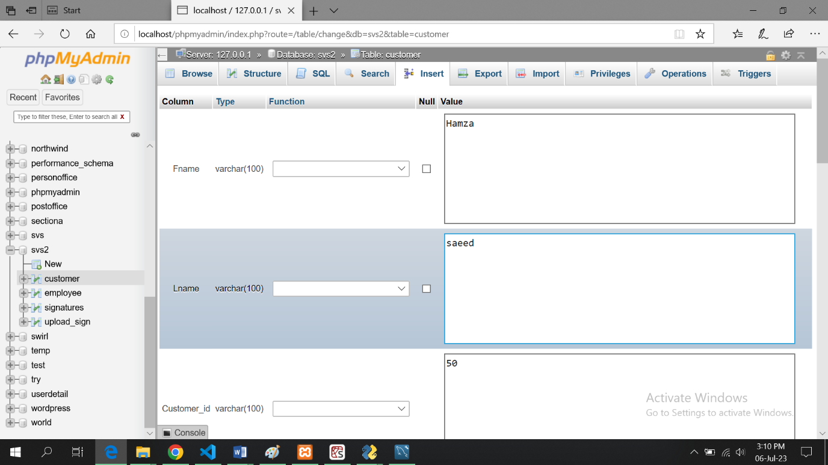

**Click go button:**

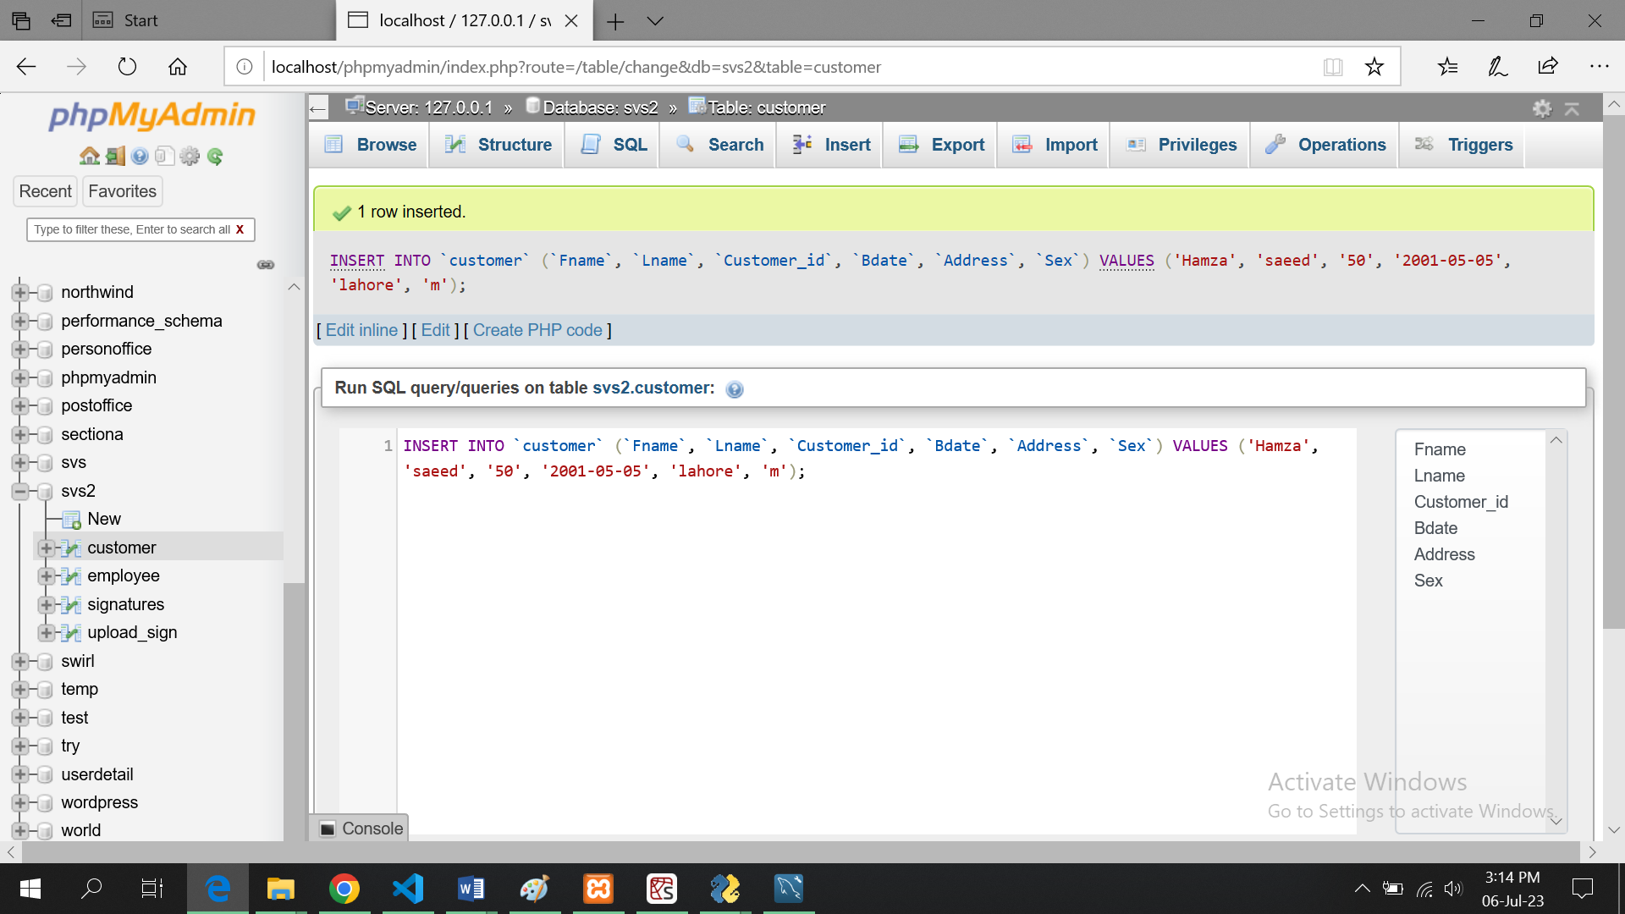

# User Manual

**Introduction:**

* Welcome to the User Guide for the Signature Verification System.
* This guide provides instructions on how to use the system effectively.
* Contact your bank's admin or the designated personnel to gain access to the Signature Verification System.

**Registration:**

* Admin will be the person registered in database
* Admin will be able to register himself in app
* And if admin wants to login he will enter id assigned to him if id exists in database he is a registered employee and will able to login
* Regular User will not be able to register himself he will also be registered by admin
* Customer will also not be able to register themselves they will be registered by admin
* Regular user cannot Add, delete, update any customer’s data
* User can only verify signatures
* Admin can also act as regular user along with administrative rights

**Login:**

* Launch the desktop application by double-clicking the application icon.
* The first screen will prompt you to choose between being a user or an admin.
* Select the desired mode (User or Admin) by clicking on the respective option.
* If you are an admin, enter your admin credentials (username and password) and click the "Sign In" button.
* If you are a user, enter your user id and if you are a registered user, you will able to access your account and start verifying



**Admin Panel:**

* After successful admin login, the admin panel will open.
* The admin panel provides various options for managing customer records.

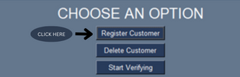**Customer Record Management (Admin):**

* To update a customer's record, select the customer from the list or search for the customer using their details.
* Make the necessary changes to the customer's information, such as name, CNIC, and contact number.
* To delete a customer's record, enter the customer ID you want to delete and the customer and its record will be deleted.



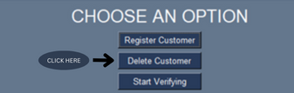

* To add a new customer, click on the "Add Customer" button and provide the required details, including name, ID, contact number.
* Once the customer is registered the app will ask you to enter the 4 genuine signatures of the customer against his id which will be stored in database.

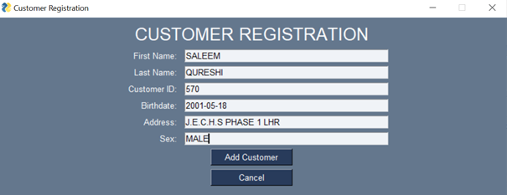

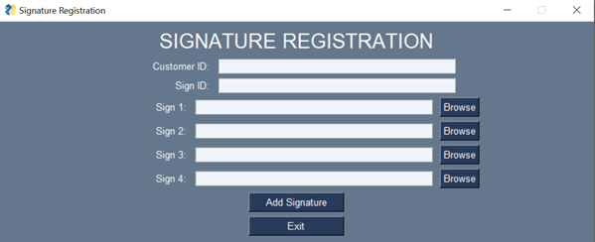

**User Panel:**

* If you are a user, after successful login, the user panel will open.
* Your unique ID will be displayed on the screen.
* You will have two options Start Verifying and exit.
* By pressing exit button, you will leave the app.



* By pressing start verifying a new screen will occur.



* The new screen will require customer id whose signature are to be verified.



* It will also require 4 genuine signs and 1 test sign
* For every signature there will be a BROWSE button by clicking that button you will be able to choose signature from a folder or wherever you kept the signatures

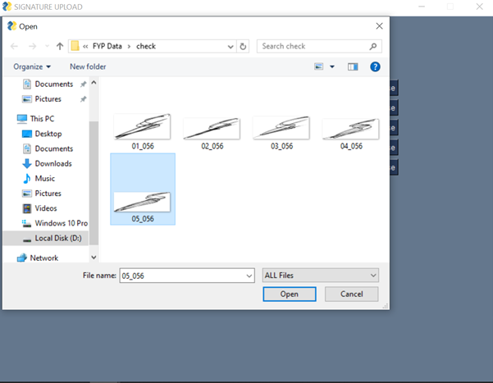

**Signature Verification Process (User):**

To validate your signatures, follow these steps:

* Once 4 genuine signatures and one test signature is uploaded to the app.

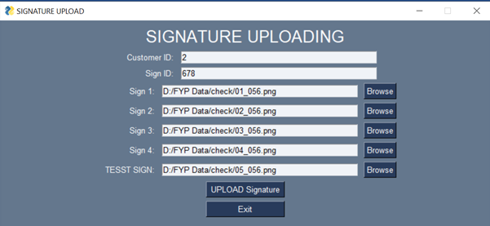

* There will be a test button on screen
* After pressing the test button, the signatures will be given to backend.
* Processing will take some time 10 to 15 seconds.
* After that a result will be shown on screen indicating that if signatures are fake or real.

